Accelerated 2
Spring Student Enrichment Packet

PRINCE GEORGE’S COUNTY PUBLIC SCHOOLS
Office of Academic Programs
Department of Curriculum and Instruction

™

NOTE TO THE STUDENT

This Spring Student Enrichment Packet has been compiled to complement middle school mathematics classroom instruction aligned to the Maryland College and Career Ready Standards (MCCRS). The packet is intended to be used for review and practice of previously taught and new concepts.

The questions in this packet, which have the corresponding Maryland College and Career Ready standard listed next to them, are similar to those you will encounter later this year on the PARCC assessment. See more resources for PARCC at www.parcconline.org.

We strongly encourage you to work diligently to complete the activities. You may experience some difficulty with some activities in this packet, but we encourage you to think critically and creatively and complete them to the best of your ability.

Use this Assessment Reference Sheet as needed as you solve the problems in this packet.

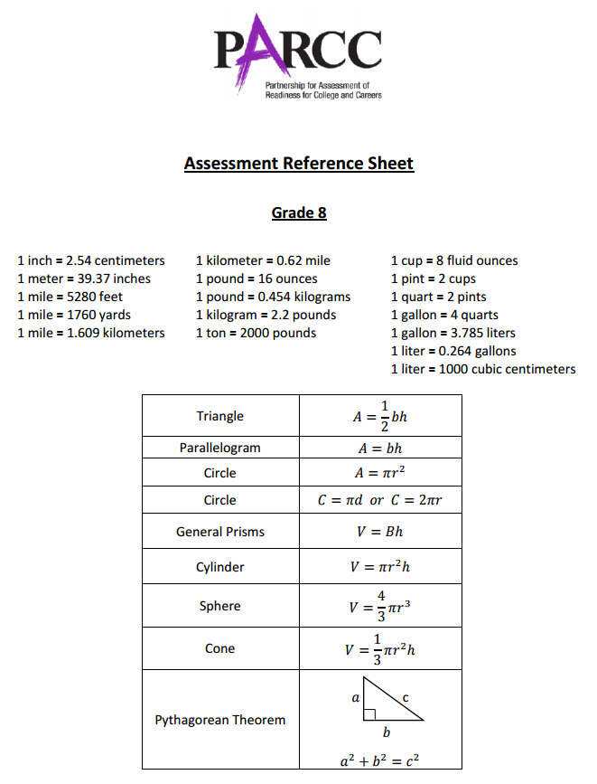

Directions: Select or find the best answer to each problem. Write your answer in the space provided or on a separate sheet of paper.

1. (8.EE.8)

What is the solution to the system of equations below? Enter your answer in the blanks.

$$5x+4y=6$$
$$x-3y=5$$

Solution: _______ , ________

2. (8.EE.8)

Four systems of equations are shown in the table. Indicate whether each system of equations has no solution, one solution, or infinitely many solutions.

Check a box in each column.

 | $$\left\{\begin{aligned}4x+8y=-12 \\ x+2y=-3\end{aligned}\right.$$ | $$\left\{\begin{aligned}y=-1 \\ x=0\end{aligned}\right.$$ | $$\left\{\begin{aligned}3x+2y=-1 \\ 3x+2y=1\end{aligned}\right.$$ | $$\left\{\begin{aligned}y=-2x-2 \\ 2y=-4x-4\end{aligned}\right.$$
No Solution | □ | □ | □ | □
One Solution | □ | □ | □ | □
Infinitely Many Solutions | □ | □ | □ | □

3. (8.EE.2)

Which of the following statements are correct? Select ALL that apply.
□ A. If $x^{3}= \frac{1}{8}$, then $x= \frac{3}{2}$
□ B. If $x^{2}= \frac{4}{36}$, then $x= \frac{1}{3}$
□ C. If $x^{2}= \frac{16}{100}$, then $x= \frac{4}{25}$
□ D. If $x^{3}= \frac{27}{64}$, then $x= \frac{3}{4}$
□ E. If $x^{3}= \frac{8}{125}$, then $x= \frac{2}{5}$

4. (8.EE.8)

Two coaches purchased sandwiches and drinks for their teams. Coach Patrick spent $144 for 16 sandwiches and 12 drinks, while Coach Samuel spent $120 for 12 sandwiches and 15 drinks.

Part A
Write a system of equations that represent how much each coach spent. Use s for sandwiches and d for drinks. Write your equations in the blanks.

Coach Patrick: ______________________

Coach Samuel: ______________________

Part B
Use your equations to determine the cost for one sandwich and one drink. Write your answers in the blanks.

1 Sandwich = $___________ 1 Drink = $___________

5. (8.EE.3)

The weights of different animals are shown in the table below.

Animal | Weight (ounces)
Elephant | $$2.22 ×{10}^{5}$$
Dog | $$1.92 ×{10}^{2}$$
Rat | $$8.4 ×{10}^{-1}$$
Deer | $$9.3 ×{10}^{3}$$

Approximately how many times heavier is an elephant than a dog?

A. 3
B. 30
C. 100
D. 1,000

6. (8.EE.8)

Your teacher told you to graph the following system of equations:

$$\left\{\begin{aligned}y=\frac{1}{2}x+3 \\ 6x+3y=-6\end{aligned}\right.$$

Your graph of the system is shown below:

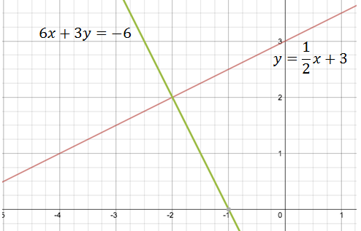
Part A
What is the solution of this system? Enter your answer in the blanks.

_______ , ________

Part B
Explain how you can check that your solution is correct. Enter your answer in the space below.

7. (8.F.4)

The graph below shows the relationship between the height (centimeters) of a seedling, and the time (weeks), that it grows.

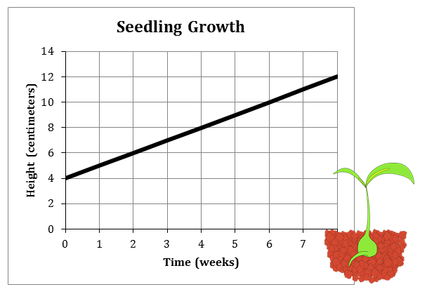

Choose the correct statement below about the slope of the graph.

A. The slope of the line is $\frac{1}{2}$.
B. The slope of the line is 4 because the graph line begins at 4 on the y-axis.
C. The slope indicates that in one week, the seedling grows one centimeter.
D. The slope indicates that in one week, the seedling grows $\frac{1}{2}$ centimeter.

8. (8.SP.1)

The table below shows the height and weight for 10 players from the University of Maryland men’s basketball team.

Height (in.) | 76 | 71 | 75 | 76 | 81 | 79 | 81 | 78 | 70 | 83
Weight (lb.) | 190 | 170 | 185 | 210 | 220 | 205 | 230 | 200 | 190 | 250

Part A
Use the points to create a scatter plot.

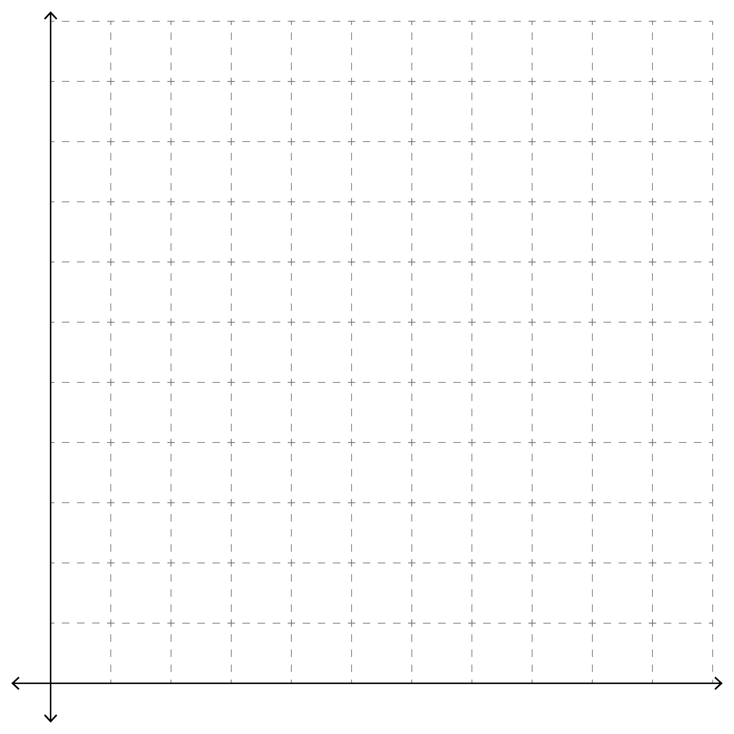

Part B
Use the graph you created to select the correct word from each box to complete the statement:
positive
negative
The pattern of association between the quantities is because generally, the taller the player, the
more
less
his weight is.

9. (8.SP.4)

A store carries yellow, purple, and white shirts in small, medium, and large. The table below displays some of the data on what the store currently has in stock.

 | Small | Medium | Large | TOTALS
Yellow | 21 |  |  | 70
Purple |  | 48 |  | 102
White | 9 | 24 | 6
TOTALS | 60 | 108

Part A
What is the relative frequency to small yellow shirts to all small shirts? Write your answer as a fraction.

Part B
What is the relative frequency of large white shirts to all white shirts? Write your answer as a fraction.

10. (8.EE.1)

Seven expressions are shown. Indicate whether each expression is equivalent to or not equivalent to $3^{6}×3^{-3}$ by placing it in the correct box.

$$3^{-18}$$ |  | $$3^{-3}$$ |  | $$3^{3}$$ |  | $$3^{(6-3)}$$ |  | $$\frac{3^{6}}{3^{-3}}$$ |  | $$\frac{3^{6}}{3^{3}}$$ |  | $${{(3}^{6})}^{-3}$$

Equivalent to $3^{6}×3^{-3}$ |  | Not Equivalent to $3^{6}×3^{-3}$

11. (8.NS.1, 2)

Mark True or False for each of the following statements:

True False
All integers are whole numbers. ☐ ☐
$7 × π=22$ ☐ ☐
$\sqrt{\frac{54}{6}}$ is rational. ☐ ☐
$\sqrt{2}$ is rational. ☐ ☐
Irrational numbers cannot be negative. ☐ ☐

12. (8.NS.2)

Approximate the values of the numbers shown below; place each in the correct position on the number line.

$\sqrt{2}$ $\frac{\sqrt{14}}{2}$ $\frac{186}{97}$ $\frac{π}{3}$ $\sqrt{3}$

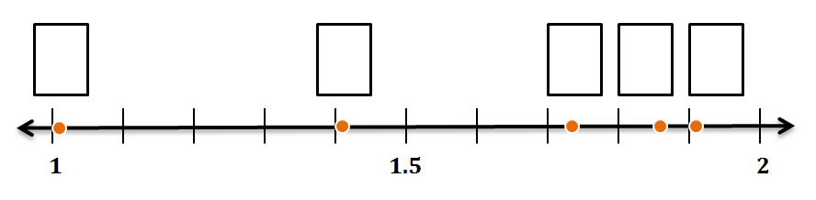
13. (8.G.7)

What is the area of the shaded square in the figure below?

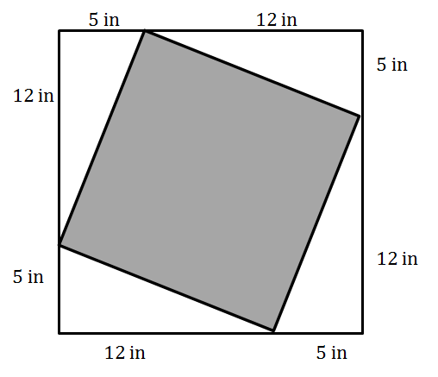
A. 52 in²
B. 144 in²
C. 169 in²
D. 289 in²

14. (8.G.7)

The image below shows the approximate locations of three Prince George’s County middle schools on a map in kilometers.

How far apart are Buck Lodge MS and Nicholas Orem MS?
Buck Lodge MS
Charles Carroll MS
Nicholas Orem MS
17 km
15 km

A. 3 kilometers
B. 5 kilometers
C. 8 kilometers
D. 16 kilometers

15. (8.G.7, 8)

The points on the coordinate plane below show different locations on a college campus. Each unit on the grid represents 1 kilometer.
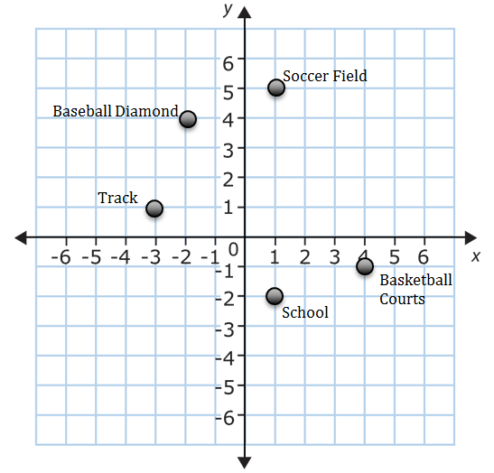
Part A
Determine the distance between the baseball diamond and the track to the nearest tenth of a kilometer. Show your work below.

Part B
What two other pairs of locations have an equal distance between them as the baseball diamond and the track? Explain how you determined your answer.

Part C
Is it farther from the track to the basketball courts or the soccer field to the basketball courts? Show your work or explain how you determined your answer.

