Accelerated 2
Spring Student Enrichment Packet

PRINCE GEORGE’S COUNTY PUBLIC SCHOOLS
Office of Academic Programs
Department of Curriculum and Instruction

™

Accelerated 2 Spring Enrichment Packet
Answer Key

Problem | Answer
1. | (2, -1)
2. | 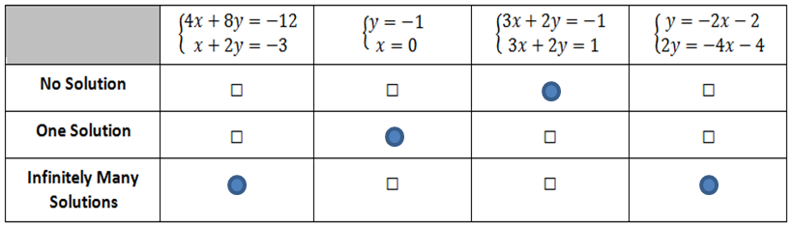
3. | D, E
4. Part A | Coach Patrick: 16s + 12d = 144  Coach Samuel: 12s + 15d = 120
Part B | 1 Sandwich = $7.50  1 Drink = $2
5. | D
6. Part A | (-2, 2)
Part B | I can check that the solution is correct by substituting -2 for x and 2 for y and checking that the two sides of the equation are equal.  6(-2) + 3(2) = -6 and 2 = ½(-2) + 3
7. | C
8. Part A | The axis intervals and points plotted should be accurate.
Part B | Positive; more
9. Part A | 7/20
Part B | 3/13
10. | Equivalent: 3³, 3⁶⁻³, $\frac{3^{6}}{3^{3}}$ Not Equivalent: 3⁻¹⁸, 3⁻³, $\frac{3^{6}}{3^{-3}}$, ${{(3}^{6})}^{-3}$
11 | False, False, True, False, False
12. | From left to right: $\frac{π}{3}$ , $\sqrt{2}$ , $\sqrt{3}$ , $\frac{\sqrt{14}}{2}$ , $\frac{186}{97}$
13. | C
14. | C
15. Part A | 3² + 1² = c²  10 = c²  3.2 = c  The baseball diamond is 3.2 km from the track.
Part B | One pair that has an equal distance of 3.2 km is the soccer field and the baseball diamond, and the other is the basketball courts and the school. I know this because each pair is separated by a diagonal of a triangle which has three units on one side and one unit on the other.
Part C | From the track to the basketball courts, it is 7.3 km:  7² + 2² = c²  49 + 4 = c²  53 = c²  7.3 = c  From the soccer field to the basketball courts, it is 6.7 km:  3² + 6² = c²  9 + 36 = c²  45 = c²  6.7 = c  So it is farther from the track to the basketball courts than the soccer field to the basketball courts.

