**Foundations for Algebra**

**Spring Student**

**Enrichment Packet**



PRINCE GEORGE’S COUNTY PUBLIC SCHOOLS

Office of Academic Programs

Department of Curriculum and Instruction

**™**

***NOTE TO THE STUDENT***

*This Spring Student Enrichment Packet has been compiled to complement middle school mathematics classroom instruction aligned to the Maryland College and Career Ready Standards (MCCRS). The packet is intended to be used for* ***review and practice*** *of previously taught and new concepts.*

*The questions in this packet, which have the corresponding Maryland College and Career Ready standard listed next to them, are similar to those you will encounter later this year on the PARCC assessment. See more resources for PARCC at* [*www.parcconline.org*](http://www.parcconline.org)*.*

*We strongly encourage you to work diligently to complete the activities. You may experience some difficulty with some activities in this packet, but we encourage you to think critically and creatively and complete them to the best of your ability.*



*Use this Assessment Reference Sheet as needed as you solve the problems in this packet.*

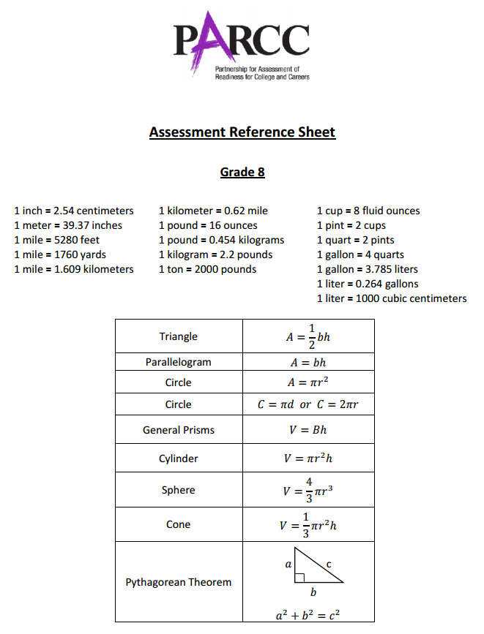

**Directions: Select or find the best answer to each problem. Write your answer in the space provided or on a separate sheet of paper.**

**1.** (8.G.1)

$$∆ABC$$ below is dilated by a scale factor of 3.

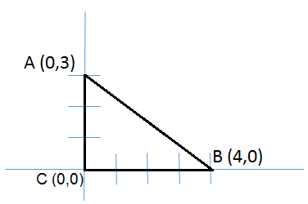

**Part A**

* Yes
* No

Is the dilated triangle a right triangle?

**Part B**

* Similar
* Congruent
* Neither Similar nor Congruent

The original triangle and the new triangle are:

**2.** (8.EE.1)

Six expressions are shown. Circle which expressions are equivalent to $6^{-4}×6^{2}$**.**

|  |  |  |  |  |  |
| --- | --- | --- | --- | --- | --- |
| $$6^{(-4+2)}$$ | $${{(6}^{-4})}^{2}$$ | $$6^{2}$$ | $$6^{-2}$$ | $$6^{-8}$$ | $$\frac{1}{6^{2}}$$ |

**3.** (8.G.2)

The pre-image of $∆ABC$ is mapped to the image of $∆A'B'C'$ by a transformation.

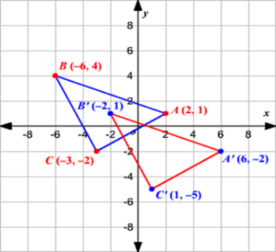

**Make** **a correct selection from each box below.**

up.

down.

left.

right.

1

2

3

4

1

2

3

4

up

down

left

right

The translation shifts the figure units and units

**4.** (8.G.8)

What is the distance between the points on the grid below? Round your answer to the nearest hundredth. Enter your answer in the box.

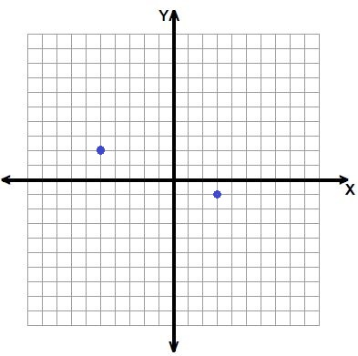 **units**

**5.** (8.G.5)

In the figure below, $\overline{AB}$ is parallel to $\overline{CD}$ and they are crossed by transversal $\overline{EF}$.

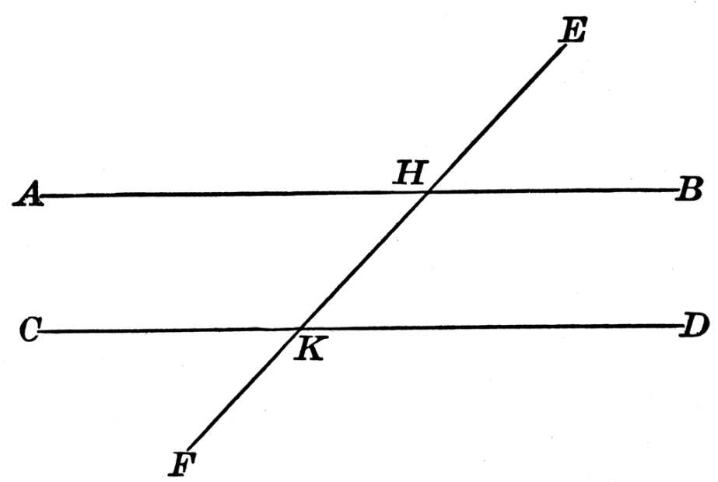

If $m∠DKF=112°$, how many angles above have a measure of $68°$?

A. 4

B. 2

C. 1

D. 0

**6.** (8.G.4)

The pre-image of parallelogram *ABCD* and the image of parallelogram *A’B’C’D’* are shown below.

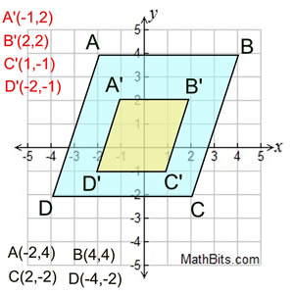

**Part A**

Describe the transformation that moved each vertex of parallelogram *ABCD* onto the image of parallelogram *A’B’C’D’*. Explain how you determined your answer.

**Part B**

Does the transformation that you described prove similarity between the two figures? Why or why not? Explain your answer.

**7.** (8.G.4)

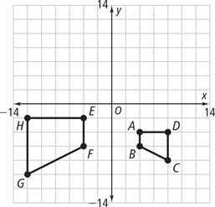

Describe the sequence of transformations that maps trapezoid *ABCD* directly onto trapezoid *EFGH*.

A. a 90o clockwise rotation about the origin followed by a dilation with a scale factor of 2

B. a reflection over the y-axis followed by a translation 1 unit up

C. a reflection over the y-axis followed by a dilation with a scale factor of 2

D. a dilation with a scale factor of 2 followed by a 90o clockwise rotation about the origin

**8.** (8.G.6)

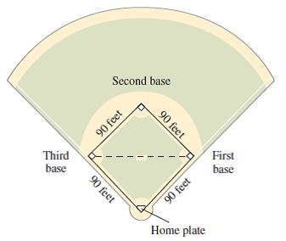

A baseball “diamond” is actually a square with sides of 90 feet as shown in the figure above. If a fielder stands on third base and throws the ball to first base, how far must the fielder, throw the ball? Round your answer to the nearest tenth of a foot if necessary. Write your answer in the box.

**feet**

**9.** (8.EE.3)  
  
Rewrite the number 5,616,000 in scientific notation. Fill in the blanks in the expression below.

**x 10**

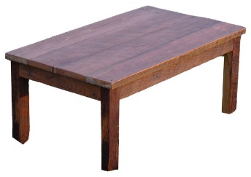**10.** (8.G.6)  
  
In construction, the term "square” means every corner of the table has a right angle.

In shop class, you build a table. For the table top, the length measures 36 inches and the width measures 18 inches. If the diagonal measure of the table top measures 43 inches, is the table “square”?  Justify your reasoning with mathematics in the space below.

**11.** (8.G.7)  
  
A right rectangular prism is shown below.

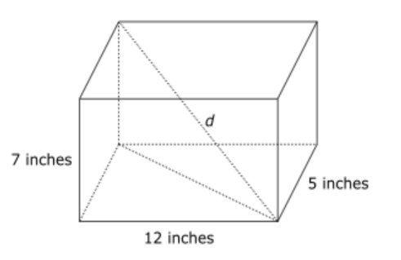

To the nearest tenth of an inch, what is the length of the diagonal, *d*?

A. 13.8 inches

B. 14.3 inches

C. 14.8 inches

D. 15.3 inches

**12.** (8.G.8)  
  
The points (3, 5) and (–2, –5) are plotted on a coordinate plane. How many units apart are the two points? Round your answer to the nearest tenth. Enter your answer in the box.

**units**

**13.** (8.EE.1)

Which expression is equivalent to $\frac{3^{-2}}{3^{-4}}$?

A. $3^{2}$

B. $\frac{1}{3^{2}}$

C. $3^{6}$

D. $\frac{1}{3^{6}}$

**14.** (8.EE.2)  
  
Which of these expressions represent solutions to the equation $n^{3}=27?$ Select **each** correct answer.

□ A. 3

□ B. –3

□ C. 9

□ D. –9

□ E. $\sqrt[3]{27}$

□ F. – $\sqrt[3]{27}$

**15.** (8.EE.4)  
  
A painter bought 750 paintbrushes. Each paintbrush has a mass of $5.2×{10}^{-3}$ kilograms. What is the total mass in kilograms of the paintbrushes that the painter bought? Write your answer as a decimal in the blank.

**kg**

