Geometry Common Core
SPRING STUDENT
ENRICHMENT PACKET

™

Prince George’s County Public School
Office of Academic Programs
Department of Curriculum and Instruction

NOTE TO STUDENT

This Spring Student Enrichment Packet has been compiled to complement high school mathematics classroom instruction aligned to Maryland College and Career Ready Standards (MCCRS). It is intended to be used for review and practice of previously taught and new concepts.

We strongly encourage you to work diligently to complete the activities in this packet. You may experience some difficulty with some problems in this packet, but we encourage you to explore and attempt to find a solution to the best of your ability.

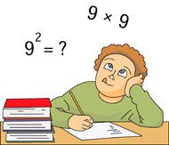

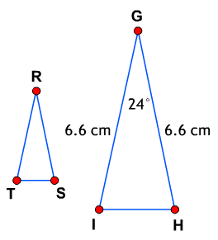
Given that $∆RST \sim ∆GHI,$ what is the measure of $∠RTS?$

- $m∠RTS$ = 24°
- $m∠RTS$ = 78°
- $m∠RTS$ = 156°
- Not enough information is given

A table top best models a

- point.
- plane.
- line.
- space.
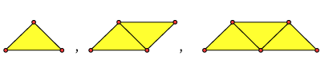
Debra and Monica are creating a tessalation using triangles. Use inductive reasoning to help them find the next shape in the pattern.

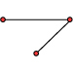
A.

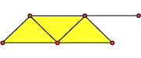

B.

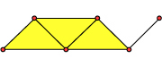
C.

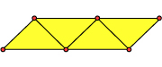
D.
The figure shows lines r, n, and p intersecting to form angles numbered 1, 2, 3, 4, 5, and 6. All three lines lie in the same plane.

Based on the figure, which of the individual statements would provide enough information to conclude that line r is perpendicular to line p?

Select all that apply.

- $m∠2=90°$
- $m∠6=90°$
- $m∠3= m∠6$
- $m∠1+ m∠6=90°$
- $m∠3+ m∠4=90°$
- $m∠4+ m∠5=90°$
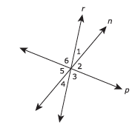

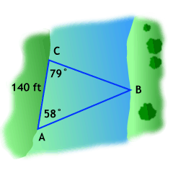
One relaxing attraction at the park is a ferry ride across the river. Visitors are picked up at point A and taken across to point B. The return trip drops them off at point C. Find the length of side $\overline{AB}.$

- It is not possible to determine the length of $\overline{AB}.$
- 97.3 feet
- 174.1 feet
- 120.9 feet
- 201.5 feet
Line segment AB with endpoints A(4, 16) and B(20, 4) lies in the coordinate plane. The segment will be dilated with a scale factor of$\frac{3}{4}$ and a center at the origin to create $\overline{A^{'}B^{'}.}$ What will be the length of $\overline{A^{'}B^{'}}$?

- 15
- 12
- 5
- 4
The table shows the approximate measurements of the Great Pyramid of Giza in Egypt and the Pyramid of Kukulcan in Mexico.

Pyramid | Height  (meters) | Area of Base  (square meters)
Great Pyramid of Giza | 147 | 52,900
Pyramid of Kukulcan | 30 | 3,025

Approximately what is the difference between the volume of the Great Pyramid of Giza and the volume of the Pyramid of Kukulcan?

- 1,945,000 cubic meters
- 2,562,000 cubic meters
- 5,835,000 cubic meters
- 7,686,000 cubic meters
Nicholas owns two triangular plots of land, as shown below. He wants to build a sculpture garden on the largest plot. Which plot will give him the most area to display his sculptures?

The pictures are not drawn to scale.

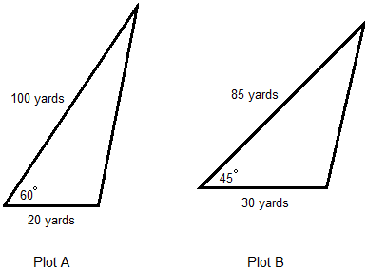

- Plot A has the greatest area.
- Plot B has the greatest area.
- Plots A and B have the same area.
- Not enough information to determine.

Candace wants to prove triangle congruence using ASA. Which of the following pairs of triangles can Candace use as an example for ASA congruency?
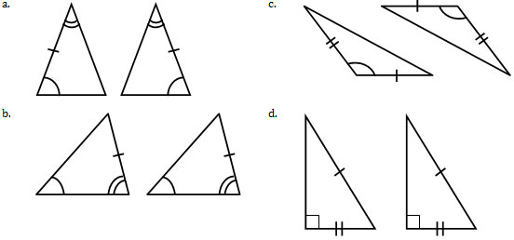

Robert, John, and Kyle are playing catch. Robert throws the ball to Jesse; Jesse throws the ball to Kyle; and Kyle throws the ball to Robert. John knows that the distance between him and Robert is 20 yards and the distance between him and Kyle is $20√3$ yards. He also knows that the angle created between Robert, himself, and Kyle has a measure of 30°.
Which person is making the shortest throw?
- Robert
- Kyle
- Jesse
- Robert and Kyle
- Kyle and Jesse
- Robert and Jesse

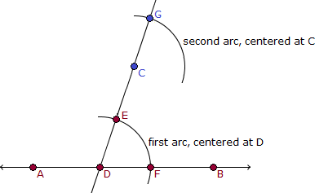
Below is a stage in the construction of a line parallel to $\overset{⃡}{AB}$ that passes through point C not on $\overset{⃡}{AB}$.

Which of the following sentences describes the next step in the construction?

- Set the compass width to $\overline{CE}$ and draw an arc centered at point E intersecting the first arc.
- Set the compass width to $\overline{EF}$ and draw an arc centered at point G intersecting the first arc.
- Set the compass width to $\overline{DE}$ and draw an arc centered at point G intersecting the first arc.
- Set the compass width to $\overline{CG}$ and draw an arc centered at point G intersecting the first arc.

The figure below illustrates constructing _____________.
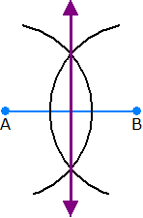

- segment addition.
- a bisector of a segment.
- an obtuse angle.
- a congruent segment.

Given: ABCD is an isosceles trapezoid. M is a midpoint of $\overline{AB}.$

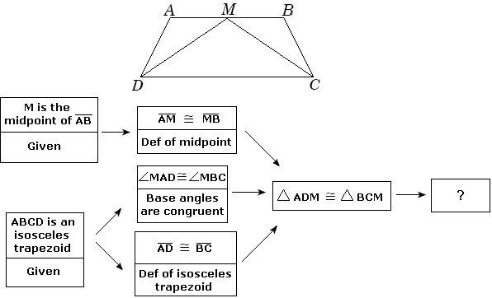

Which statement does the above diagram prove and why?

- $\overline{DM}≅ \overline{CM};ASA$
- $\overline{DM}≅ \overline{CM};SSS$
- $\overline{DM}≅ \overline{CM};Congruent parts of congruent triangles are congruent$
- $\overline{DM}≅ \overline{CM};SAS$

The vertices of a rectangle are listed below.
E(2, 2), F(2, 8), G(10, 8), J(10, 2)

What is the area of the rectangle?

- 28 square units
- 48 square units
- 192 square units
- 96 square units

The vertices of a triangle are listed below.
Q(-5, 4), R(3,4), S(-7, -6)

Which of the following correctly classifies the triangle?

- The triangle is an obtuse scalene triangle.
- The triangle is an acute scalene triangle.
- The triangle is an obtuse isosceles triangle.
- The triangle is a right isosceles triangle.

