SPRING STUDENT ENRICHMENT
READING AND SOCIAL STUDIES PACKET
Grade 1



™
Prince George’s County Public Schools
Office of Academics Programs
Department of Curriculum and Instruction
GRADE 1 SPRING STUDENT ENRICHMENT
READING AND SOCIAL STUDIES PACKET

DIRECTIONS

Complete the activities using the response pages
provided at the end of the packet.

Students are to complete:
1. Poetry Activities (pages 3-6)
2. Making Words Activity (page 7)
3. Social Studies (pages 8-9)
4. Reading Log (page 10) – Students are expected to read for a minimum of 15 minutes each day of Spring Break.

Parents are encouraged to assist in the following ways:

- Make a plan to complete the activities during Spring Break.

- Provide a quiet space and time for your child to work on the packet.

- Help your child with the directions and completing the activities.

- Review and discuss your child’s responses. Provide positive feedback and praise for sincere effort and independence.

- If your child is just beginning to learn to write independently, encourage him/her to write and spell as best as he or she can. You may rewrite the sentence underneath the child’s to show correct letter and word formation and spelling.

Thank you for helping your child succeed as a reader!

Poetry Activities

April is National Poetry Month.

Please read the following directions with your child.

- Before reading the poem, think about things that you might see outside (trees, ponds, bushes, mountains) and share your ideas.

- Read the poem aloud. Read it again three times fluently (smooth reading with expression). Try to make your reading sound like the poet would want it read–emphasizing certain words and phrases. Read it aloud to someone else

- After reading the poem, think about taking a walk outside. What things would you see that are bigger than you? Fill in the chart with a word that compares what is bigger or smaller than the words already provided. On the response sheet, draw a picture of what you would see and write sentences or a paragraph describing your picture.

- Highlight three words in the poem and write two or more rhyming words for each highlighted word.

- Word Work: Making Words.

- Social Studies: People at Work.

- Visit the public library with your family. Read and learn more about poets and read different types of poetry.

Name __________________________

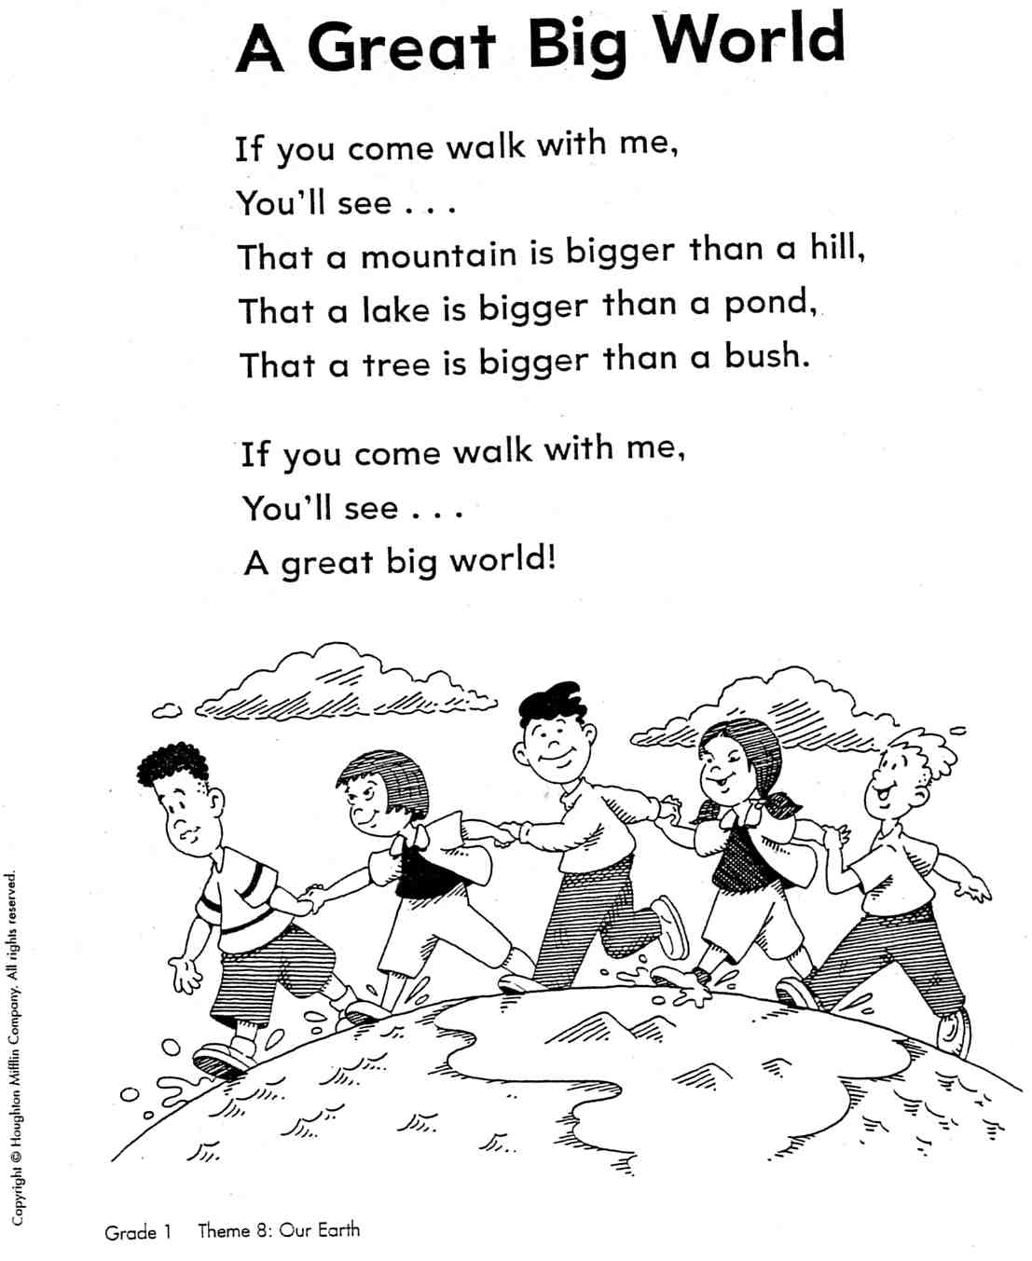

Name ______________________________

MY RESPONSE PAGES

Draw a picture of what you would see outside that is bigger than you.

Describe your picture.

_________________________________________________________

_________________________________________________________

__________________________________________________________

__________________________________________________________

__________________________________________________________

__________________________________________________________

__________________________________________________________

__________________________________________________________

__________________________________________________________

__________________________________________________________

Write three words from the poem. Then write two or more words that rhyme with each word.

Word from Poem Rhyming Words

1.___________________ _____________ ________________

2.___________________ ______________ _______________

3.___________________ ______________ ________________

Thinking About Poetry
Fill in this chart, comparing things from the poem “A Great Big World,” with the correct word from smallest largest.


h i l l
m o u n t a i n

b u s h
t r e e

p o n d
l a k e
MAKING WORDS ACTIVITY
Directions: Cut apart the letters to make as many words as you can. In the boxes below, write the words that you made. Challenge: How many four or five letter words can you make?

------------------------------------------------------------------------------------------------------------------
r | p | i | s | n | g

SOCIAL STUDIES
Read and Write

People at Work
by Joy Darlington

Come and watch us work. Learn how we do our many different jobs. Meet Joe. Joe works in a busy factory. He makes crayons in many different colors. Meet Emma. Emma runs a daycare center in her home. She takes care of small children. Meet Maria. She is a plumber. She uses her wrench and other tools to fix broken pipes. Meet Oliver. Oliver works for free. He is a volunteer at a hospital. He reads books to patients. He talks with them.


Jobs - the work people do
Tools - things that are used to help people do work
Volunteer - a person who works for free

Write to It! 

- Write one or two sentences about the jobs that you just read about.
_____________________________________________________________________________________________________________________________________________________________________________________________________________________________________________________________________________________________________________

- Would you like to do one of these jobs? Why or why not?
__________________________________________________________________________________________________________________________________________________________________________________________________________________________________________________________________


Reading Log for Spring Break
First Grade
First grade students may read by themselves or have someone read to them. Read for a minimum of 15 minutes each day of Spring Break. Students may read the same book more than once to practice fluency. Record what you read in the log below.
Date | Title of Book Read | Minutes Read

