Grade 3
Science
SPRING ENRICHMENT PACKET

Prince George’s County Public Schools
Office of Academic Programs
Department of Curriculum and Instruction

Note to Student and Parents/Guardians

This is an “at-home” supplemental science instructional packet for middle school students during Spring Break.

This packet has been created to provide practice for students to answer Selected Response (SR) items and work through technical reading passages of informational text to write Constructed Responses (CRs) to support middle school science and the PGCPS Literacy Initiative. For Constructed Response items, it is highly recommended that students practice their annotating skills when reading the text.

Students will use the passages to write claims, evidence, and reasoning for Constructed Response items and circle the correct answer choice for Selected Response items.

- For more information about the PGCPS Literacy Initiative, visit: http://www.pgcps.org/literacy/ for parents and students.

The items in the Spring Enrichment Packet are aligned to the Next Generation Science Standards’ (NGSS) Science and Engineering Practices (SEPs), physics and chemistry.

For more information about the PGCPS Science and NGSS, visit:
- PGCPS Science Department: http://www1.pgcps.org/science/
- NGSS Website: https://www.nextgenscience.org/
- NGSS Parent Guide: https://tinyurl.com/NGSSParentGuide

The answer key for SR items and the writing rubric for CR items are located on pages 12 - 14.
.

Three Kinds of Water
By Linda Ruggieri
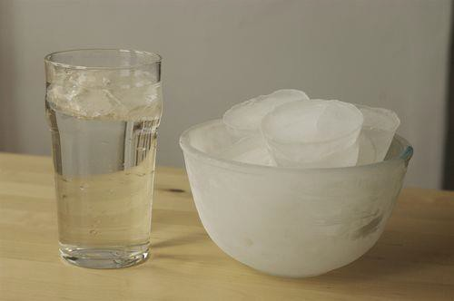

Credit: alisdair, CC BY 2.0

Did you know that water comes in three different forms? Water can be liquid. We drink liquid water, and we wash with it.

Water can be solid. Frozen water is called ice. Ice is solid. We use ice cubes to keep drinks cold.

Water can be gas, or steam. Steam is made of tiny
drops of water. When we boil water, it turns into steam. Steam also creates heat to warm homes.

People need water to live. So remember, use water carefully. Never waste water. ReadWorks® Inc.

- Write four sentences about what you learned from reading, “Three Kinds of Water”?

What is a magnet?
How can you pick up or move something without touching it? Use a magnet! Magnets attract
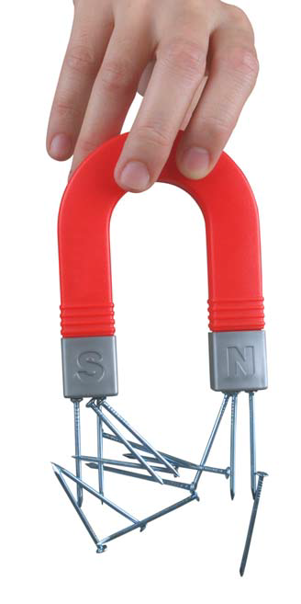
some objects. The object is pulled toward the magnet.

Look at this picture. The magnet easily picks up the nails. When the magnet is lifted, the nails will still hang from the magnet.

Magnets attract iron or nickel. They don’t attract other metals. They don’t attract paper, wood, glass, or plastic.
Look at these little bits of iron. If you move the magnets, the iron bits will move, too. You don’t have to touch the iron bits.

These toy pieces have a magnet on each end. The round magnets attract one another. Would the toy come apart if you picked it up? Why or why not? No, the magnets hold the toy together.

To answer question 2, use the reading on “What is a Magnet” to write your correct answer.

2. Will a magnet stick to this beach ball? Explain your answer below.

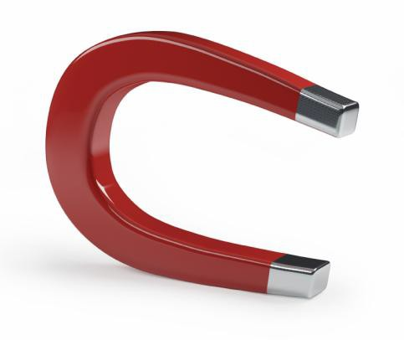
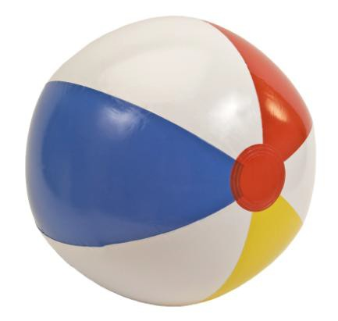

3. The data table below shows the physical properties of four materials.
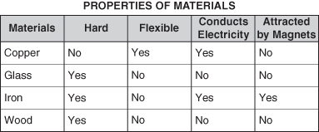
How are glass and copper similar? Circle your answer below. Circle your answer.
- Neither is hard.
- Both are flexible.
- Both conduct electricity.
- Not attracted by magnets.

Use the information below to answer Question 4.
A tennis player hit a tennis ball into the air, giving the ball a speed of 30 meters per second. The data table below shows the time the ball was in the air and the speed of the ball as it went up and down.
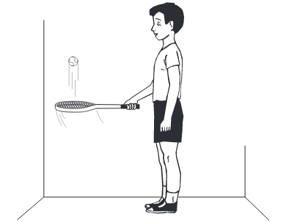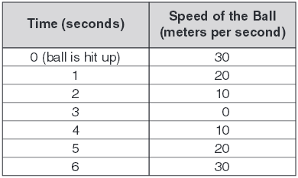
4. In what direction does gravity pull on the ball? Circle your answer.
- upward
- downward
- toward the left
- toward the right

5. A kitten is looking directly into a mirror. Which
drawing best shows the image of the kitten in the mirror? Circle your answer.

- 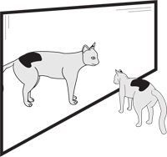
- 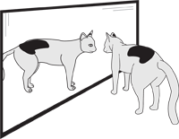
- 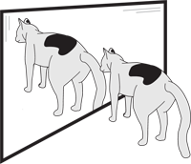
- 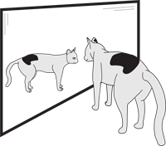

Use the information and pictures below to answer Question 6.
Wild ponies have lived on Assateague Island for about 300 years. The ponies have become well adapted to the harsh environment, including extreme temperatures in summer and winter. The ponies mainly eat salty marsh grasses and grow thick fur in winter. Domestic horses are larger than the ponies. An Assateague pony drinks twice as much fresh water as a domestic horse does. Other organisms on the island include rodents, birds, small foxes, marsh grasses, mussels, and deer.
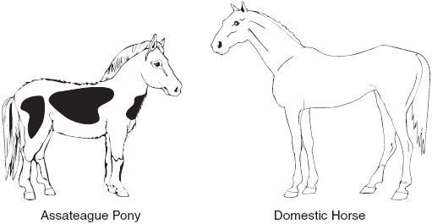
6. Why have the ponies developed a coat of thick fur?
- to stay warm
- to help them swim
- to prepare them to find mates
- to protect them from predators

The drawing below shows a field habitat.
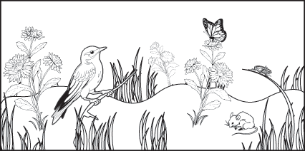
7. Which of these changes would be most harmful to
the organisms in the field habitat? Circle your answer.

- more birds flying over the field
- increase of rainfall on the field
- students taking pictures of the field
- construction of a buildings and roads in the field

Answer Key

# Item | Answer
1 | USE THE WRITING RUBRIC ON PAGES 13 and 14 TO SCORE  Example sentences:  - I learned that water could be a solid, liquid and gas.  - Steam is made of tiny water drops.  - People need water to live.  - Never waste water.
2 | USE THE WRITING RUBRIC ON PAGES 13 and 14 TO SCORE  Example: Magnets do not attract paper or plastic. Magnets stick to iron or nickel. Magnets can pick up nails.
3 | D
4 | B
5 | B
6 | A
7 | D

MISA 4-POINT RUBRIC
Rubric derived from the Maryland State Department of Education for use with Maryland Integrated Science
Assessment (MISA).

Score Point 4
There is evidence in this response that the student has a full and complete understanding of the solution to a problem or constructs a full and complete explanation of the question.
- Demonstrates complete integration of the use of science and engineering practices such as modeling, engaging in argument from evidence, obtaining, evaluating, and communicating information, etc.
- Provides a solution or explanation that is coherent and based on disciplinary core ideas
- Reflects a complete synthesis of understanding of complex ideas and crosscutting concepts
- Includes an effective application of the 3 dimensions (SEP, DCI, and CCC) to a practical problem or real-world situation which demonstrates a complete understanding of the 3 dimensions
Score Point 3
There is evidence in this response that the student has a general understanding of the solution to a problem or constructs a complete explanation of the question.
- Demonstrates integration of the use of science and engineering practices such as, modeling, engaging in argument from evidence, obtaining, evaluating, and communicating information, etc.
- Provides a solution or explanation that is mostly coherent and based on disciplinary core ideas
- Reflects a synthesis of understanding of complex ideas and crosscutting concepts
- Includes an effective application of the 3 dimensions to a practical problem or real-world situation which demonstrates an understanding of the 3 dimensions

Score Point 2
There is evidence in this response that the student has a partial understanding of the solution to a problem or constructs an explanation of the question.
- Demonstrates some integration of the use of science and engineering practices such as, modeling, engaging in argument from evidence, obtaining, evaluating, and communicating information, etc.
- Provides a solution or explanation that is adequately coherent and based on disciplinary core ideas
- Reflects some synthesis of understanding of complex ideas and crosscutting concepts
- Includes an application of the 3 dimensions to a practical problem or real-world situation which demonstrates a partial understanding of the 3 dimensions

Score Point 1
There is evidence in this response that the student has a minimal understanding of the solution to a problem or constructs a minimal explanation of the question.
- Demonstrates little or no integration of the use of science and engineering practices such as, modeling, engaging in argument from evidence, obtaining, evaluating, and communicating information, etc.
- Provides a solution or explanation that is minimally based on disciplinary core ideas
- Reflects little or no synthesis of understanding of complex ideas and crosscutting concepts
- Includes an application of the 3 dimensions to a practical problem or real-world situation which demonstrates a minimal understanding of the 3 dimensions

Score Point 0
There is evidence that the student has no understanding of the solution to a problem or the question.
- The response is completely incorrect, too vague, or irrelevant to the solution or question

