**SPRING STUDENT ENRICHMENT PACKET**

**RESEARCH SIMULATION TASK**

**& READING LOG**

**Grade 8**

**STEALING LINCOLN**

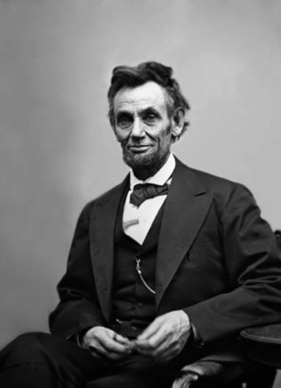

**Reading/English Language Arts**

**™**

**Prince George’s County Public Schools**

**Office of Academic Programs**

**Department of Curriculum and Instruction**

**[Type the company address]**

**Note to Students:**

You've learned so much in school so far! It is important that you keep your brain active over the break. In this package you will find a calendar of activities to last you all Spring Break. This year we have also incorporated a fun project for you to complete. Once you have completed the activity, create a journal that you can use to note your thoughts, ideas, and any work you complete.

**Directions:**

Family members should preview the packet together. There are activities that may require advance planning, or you may want to consider working together with other family and friends on some activities.

* **Students should read for at least 30 minutes each day.**
* **Students will need a Reader’s & Writer’s Journal to complete this spring work.** Your journal will be your special place for your daily calendar work and writing. Students can purchase a journal or they can make one by stapling several pieces of paper together or by using a notebook/binder with paper. Students should be creative and decorate the journal. Specific journal tasks are given some days, but students may also journal after each day's reading, notice things that stood out, questions that they have, or general wondering about the text.
* **Each journal entry should:**
* have the date and assignment title;
* have a clear and complete answer that explains the students thinking and fully supports the response; and
* be neat and organized.
* **Use the chart in this package to record all of the books read during Spring Break.**



**READING LOG**

**Ideally, students in the middle grades should read for 30 or more minutes each day.**

|  |  |  |  |  |  |  |
| --- | --- | --- | --- | --- | --- | --- |
| ***All good books are alike in that they are truer than if they had really happened and after you are finished reading one you will feel that all that happened to you and afterwards it all belongs to you…***    Ernest Hemingway  *Esquire,* December 1936  bd05509_[1] |  |  |  | **Day 1**  Pages Read:  Amount of Time: | **Day 2**  Pages Read:  Amount of Time: | **Day 3**  Pages Read:  Amount of Time: |
| **Day 4**  Pages Read:  Amount of Time: | **Day 5**  Pages Read:  Amount of Time: | **Day 6**  Pages Read:  Amount of Time: | **Day 7**  Pages Read:  Amount of Time: | **Additional**  Pages Read:  Amount of Time: | **Additional**  Pages Read:  Amount of Time: | **Additional**  Pages Read:  Amount of Time: |

**Looking for a “novel” idea?** Browse your bookshelves at home for a title, or visit your local library or bookstore for a great read! If you need some ideas, a few authors are listed below.

* + Avi
  + Virginia Hamilton
  + Lois Lowry
  + Louis Sachar

**Do you prefer nonfiction?** Browse your bookshelves at home for a title, or visit your local library or bookstore for a great informational text.

* + From your World Cultures studies
  + From your Science studies
  + Current events (such as presidents and political races or global warming and other environmental issues)
  + Biographies of interesting people

**Are you still looking for ideas?**

* + Prince George’s County Memorial Library suggested reading lists by grade – <http://www.pgcmls.info/website/childrens-graded-reading-lists-442>
  + Metametrics’ Lexile website – <http://www.lexile.com/fab/>

**Introduction**

On the night of the presidential election in 1876, a gang of money counterfeiters out of Chicago attempted to steal the entombed body of Abraham Lincoln and hold it for ransom.

In this series of tasks, you will research different media sources related to the plot to kidnap President Lincoln’s body from his grave and compare/contrast how information is presented. You will see how different authors choose to present their information in diverse ways.

First, you will read a news magazine article that summarizes the attempted kidnapping. Then, you will read a book excerpt that offers more detail about the kidnapping plot. Finally, you will watch a video that explains the actual kidnapping attempt.

As you review these sources, think about the advantages and disadvantages of using different mediums (for example, print or digital text, video, multimedia) to present a particular topic or idea.

*HINT: Keep this information in mind as you review each source! It will be helpful, not only for each text but for the final task, too!*

**Research Simulation Task Texts**

Three texts will be used in this set of practice materials. Print copies for Texts 1 and 2 are included in this packet.

* Text 1: “A Plot to Steal Lincoln’s Body: A posthumous kidnapping attempt shaped the Secret Service” (a news magazine article)
* Text 2: *Lincoln’s Grave Robbers* (excerpted and adapted from the literary nonfiction book of the same title) <http://www.usnews.com/news/articles/2007/06/24/a-plot-to-steal-lincolns-body>
* Text 3: *Stealing Lincoln’s Body* (video clip) <https://www.youtube.com/watch?v=HV2_0G4OAxc&feature=youtu.be>

**Research Simulation Tasks**

For this task, you will complete questions related to each text noted above. Then, you will complete an Analysis Project that is based on all three texts.

**TEXT 1**

**Please read the passage. You may also read this article online at:** [**http://www.usnews.com/news/articles/2007/06/24/a-plot-to-steal-lincolns-body**](http://www.usnews.com/news/articles/2007/06/24/a-plot-to-steal-lincolns-body)**.**

**Then answer questions 1 - 4.**

**A Plot to Steal Lincoln’s Body**

**A posthumous kidnapping attempt shaped the Secret Service.**

***By*** [***Thomas J. Craughwell***](http://www.usnews.com/topics/author/thomas_j_craughwell)**U.S. News & World Report *June 24, 2007 | 3:00 p.m. EDT***

Before Secret Service agents guarded the president, they chased counterfeiters. Their assignment did not formally shift until 1894, when a handful of agents served as Grover Cleveland's bodyguards. But there is an earlier example of the Secret Service getting involved in presidential security, albeit briefly, and in a posthumous kind of way.

In 1876, Abraham Lincoln's body lay within an aboveground white marble sarcophagus in a handsome tomb on the grounds of Springfield, Ill.'s Oak Ridge Cemetery. Oak Ridge was a rural cemetery located about 2 miles outside of the town. No groundskeeper lived there. No night watchman patrolled the area around the president's tomb. And the only thing standing between Lincoln's body and any would-be grave robbers was a single padlock on the tomb's chamber door. Not even the president's sarcophagus was burglarproof: Its lid was sealed, not with cement but with the less permanent plaster of Paris. To the distinguished gentlemen of Springfield who were members of the National Lincoln Monument Association, the organization charged with maintaining Lincoln's tomb, the absence of rigorous security measures seemed perfectly reasonable. After all, who would want to steal Lincoln's body?

***Comic caper.*** The answer to that question was a gang of Chicago Irish counterfeiters led by a small-time crime boss named Big Jim Kennally. Early in 1876, Kennally's best engraver of counterfeit plates, Benjamin Boyd, had been sentenced to 10 years in the state penitentiary in Joliet, Ill. To pressure the governor to release his man, Kennally recruited two members of his gang, Terence Mullen, a saloonkeeper, and Jack Hughes, a sometime manufacturer of counterfeit nickels, to kidnap Lincoln's body. For ransom, they would demand $200,000 in cash and a full pardon for Boyd.

Given the cemetery's minimalist approach to security, the gang actually had a better-than-even chance of pulling off the heist. But they made a significant mistake. Neither Mullen nor Hughes had any body-snatching experience, so they invited a man named Lewis Swegles, who they thought was a grave robber, to help them. They couldn't have made a worse choice, because Swegles was a paid informant—a "roper"—of the Secret Service.

Swegles played his part as double agent well, reporting every detail of the plot to his boss, Patrick D. Tyrrell, chief of the Chicago district office of the Secret Service. On the night Swegles accompanied Mullen and Hughes to Oak Ridge Cemetery, Tyrrell and his agents were lying in wait for them at Lincoln's tomb, witnesses for the comedy of errors that soon began. Although Mullen and Hughes were career criminals, they couldn't pick a lock, so they had to cut through the padlock with a file. Once inside the tomb chamber, they found they could not lift Lincoln's 500-pound cedar-and-lead coffin. The inept grave robbers were considering their options when a detective's pistol accidentally went off outside. Mullen and Hughes bolted, but it wasn't much of a getaway—they headed straight back to their saloon in Chicago where Tyrrell arrested them a couple days later.

Meanwhile, back in Springfield, the custodian of the tomb, John Carroll Power, was in a state of panic. If hapless amateurs could come so close to carrying off Lincoln's body, what would happen if professional body snatchers targeted the tomb? The only solution Power could think of was to hide the body where no one could find it. So after dark, Power and five friends buried Lincoln in a shallow, unmarked grave in the tomb's basement.

***Code of honor.*** None of the men who buried the coffin that night had known Lincoln. They were ordinary guys—one was a railroad ticket agent, another was a hotel-keeper, and a third worked as a bank clerk. Yet it had fallen to them to safeguard the remains of Lincoln, and they took that obligation seriously, swearing never to reveal the location of the martyred president's body. And in the years that followed, they kept that secret faithfully.

They were finally relieved of their obligation in 1901, when, under instructions from Robert Lincoln, the president's only surviving child, Lincoln's body was placed inside a steel cage, lowered into a 10-foot-deep vault, and buried under tons of wet concrete. He's still there, in his tomb on the grounds of Oak Ridge Cemetery.

While Tyrrell was the undisputed hero of the hour, the Secret Service perhaps benefited most of all from the failed crime. Protecting Lincoln's body led them to protecting the office of the presidency.

*Craughwell is the author of* Stealing Lincoln’s Body *(Harvard University Press, 2007). He lives in Bethel, Conn.*

Accessed 15 January 2015

<http://www.usnews.com/news/articles/2007/06/24/a-plot-to-steal-lincolns-body>

**1. Part A**

What is the meaning of ***heist*** as it is used in paragraph 4 of “A Plot to Steal Lincoln’s Body…?”

1. a playful, carefree incident or activity
2. an imitation, fake, or forgery
3. the weight or heaviness of an object
4. to take or steal, as in a robbery

**Part B**

Which phrase from the article best supports the correct answer in Part A?

1. “…there is an earlier example of the Secret Service getting involved in presidential security…”
2. “The only thing standing between Lincoln’s body and any grave robbers was a single padlock…”
3. “They couldn’t have made a worse choice because Swegles was a paid informant.”
4. “Yet it had fallen to them to safeguard the remains of Lincoln, and they took that seriously…”

**2. Part A**

Which sentence **best** states an important, or central, idea of “A Plot to Steal Lincoln’s Body…”?

1. The Secret Service has always protected President during their time in office.
2. The grave robbers did not succeed because of the weight of Lincoln’s coffin.
3. The role of the Secret Service changed because of the kidnapping plan.
4. The plan developed by the grave robbers was ruined by undercover spies.

**Part B**

Which detail from the article provides the **best** example of the central idea in Part A?

1. “Its lid was sealed, not with cement but with the less permanent plaster of Paris.”
2. “So after dark, Power and five friends buried Lincoln in a shallow grave in the tomb’s basement.”
3. “Yet it had fallen to them to safeguard the remains of Lincoln, and they took that seriously.”
4. “Protecting Lincoln’s body led them to protecting the office of the presidency.”

**3. Part A**

What is the author’s point of view of the kidnapping in “A Plot to Steal Lincoln’s Body…”?

1. He feels that the Secret Service did their job in protecting the President.
2. The author views the kidnapping plot as a comic stunt.
3. He gives Tyrrell all the credit for destroying the plot and rescuing Lincoln.
4. The author believes that the plan is foolproof and will be successful.

**Part B**

What sentence from the article **best** supports the answer to Part A?

1. “Tyrell and his agents were lying in wait for them, witnesses for the comedy of errors that soon began.”
2. “Meanwhile, back in Springfield, the custodian of the tomb, John Carroll Power, was in a state of panic.”
3. “Yet it had fallen to them to safeguard the remains of Lincoln, and they took that obligation seriously.”
4. “While Tyrrell was the undisputed hero of the hour, the Secret Service perhaps benefitted most of all.”

**4.** What are advantages and disadvantages of this format to present information? Use this graphic organizer to organize your thoughts about the advantages/disadvantages of the format of this form of media.

|  |  |  |
| --- | --- | --- |
| **“A Plot to Steal Lincoln’s Body:**  **A posthumous kidnapping attempt shaped the Secret Service”** | | |
| **Media format** |  | |
|  | **Evidence/Detail** | **Explanation/Importance** |
| **Advantages of this format to presenting information** | **1:** |  |
| **2:** |  |
| **3:** |  |
| **Disadvantages of this format to presenting information** | **1:** |  |
| **2:** |  |
| **3:** |  |

**TEXT 2**

**Please read the passage. Then answer questions 5 – 8.**

**Excerpted and adapted from the book**

**Lincoln’s Grave Robbers**

**By Steve Sheinkin**

**Coney Men vs. the Secret Service**

Counterfeiting went big-time during the Civil War, which started in 1861. As war ripped the country apart, the U.S. government needed piles of cash to pay millions of soldiers and to buy supplies for the massive Union Army. Congress responded with the Legal Tender Act, and the new law gave the U.S. Treasury the power to print paper currency. Government printing presses started pumping out hundreds of millions of dollars.

And counterfeiters started copying it.

This was becoming a gigantic problem for honest business owners. Say you own a store, and a guy comes in and buys five dollars’ worth of stuff. He pays with a twenty, and you give him fifteen dollars in change. But then, when

you go to put the twenty in the bank, they tell you it’s Coney—worthless. So you’ve lost the five bucks’ worth of goods *and* the fifteen you gave in change.

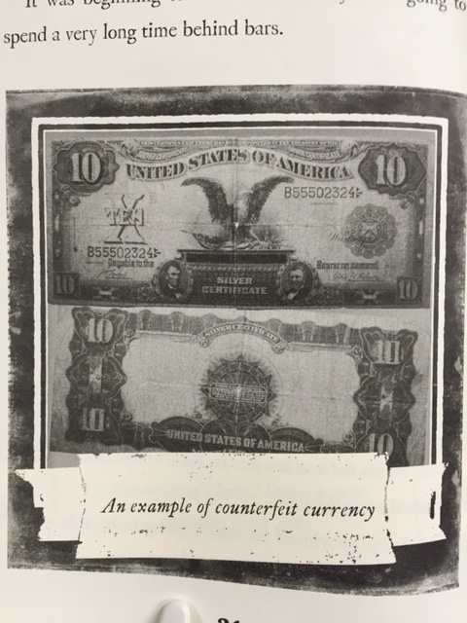

Americans were beginning to lose faith in the green slips of paper. And if citizens stopped trusting the currency, there’d be no way for the government to pay for the war. A very frightened Treasury Department responded in 1865 by creating the Secret Service, and charging the agency with leading the fight against counterfeiters. Back in the 1870s, the one and only task of the Secret Service was to stop the counterfeiters.

**Big Jim**

In St. Louis, Missouri, James Kennally—known as Big Jim—was concerned. The arrest, conviction, and punishment of counterfeiter Ben Boyd threatened to bring his entire empire crashing down.

Big Jim Kennally set up and managed one of the biggest counterfeiting networks in the Midwest. It was wildly profitable, but the entire operation was based on one simple fact: Kennally produced the best, most realistic-looking Coney available. And he was able to do this for one simple reason: he hired the best engraver, Ben Boyd. Now, his business was falling apart.

“The men who made their living mainly by means of Boyd’s work have been down in the mouth ever since his arrest,” declared the *Chicago Tribune*. “They have used every means in their power to get him out.” The *Tribune* reporter heard that Boyd’s friends had tried to bribe court officials and prison guards, with no luck. “Money could not obtain a pardon.” The paper explained. Big Jim was getting desperate.

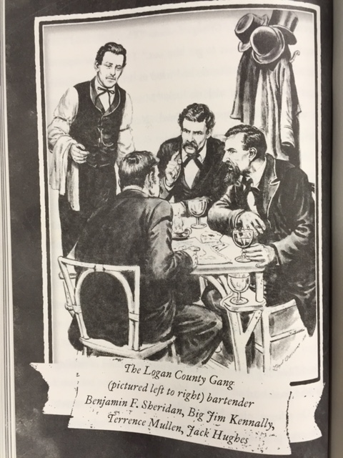

Big Jim concocted a plan: he wanted to steal the body of Abraham Lincoln. To get Lincoln’s body back, the government would have to let Ben Boyd out of jail. Kennally traveled to Lincoln, Illinois—named for the president—and shared his idea with members of the Logan County Gang, regular customers of his.

**First Try**

When Thomas Sharp and his gang came to check out the Lincoln Monument in Springfield, Illinois, the first thing they saw was a tall obelisk—a needle-shaped tower of gray granite. The tower rose from the center of a square building made of the same light stone. The whole thing sat on the top of a low, grassy hill, surrounded by trees.

In charge of the place was a bearded, fifty-seven-year-old man named John Carroll Power. As official custodian of the Lincoln Monument, Power earned fifty dollars a month to take care of the monument and lead tours of the tomb. He personally greeted every visitor—including each of the Logan County Gang members. They seemed to him like typical tourists. “All visited the monument, and mingles with other visitors,” he would later write.

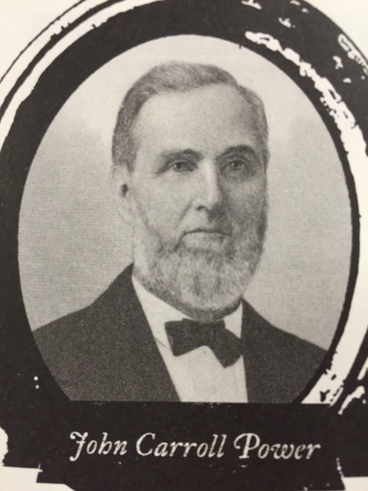

Power showed guests into the structure and escorted them through Memorial Hall, a homemade museum of Lincoln memorabilia. An interesting show, but the Logan County boys saw no sign of a coffin. Several of them asked Power where Lincoln’s body was.

It was a question Power got all the time, and not one that aroused suspicion. He explained that on the other side of the building was a second, smaller room—the tomb chamber or “catacomb,” as Power called it.

Power led his guests outside and around the monument to the catacomb. Two locked doors guarded the small room. The first was wood, with a glass window. It was a joke, the gang saw—you could simply kick it in, or break the glass. The second, inner door was a gate of thick steel bars, secured with a padlock. That would be more of an obstacle, but hardly discouraging.

Each gang member had a look, and heard some version of Power’s presentation. To be sure he’d understood, one of them asked Power if the body was really right there, above ground.

“Yes,” said Power. The room had a tile floor, and the marble sarcophagus rested on the tiles.

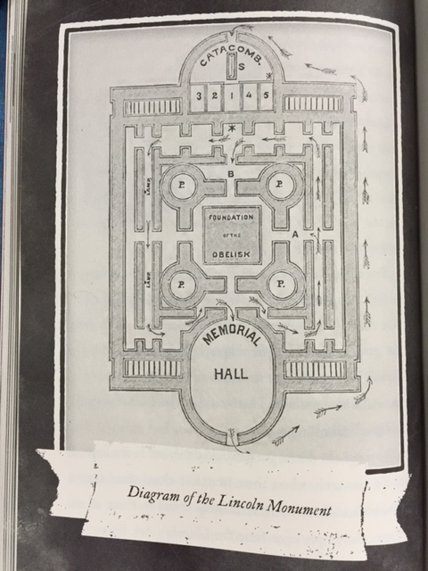

Another gang member asked if he could take a look inside, just out of curiosity.

“Sorry,” Power apologized, “no visitors allowed in the catacomb.” “How about a night guard? Surely someone stayed in there at night to keep watch?”

“No,” said Power, “there was no night watchman, either at the tomb or in the surrounding cemetery.”

By early June, the gang had all the details worked out, all the tools ready. The only thing left to do was wait for the big night. That turned out to be the hardest part.

With time to kill, the men started hanging around in bars, drinking and trying to impress the women of Springfield. One night Thomas Sharp drank too much and started crowing about a big deal he had in the works. He bragged, “I’m gonna be out at Oak Ridge, stealing old Lincoln’s bones!” A woman named Belle Bruce turned to Sharp in shock. Was he really serious? Sharp assured her he was.

Later that night, Bruce repeated Sharp’s strange tale to Abner Wilkinson, Springfield’s chief of police. Wilkinson ran into John Carroll Power on the street the next morning and shared that he had “discovered a plot to steal the remains of President Lincoln.”

Meanwhile, Bell Bruce must have told a few other folks Sharp’s wild story, because within a day it was all over town. The rumors quickly got back to Sharp himself—he’d blown the job.

The Logan County Gang lugged everything movable out of the saloon, loaded it onto a wagon and raced out of town.

With the election and other events going on in the country, no one was too concerned with the bizarre rumors floating around Springfield, Illinois. Basically, Lincoln’s old friends didn’t believe the story, and they told Power to forget the whole thing.

Big Jim Kennally was stewing with fury at the Logan County Gang for their boneheaded blunder. They had blown a golden opportunity—but the good news was, no one seemed to have noticed. Big Jim was convinced his idea could still work. He just needed a better team.

*Excerpt and images adapted from* Lincoln’s Grave Robbers *by Steve Sheinkin*

*Copyrighted 2012*

*Published by Scholastic Press, New York, NY 2013*

**5. Part A**

Read this sub-heading from the text.

**Coney Men vs. the Secret Service**

What does the word **Coney** mean?

1. criminal actions
2. federal agents
3. engraving tools
4. fake money

**Part B**

Which line from the text best supports the correct answer in Part A?

1. “Now his business was falling apart.”
2. “The one and only task of the Secret Service was to stop counterfeiters.”
3. “And counterfeiters started copying it.”
4. “This was becoming a gigantic problem for honest business owners.”

**6. Part A**

Which sentence **best** states an important, or central, idea of the section titled “Big Jim?”

1. Counterfeiting money, or Coney was a big-time business, both during and after the Civil War.
2. The kidnapping plan was developed to revive counterfeiting in the Midwest.
3. Jim Kennally planned to kidnap Lincoln’s body in revenge for being arrested for counterfeiting.
4. The Logan County Gang made a first failed attempt to kidnap Lincoln’s coffin in 1876.

**Part B**

Which line from the book excerpt provides the **best** example of an important idea in Part A?

1. “Government printing presses started pumping out hundreds of millions of dollars.”
2. “The men who made their living by means of Boyd’s work have been down in the mouth since his arrest.”
3. “Kennally shared his idea with members of the Logan County Gang, regular customers of his.”
4. “Big Jim Kennally was stewing with fury at the Logan county Gang for their boneheaded blunder.”

**7**. **Part A**

Read these lines from the book excerpt below.

Each gang member had a look, and heard some version of Power’s presentation. To be sure he’d understood, one of them asked Power if the body was really right there, above ground.

“Yes,” said Power. The room had a tile floor, and the marble sarcophagus rested on the tiles.

Another gang member asked if he could take a look inside, just out of curiosity.

“Sorry,” Power apologized, “no visitors allowed in the catacomb.”

“How about a night guard? Surely someone stayed in there at night to keep watch?”

“No” said Power, “there was no night watchman, either at the tomb or in the surrounding cemetery.”

How do these lines help develop an important idea of the text?

1. They offer readers a good understanding of why the counterfeiters wanted to steal the body.
2. They explain why the Secret Service was suspicious of the group’s actions after Boyd’s trial.
3. They show that the gang seemed no different from other visitors to the tomb of the President.
4. They were a reminder to Power that all kinds of visitors were interested in visiting Lincoln’s grave.

**Part B**

What other line/s below serves a similar purpose as in Part A?

1. “As official custodian of the monument, Power earned fifty dollars a month to take care of the monument and to lead tours.”
2. “Power led his guests outside and around the monument to the catacomb. Two locked doors guarded the room.”
3. “To be sure he’d understood, one of them asked Power if the body was really right here above ground.”
4. “It was a question Power got all the time, and not one that aroused suspicion.”

**8.** What are advantages and disadvantages of this format to present information? Use this graphic organizer to organize your thoughts about the advantages/disadvantages of the format of this form of media.

|  |  |  |
| --- | --- | --- |
| ***Lincoln’s Grave Robbers*** | | |
| **Media format** |  | |
|  | **Evidence/Detail or Image** | **Explanation/Importance** |
| **Advantages of this format to presenting information** | **1:** |  |
| **2:** |  |
| **3:** |  |
| **Disadvantages of this format to presenting information** | **1:** |  |
| **2:** |  |
| **3:** |  |

**TEXT 3**

**Watch the video from time marker 49:56 to 54:44.** **Then answer questions 9 – 11.**

**Video Excerpt from**

**Stealing Lincoln’s Body**

[**https://www.youtube.com/watch?v=HV2\_0G4OAxc&feature=youtu.be**](https://www.youtube.com/watch?v=HV2_0G4OAxc&feature=youtu.be)

*HINTS: You may want to view it once to get the gist, or general idea. You can then view it a second time for deeper understanding of the information.*

*You may watch the video clip as many times as you want. However, keep in mind that watching the full video clip too many times can take away from your time to think and respond.*

You may take notes in the space below.

**9. Part A**

Read this transcription from the video clip (@ 50:05)

Election Day, November 7 in 1876, is one of the most **turbulent** election days in American history.

What does the word **turbulent** mean?

1. a weapon or transformer driven by pressure
2. something that is powered by turbine engines
3. being in a state of disorder, destruction, or wildness
4. a storm that produces thunder our loud, powerful noises

**Part B**

Which adjective from the video best supports the correct answer in Part A?

1. “tense” (@ 50:17)
2. “turnout” (@ 50:23)
3. “eligible” (@ 50:23)
4. “wonderful” (@ 50:33)

10. Below is an important idea from the video ***Stealing Lincoln’s Body***.

**The plot was doomed to fail because some of the kidnappers didn’t know what they were doing.**

Drag and drop the two lines that best support this idea into the boxes below. If you are working with a paper version, copy the two lines into the boxes below.

|  |  |
| --- | --- |
| 1. | 2. |

B. “They made a bee-line to the back door—to the tomb entrance door.”

(@ 51:34)

A. “This is a wonderful night to steal the corpse of Abraham Lincoln…this is the perfect chance.” (@ 50:32)

C. “They’re standing there—three career criminals—none of whom know how to pick a lock.” (@ 51:52)

D. “Once they got open the padlock, immediately was Lincoln’s white marble sarcophagus.” (@ 52:27)

E. “No, no, no – wait! There may be an easier way to do this!” (@ 52:58)

11. What are advantages and disadvantages of this format to present information? Use this graphic organizer to organize your thoughts about the advantages/disadvantages of the format of this form of media.

|  |  |  |
| --- | --- | --- |
| ***Stealing Lincoln’s Body*** | | |
| **Media format** |  | |
|  | **Evidence/Detail or Image** | **Explanation/Importance** |
| **Advantages of this format to presenting information** | **1:** |  |
| **2:** |  |
| **3:** |  |
| **Disadvantages of this format to presenting information** | **1:** |  |
| **2:** |  |
| **3:** |  |

**Analysis Project**

You have learned about the plan to kidnap President Lincoln’s body by examining three texts in different media:

* “A Plot to Steal Lincoln’s Body: A posthumous kidnapping attempt shaped the Secret Service;”
* *Lincoln’s Grave Robbers;* and
* *Stealing Lincoln’s Body*.

For your project, **assess and evaluate the advantages and disadvantages of one text media format over another**.

*HINTS: What are the available media formats to choose from for this RST? What are the advantages and disadvantages of each format? Is one format better than the other? So what—or why is this important?*

Support your response with relevant textual, graphic, or visual evidence from **each** source to support your ideas.

You can produce your response to the above prompt through the following methods:

* Multi-paragraph Essay – type or write your response
* Prezi – <https://prezi.com/signup/public/>
* Google Slides – available through your PGCPS Gmail account (similar tools are PowerPoint and Keynote)
* Website – available through your PGCPS Gmail account
* Brochure/Pamphlet
* Mock Interview with an “Expert” – videotaped or done in class after the break
* Mock news broadcast (like a “60 Minutes” or “Dateline” segment) – videotaped to share with your classmates