**Grade 8**

**Science**

**SPRING ENRICHMENT PACKET**

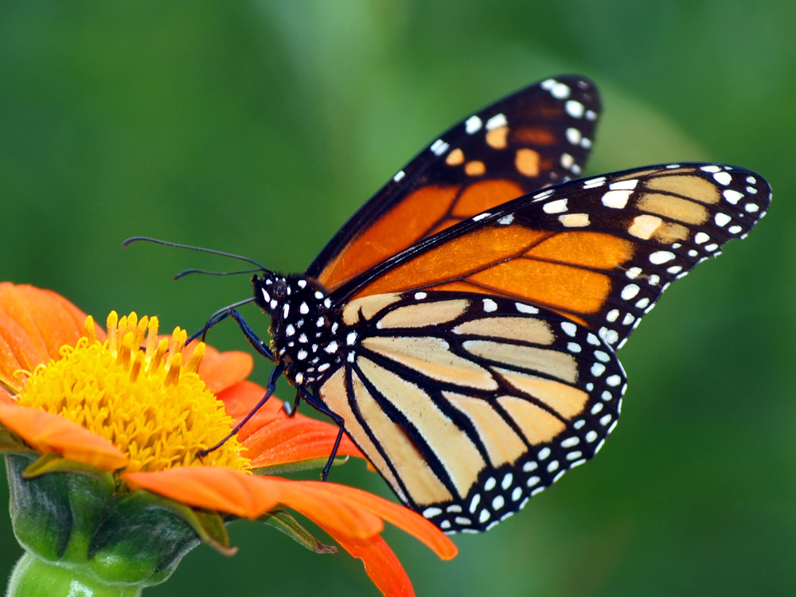



**Prince George’s County Public Schools**

**Office of Academic Programs**

**Department of Curriculum and Instruction**

**Note to Student and Parents/Guardians**

This is an “at-home” supplemental science instructional packet for middle school students during Spring Break.

This packet has been created to provide practice for students to answer Selected Response (SR) items and work through technical reading passages of informational text to write Constructed Responses (CRs) to support middle school science and the PGCPS Literacy Initiative. For Constructed Response items, it is highly recommended that students practice their annotating skills when reading the text.

Students will use the passages to write claims, evidence, and reasoning for Constructed Response items and circle the correct answer choice for Selected Response items.

* For more information about the PGCPS Literacy Initiative, visit: <http://www.pgcps.org/literacy/> for parents and students.

The items in the Spring Enrichment Packet are aligned to the Next Generation Science Standards’ (NGSS) Science and Engineering Practices (SEPs).

For more information about the PGCPS Science and NGSS, visit:

* PGCPS Science Department: <http://www1.pgcps.org/science/>
* NGSS Website: <https://www.nextgenscience.org/>
* NGSS Parent Guide: <https://tinyurl.com/NGSSParentGuide>

The answer key for SR items and the writing rubric for CR items are located on pages 9 and 10.

**1. Scientists perform experiments to test hypotheses.**

**How do scientists try to remain objective during experiments?**

* 1. Scientists analyze all results.
  2. Scientists use safety precautions.
  3. Scientists conduct experiments once.
  4. Scientists change at least two variables.

**2. A teacher asks her students the following question: How does the air pressure inside a**

**soccer ball affect the distance the soccer ball travels after the ball is kicked?**

**Which statement below is the best hypothesis for this investigation?**

1. If a soccer ball is large, then the soccer ball will travel a farther distance than a small soccer ball.
2. If a soccer ball has a high internal air pressure, then the ball will travel a farther distance than a soccer ball with less internal air pressure.
3. If a soccer ball travels a distance of 15 meters, then the ball is traveling faster than a soccer ball that travels a distance of 20 meters.
4. If a soccer ball has 0.5 atmospheres of internal pressure, then the ball will travel slower than a ball with 0.8 atmospheres of internal pressure.

**3. During an investigation, students were given chemical data for several common**

**household products, as shown in the data table below. Students were to determine if a**

**substance was an acid or base by using litmus paper. Litmus paper turns red in an acid**

**and turns blue in a base.**

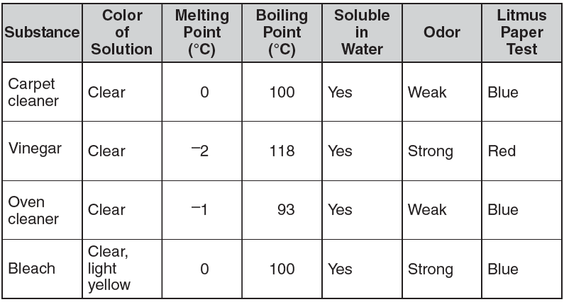

**Which conclusion is supported by the data from the investigation?**

1. Many cleaning supplies are soluble in water.
2. Cleaning solutions with a weak odor are acids.
3. Water is the main ingredient in many cleaning supplies.
4. A substance changes from a gas to a liquid as the temperature of the substance increases.

**4. Biologists conduct investigations to learn about living organisms.**

**Which method helps reduce bias during an investigation?**

1. developing a hypothesis after collecting data in the investigation
2. limiting the amount of background research before the investigation
3. designing an investigation with repeated trials during the investigation
4. obtaining other opinions concerning what should happen during the investigation

**Use the chart below to respond to Number 5.**

|  |  |
| --- | --- |
| **Effect of Temperature on Length of Onion Cell Cycle** | |
| **Temperature**  **(°C)** | **Length of Cell Cycle**  **(hours)** |
| **10** | **54.6** |
| **15** | **29.8** |
| **20** | **18.8** |
| **25** | **13.3** |

**5. A scientist performed an experiment to determine the effect of temperature on the length of the cell cycle. On the basis of the data in the table above, how long would you expect the cell cycle to be at 5°C?**

1. less than 12.3 hours
2. more than 54.6 hours
3. between 29.8 hours and 54.6 hours
4. about 20 hours

**Use the information and chart below to answer Number 6 on page 7.**

**Eight students conducted a controlled experiment to demonstrate how walking and running affected their heart rates. Use the data below to answer the following questions.**

**Effects of Activity on Heart Rate (in beats per minute)**

|  |  |  |  |
| --- | --- | --- | --- |
| **Student** | **Heart Rate**  **(at rest)** | **Heart Rate**  **(walking)** | **Heart Rate**  **(running)** |
| 1 | 70 | 90 | 115 |
| 2 | 72 | 80 | 100 |
| 3 | 80 | 100 | 120 |
| 4 | 65 | 75 | 95 |
| 5 | 88 | 112 | 125 |
| 6 | 74 | 83 | 104 |
| 7 | 75 | 88 | 109 |
| 8 | 77 | 95 | 130 |

**6. The students came to the conclusion that heart rates raise by 10 to 20 beats per minute**

**after walking and 20 to 40 beats per minute after running. First, identify the independent**

**(manipulating) and dependent (responding) variables. Then, explain whether or not the data**

**table supports this conclusion. In your explanation, be sure to include:**

* **the manipulated and responding variables**
* **evidence to support or reject the conclusion given by the students**
* **any other information that may have been recorded to indicate a controlled experiment or to improve the presentation of the experimental data.**

**Write your answer in the space provided.**

|  |
| --- |
|  |
|  |
|  |
|  |
|  |
|  |
|  |
|  |

**Use the data table below to answer Number 7.**

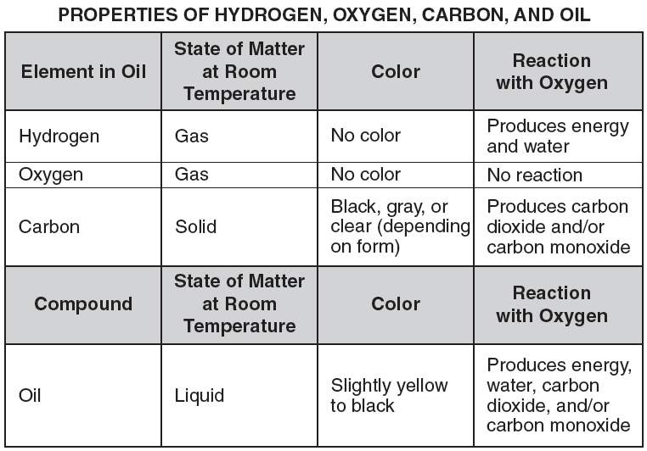

**7. Use the space on page 9 to compare the properties of oil to the properties of the**

**elements in oil.**

**In your comparison, be sure to include:**

**• the properties of oil**

**• the properties of the elements in oil**

**• the motion of the molecules in oil, carbon, and hydrogen**

|  |
| --- |
|  |
|  |
|  |
|  |
|  |
|  |
|  |
|  |
|  |
|  |

**Answer Key**

1. A.
2. B.
3. A.
4. C
5. B
6. USE THE WRITING RUBRIC ON PAGE 9 TO SCORE

SAMPLE STUDENT RESPONSE: Since the heart rate depended upon the walking, running, and the student remaining at rest, the heart rate is the dependent variable while the different forms of exercise are the independent variables. The table does not support the conclusion proposed by the students because the range of change after walking is from 9-24 bpm and after running is from 28-53 bpm. A question for further study could be the overall health of the people in an experiment/study and how their health may impact (positively or negatively) the results of the experiment/study. The students may have recorded the amount of time and/or distance as a constant for the experiment. The students may have also required a certain height, weight, or gender as a constant.

1. USE THE WRITING RUBRIC ON PAGE 9 TO SCORE

SAMPLE STUDENT RESPONSE: The property of oil is that it is a liquid, it’s slightly yellow to black, and when it reacts with oxygen it creates energy, water, carbon dioxide, and carbon monoxide. But the properties of the elements in oil are different. Hydrogen is a gas, it has no color, and when it reacts with oxygen it produces energy and water. Oxygen is a gas, it has no color, and it doesn’t react with oxygen. Finally, carbon is a solid, it has a black grey or clear color, and when it reacts with oxygen it produces carbon dioxide and carbon monoxide. Compared to oil 2 of oil’s element have fasting moving molecules, these 2 elements are hydrogen and oxygen because they are gases. But actual product oil has faster moving molecules than its element carbon.

**MISA 4-POINT RUBRIC**

*Rubric derived from the Maryland State Department of Education for use with Maryland Integrated Science Assessment (MISA).*

***Score Point 4***

**There is evidence in this response that the student has a *full and complete understanding* of the solution to a problem or constructs a full and complete explanation of the question.**

* Demonstrates complete integration of the use of science and engineering practices such as modeling, engaging in argument from evidence, obtaining, evaluating, and communicating information, etc.
* Provides a solution or explanation that is coherent and based on disciplinary core ideas
* Reflects a complete synthesis of understanding of complex ideas and crosscutting concepts
* Includes an effective application of the 3 dimensions (SEP, DCI, and CCC) to a practical problem or real-world situation which demonstrates a complete understanding of the 3 dimensions

***Score Point 3***

**There is evidence in this response that the student has a *general understanding* of the solution to a problem or constructs a complete explanation of the question.**

* Demonstrates integration of the use of science and engineering practices such as, modeling, engaging in argument from evidence, obtaining, evaluating, and communicating information, etc.
* Provides a solution or explanation that is mostly coherent and based on disciplinary core ideas
* Reflects a synthesis of understanding of complex ideas and crosscutting concepts
* Includes an effective application of the 3 dimensions to a practical problem or real-world situation which demonstrates an understanding of the 3 dimensions

***Score Point 2***

**There is evidence in this response that the student has a *partial understanding* of the solution to a problem or constructs an explanation of the question.**

* Demonstrates some integration of the use of science and engineering practices such as, modeling, engaging in argument from evidence, obtaining, evaluating, and communicating information, etc.
* Provides a solution or explanation that is adequately coherent and based on disciplinary core ideas
* Reflects some synthesis of understanding of complex ideas and crosscutting concepts
* Includes an application of the 3 dimensions to a practical problem or real-world situation which demonstrates a partial understanding of the 3 dimensions

***Score Point 1***

**There is evidence in this response that the student has a *minimal understanding* of the solution to a problem or constructs a minimal explanation of the question.**

* Demonstrates little or no integration of the use of science and engineering practices such as, modeling, engaging in argument from evidence, obtaining, evaluating, and communicating information, etc.
* Provides a solution or explanation that is minimally based on disciplinary core ideas
* Reflects little or no synthesis of understanding of complex ideas and crosscutting concepts
* Includes an application of the 3 dimensions to a practical problem or real-world situation which demonstrates a minimal understanding of the 3 dimensions

***Score Point 0***

**There is evidence that the student has *no understanding* of the solution to a problem or the question**.

* The response is completely incorrect, too vague, or irrelevant to the solution or question