**SPRING STUDENT ENRICHMENT**

**READING AND SOCIAL STUDIES**

**PACKET**

**Kindergarten**



**™**

Prince George’s County Public Schools

Office of Academic Programs

Department of Curriculum and Instruction

KINDERGARTEN SPRING STUDENT ENRICHMENT

READING AND SOCIAL STUDIES PACKET

DIRECTIONS

**Complete the activities using the response pages**

**provided at the end of the packet.**

**Students are to complete:**

**1. Poetry Activities (pages 3-7)**

**2. Word Work (page 8)**

**3. Social Studies (pages 9-10)**

**4. Reading Log (page 11) – Students are expected to read for a minimum of 15 minutes each day of Spring Break.**

**Parents are encouraged to assist in the following ways:**

* Make a plan to complete the activities during the Spring Break.
* Provide a quiet space and time for your child to work on the packet.
* Read books at home.
* Help your child with the directions and completing the activities.
* Review and discuss your child’s responses. Provide positive feedback and praise for sincere effort and independence.
* If your child is just beginning to learn to write independently, encourage him/her to write and spell as best as he or she can. You may rewrite the sentence underneath the child’s to show correct letter and word formation and spelling.

**Thank you for helping your child succeed as a reader!**

**Poetry Activities**

**April is *National Poetry Month*.**

**Please read the following directions with your child.**

* Before reading the poem, talk about some things that you do to help around the house (making beds, setting the table, putting toys away, feeding pets).
* Read the poem aloud with a family member or a friend. Practice reading it FLUENTLY (with expression and making it sound like how you think the poet meant for each word to sound).
* After reading the poem, think about how you are a good helper at your house. On the response sheet, draw a picture and write one or two sentences telling how you are a good helper.
* Highlight or circle the upper case (capital) letters that you know in the poem.
* Reread the poem with a family member or friend and find the pairs of words that rhyme. Write the pairs of words that rhyme on the response page.
* Word Work: Short /a/ vowel sound
* Social Studies: *Helping Earth* Activity
* Visit the public library with your family. Read and learn more about poets and read different types of poetry.

### NAME: \_\_\_\_\_\_\_\_\_\_\_\_\_\_\_\_\_\_\_\_\_\_\_\_\_\_\_\_\_\_

### MY RESPONSE PAGES

Draw a picture that shows how you are a good helper.

Write one or two sentences that tell about your picture.

\_\_\_\_\_\_\_\_\_\_\_\_\_\_\_\_\_\_\_\_\_\_\_\_\_\_\_\_\_\_\_\_\_\_\_\_\_\_\_\_\_\_\_\_\_\_\_\_\_\_\_\_\_\_\_\_\_\_

\_\_\_\_\_\_\_\_\_\_\_\_\_\_\_\_\_\_\_\_\_\_\_\_\_\_\_\_\_\_\_\_\_\_\_\_\_\_\_\_\_\_\_\_\_\_\_\_\_\_\_\_\_\_\_\_\_\_

\_\_\_\_\_\_\_\_\_\_\_\_\_\_\_\_\_\_\_\_\_\_\_\_\_\_\_\_\_\_\_\_\_\_\_\_\_\_\_\_\_\_\_\_\_\_\_\_\_\_\_\_\_\_\_\_\_\_

Reread the poem and write the pairs of words that rhyme.

1.\_\_\_\_\_\_\_\_\_\_\_\_\_\_\_\_\_\_\_ \_\_\_\_\_\_\_\_\_\_\_\_\_\_\_\_\_\_\_\_\_

2.\_\_\_\_\_\_\_\_\_\_\_\_\_\_\_\_\_\_\_ \_\_\_\_\_\_\_\_\_\_\_\_\_\_\_\_\_\_\_\_\_\_

3.\_\_\_\_\_\_\_\_\_\_\_\_\_\_\_\_\_\_\_ \_\_\_\_\_\_\_\_\_\_\_\_\_\_\_\_\_\_\_\_\_\_\_

Can you think of other rhyming words? Write the words below.

Reread the poem and answer the following question:

[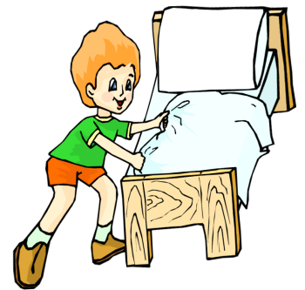](http://www.google.com/url?sa=i&rct=j&q=&esrc=s&source=images&cd=&cad=rja&docid=bk6qA01rMry6mM&tbnid=BZVaPjrwKOpMsM:&ved=0CAUQjRw&url=http://easyway1234.blogspot.com/2012_10_01_archive.html&ei=AHbhUrjAMMjNsATAyIDQCg&bvm=bv.59568121,d.eW0&psig=AFQjCNEHVSEC-4WXTGTbhYIDdp9N3AzBUQ&ust=1390593636065243)

[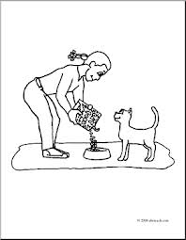](http://www.google.com/url?sa=i&rct=j&q=&esrc=s&source=images&cd=&cad=rja&docid=2DVUsVncovh2oM&tbnid=N22p7QZ-NXysgM:&ved=0CAUQjRw&url=http://cache1.abcteach.com/documents/clip-art-kids-chores-feeding-the-cat-coloring-page-31815&ei=J3ThUu3jA4zNsQSM7oGIBg&bvm=bv.59568121,d.eW0&psig=AFQjCNFe2c0Y0EptaAmxW-p_WZDWp8zT8A&ust=1390593421815289)

1

2

These pictures show how the “Good Helper” helped! Which letter shows the correct order that she did her chores?

A) 4, 2, 1, 3

B) 2, 1, 3, 4

C) 1, 2, 3, 4

D) 3, 4, 2, 1

4

3

[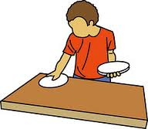](http://www.google.com/imgres?hl=en&biw=1280&bih=929&tbm=isch&tbnid=Wv_BQasnrt2fRM:&imgrefurl=http://www.flickr.com/photos/illustrator-tayseerdesign/sets/72157629510168705/detail/&docid=PsnmK_Tfcu9f0M&imgurl=http://farm8.staticflickr.com/7206/6952398961_83a6f0784c_m.jpg&w=240&h=209&ei=1ZXiUsafFYyFkQf8_IC4CA&zoom=1&ved=0CJkBEIQcMBU&iact=rc&dur=963&page=1&start=0&ndsp=25)

[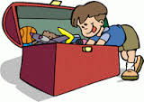](http://www.google.com/imgres?start=95&hl=en&biw=1280&bih=929&tbm=isch&tbnid=11BRs1Icq9J-LM:&imgrefurl=http://twopointfivekids.blogspot.com/2011_11_01_archive.html&docid=RODas1PSjjFCsM&imgurl=http://3.bp.blogspot.com/-0NNfugzVF_M/TtCYcwIZgQI/AAAAAAAAARQ/PEBwKWLlW5s/s200/toy+box.gif&w=200&h=142&ei=NZXiUvKGKZPGkQe8y4H4AQ&zoom=1&ved=0CAsQhBwwAjhk&iact=rc&dur=2954&page=4&ndsp=33)

**Short /a/ Vowel Sounds**

|  |
| --- |
| t |
| p |
| b |
| a |
| a |
| c |

Cut out the letters and use them to make the

words below.

****

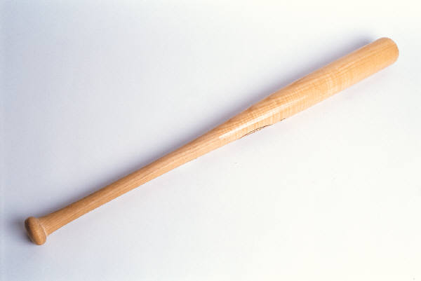

List other short /a/ words below:

\_\_\_\_\_\_\_\_\_\_\_\_\_\_\_\_\_\_\_ \_\_\_\_\_\_\_\_\_\_\_\_\_\_\_

\_\_\_\_\_\_\_\_\_\_\_\_\_\_\_\_\_\_\_ \_\_\_\_\_\_\_\_\_\_\_\_\_\_\_

Social Studies Activity



Helping Earth

By Barbara L. Luciano

This is our world. It is round.

We need to work together to keep it safe.

We need clean air, land, and water.

MCj03383600000[1]We can conserve, or save, resources.

We can recycle many things.

MCj04375750000[1]

Key Terms

conserve - to save

recycle - to turn materials into new materials

resources - things we need

round - shaped like a ball

world - where we live

Write to It!

Draw a picture of something you can do to help the Earth. Write **Save Our Earth** on your picture.

**AN01254_**

**Reading Log for Spring Break**

**Kindergarten**

Kindergarten students may read by themselves or have someone read to them. Read for a minimum of 15 minutes each day of Spring Break. Students may read the same book more than once to practice fluency. Record what you read in the log below.

|  |  |  |
| --- | --- | --- |
| Date | Title of Book Read | Minutes Read |
|  |  |  |
|  |  |  |
|  |  |  |
|  |  |  |
|  |  |  |
|  |  |  |