**Grades K-2**

**Science**

##### Student Edition

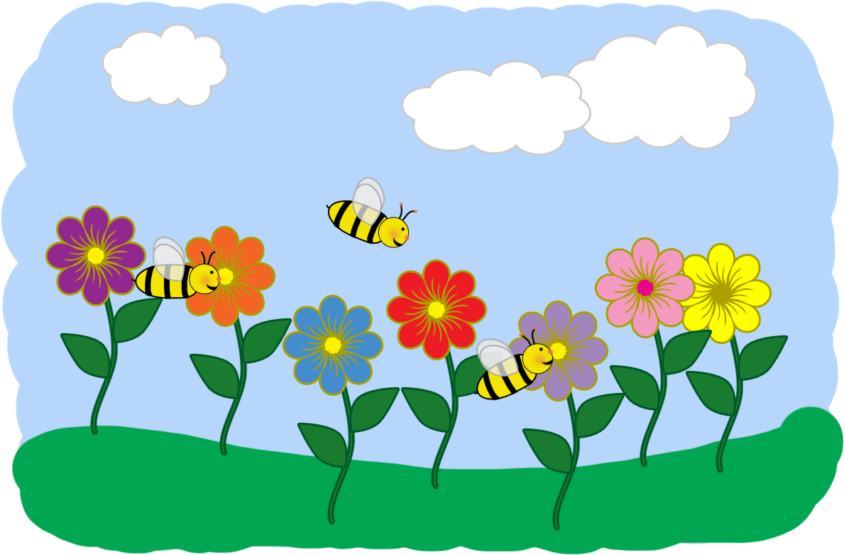

**SPRING STUDENT ENRICHMENT PACKET**



**TM**

**April 18 – April 21, 2017**

# *Note to Students and Parents*

This Spring Student Enrichment Packet has been created to provide practice for students to work through Selected Response and Brief Constructed Response items (SRs and BCRs). This packet will continue to engage students in the Next Generation Science Standards (NGSS) Performance Expectations (PEs).

These items reflect the concepts taught in their science classrooms: Earth and Space Science, Physical Science, and Science and Engineering Practices (SEPs).

The Spring Student Enrichment Packet contains informational-text passages, SRs and BCRs, graphs, and charts.

Please write your response to the SRs and BCRs on the space provided in this packet

To learn more about the NGSS, visit: <http://www.nextgenscience.org>.

**Three Kinds of Water**

**By Linda Ruggieri**

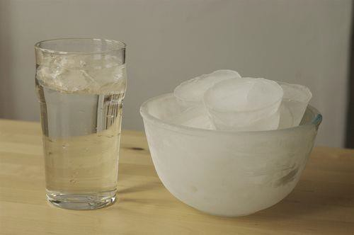

Credit: alisdair, CC BY 2.0

Did you know that water comes in three different forms? Water can be *liquid*. We drink liquid water, and we wash with it.

Water can be *solid*. Frozen water is called ice. Ice is solid. We use ice cubes to keep drinks cold.

Water can be *gas,* or steam. Steam is made of tiny

drops of water. When we boil water, it turns into steam. Steam also creates heat to warm homes.

People need water to live. So remember, use water carefully. Never waste water. *ReadWorks® Inc.*

**To answer questions 1-2, use the reading, “Three Kinds of Water,” to find the correct answer.**

1. How many forms of water are there? Circle the correct answer.





2. What form of water do we use for drinking and washing? Circle the correct answer.

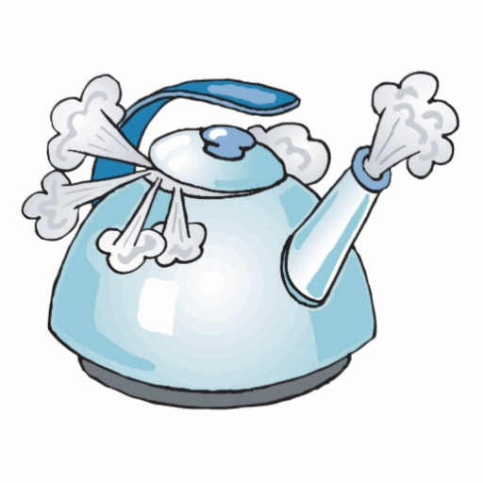

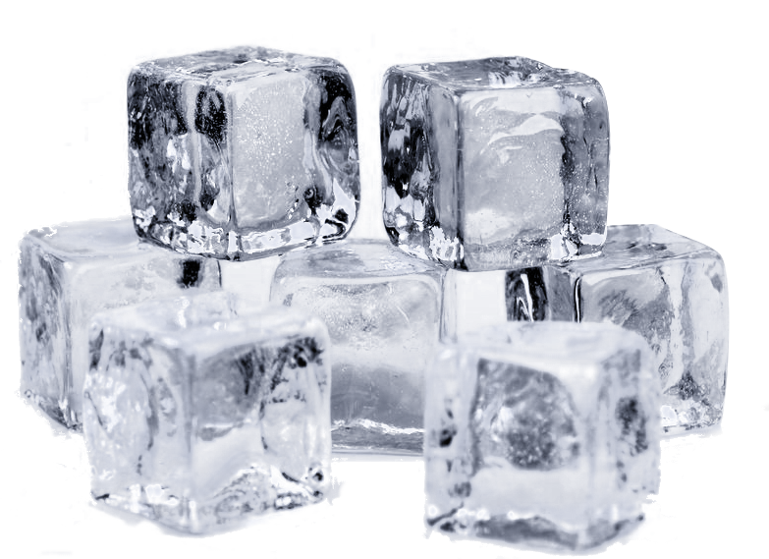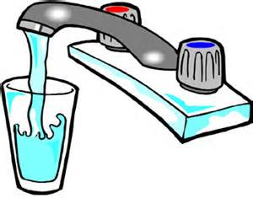

**Steam Liquid Solid**

**3. Write two sentences about what you learned from reading, “Three Kinds of Water.”**



**What is a magnet?**

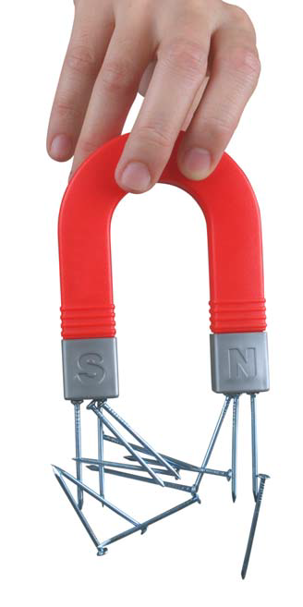How can you pick up or move something without touching it? Use a

magnet! Magnets **attract**

some objects. The object is pulled toward the magnet.

Look at this picture. The magnet easily picks up the nails. When the magnet is lifted, the nails will still hang from the magnet.

Magnets **attract** iron or nickel. They don’t attract other **metals.** They don’t attract paper, wood, glass, or plastic.

Look at these little bits of iron. If you move the magnets, the iron bits will move, too.

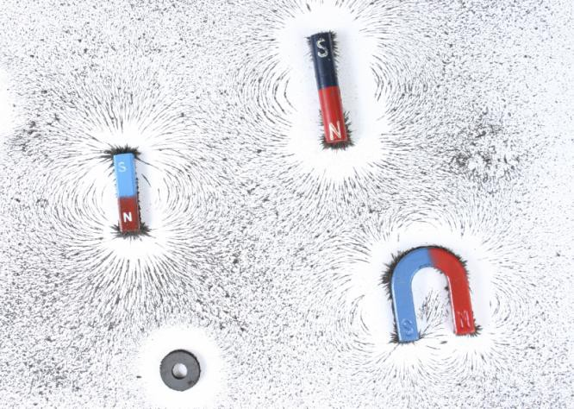

You don’t have to touch the iron bits.

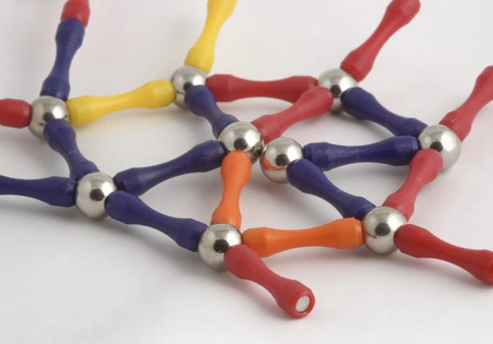These toy pieces have a magnet on each end. The round magnets attract

one another.

Would the toy come apart if you picked it up? Why or why not? No, the magnets hold the toy together.

**To answer question 4, use the reading on *“What is a magnet?”* to write your correct answer.**

**4. Will a magnet stick to this beach ball? Explain your answer below.**

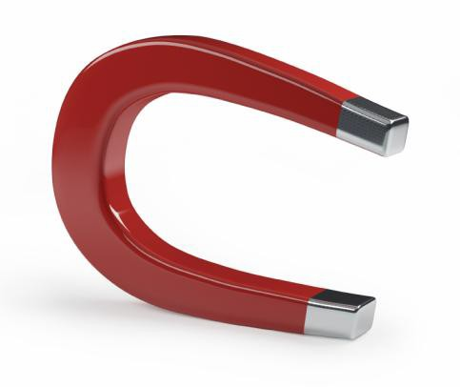

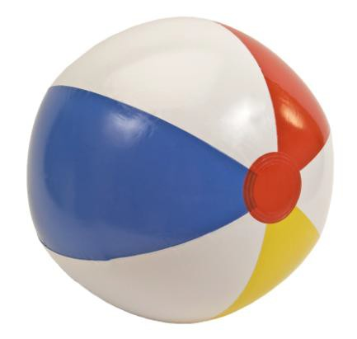



**5. INVESTIGATION:**

**With adult help, find two objects in your home that use magnets.**

**Write down the names of the two objects. Explain how the objects and magnets work together.**

