**Accelerated II**

**Winter Student Enrichment Packet**



PRINCE GEORGE’S COUNTY PUBLIC SCHOOLS

Office of Academic Programs

Department of Curriculum and Instruction

**™**

***NOTE TO THE STUDENT***

*This Winter Student Enrichment Packet has been compiled to complement middle school mathematics classroom instruction aligned to the Maryland College and Career Ready Standards (MCCRS). The packet is intended to be used for* ***review and practice*** *of previously taught and new concepts.*

*We strongly encourage you to work diligently to complete the activities for the choice board. You may experience some difficulty with some activities in this packet, but we encourage you to think critically and creatively and complete them to the best of your ability.*



**Accelerated II Winter Enrichment Choice Board**

**Directions:** Choose three activities below that form a row, column, or diagonal (make a Tic-Tac-Toe). Be sure to read the directions for each activity carefully. Fully complete the activities on a separate sheet of paper (if necessary).

|  |  |  |
| --- | --- | --- |
| **Activity 1**  Puzzle Time | **Activity 2**  Make a How-To Booklet | **Activity 3**  Calculate the  “Space Diagonal” of a Box |
| **Activity 4**  Create a Pythagorean Proof | **Activity 5**  Create a Stained-Glass Window | **Activity 6**  Digitally Create  Similar Figures |
| **Activity 7**  Play the  *Rescue the Zogs* game | **Activity 8**  Write Riddles for  Geometric Figures | **Activity 9**  Running a Small Business |

|  |  |  |
| --- | --- | --- |
| **Activity 1**  *Standard 8.EE.7*  See the problem sheet included in this packet.   * On a sheet of lined notebook paper, solve each of the equations on the **1.3 Puzzle Time** sheet by applying the Distributive Property and properties of equality as needed. * Show *all* steps you use in solving the equations! * Match your solutions to the given letters in order to write the answer to the riddle. | **Activity 2**  *Standard 7.EE.4b*  Make a booklet on *How To Solve 1-Step Inequalities, 2-Step Inequalities, and Special Case Inequalities*. (Special case inequalities are ones which require reversal of the inequality symbol because you have multiplied or divided both sides by a negative.)   * Include written instructions for how to solve each of the three types of inequalities. * Include two worked-out examples for each inequality type and set of instructions. * Include instructions for graphing the solutions on a number line. | **Activity 3**  *Standard 8.G.7*   * Choose a cardboard box to work with, such as a shoe box or a tissue box. * Get a ruler or a tape measure and measure the edges of the box. * Begin to calculate other measurements using the Pythagorean Theorem. * Determine the distance of the “space diagonal,” which is the distance from one corner of the box to the diagonally opposite corner to the nearest tenth of an inch. For an example, see [this web page](http://www.technologyuk.net/mathematics/geometry/cuboids.shtml). * On a separate sheet of paper, sketch a diagram of your box with edge dimensions clearly labeled. * Show the two or more complete calculations using the Pythagorean Theorem that you used to determine the space diagonal. |

|  |  |  |  |  |  |  |  |  |  |  |  |  |  |  |
| --- | --- | --- | --- | --- | --- | --- | --- | --- | --- | --- | --- | --- | --- | --- |
| **Activity 4**  *Standard 8.G.6*  Create a visual or concrete (made of materials) model that proves the Pythagorean Theorem.   * You can use graph paper or other materials such as cardboard, blocks, or candy. * Visual models should include significant use of color. * Your proof needs to show for the right triangle that you choose that the sum of the squares of the legs equal the hypotenuse squared. (Show the calculation.) * See these links with examples of models that prove the Pythagorean Theorem:  [Link 1](https://www.youtube.com/watch?v=CAkMUdeB06o) and [Link 2](https://www.youtube.com/watch?v=uOTs2ck1_jU) | **Activity 5**  *Standard 8.F.3*  Use coordinate grid paper (in this packet) to graph each of the following lines. Draw the lines to the edge of your graph paper. When you are finished, neatly shade or color the sections to make a stained glass window design.   |  |  |  | | --- | --- | --- | | *y* = –x – 4 | *y* = –*x* – 12 | *y* = *x* – 4 | | *y* = –*x* + 4 | *y* = *x* + 4 | *y* = *x* – 12 | | *y* = –*x* + 12 | *y* = –12 | *y* = *x* + 12 | | *y* = 0 | *y* = 12 | *x* = 0 | | **Activity 6**  *Standard 7.G.1*  Go to the following [web site](https://www.geogebra.org/m/ttQhfSGx?doneurl=%2Fmaterial%2Fshow%2Fid%2F42879): <https://www.geogebra.org/m/ttQhfSGx?doneurl=%2Fmaterial%2Fshow%2Fid%2F42879>   * Work through the problems until you have constructed a **total of 10 similar triangles.** * For each of the 10 pairs of triangles that you work with, on a separate sheet of paper, write down the base and height (in units) of each of the 10 pairs of triangles. * On your separate sheet of paper, show the steps you used to justify the similarity of your figures. |

|  |  |  |
| --- | --- | --- |
| **Activity 7**  *Standards 8.F.3, 8.F.4*  Go to [this website](http://www.mathplayground.com/SaveTheZogs/SaveTheZogs.html):  [http://www.mathplayground.com/SaveTheZogs/ SaveTheZogs.html](http://www.mathplayground.com/SaveTheZogs/SaveTheZogs.html)   * Have paper available for scratch work in case you need it. * Begin to play the game and advance through each of the 3 stages of each of the 9 levels of this game as you write equations in the form *y = mx* + *b****.*** * Once you complete the third and final stage at the end of Level 9, take a selfie (or just have someone take a picture) that clearly shows your face or your name and the computer screen that displays that you have completed the final stage of the 9th Level. | **Activity 8**  *Standard 7.G.2*  Use your knowledge of geometric figures and their characteristics to write riddles for geometric figures.   * Choose 5 geometric figures and write a riddle for each of the figures that describe angles and side lengths of the figures. * Each riddle should end with the question: *What shape am I?* * Include an answer key for your riddles.   **For example:** A quadrilateral has opposite sides that are parallel. One set of parallel sides is 5 inches long and the other set is 8 inches long. What is the name of this shape (or what are the possible names? | **Activity 9**  *Standards 8.F.1, 8.F.2, 8.F.3*  Pretend you are running a small business. For your business, you will need to purchase some materials and then sell your goods or services for a certain price.   * Write 3-5 sentences explaining the basic set-up of your business, such as how you would get the necessary materials and where and how you would sell your goods or services. * Write a total of five functions that could be used in determining costs or sales of your products. * For each of the functions, you must do the following: * Define and explain the two variables present in the function * Identify what the constants are in each of the functions. * Explain how they could be used in determining your costs, sales, etc. |

**Activity 1 – Puzzle Time**

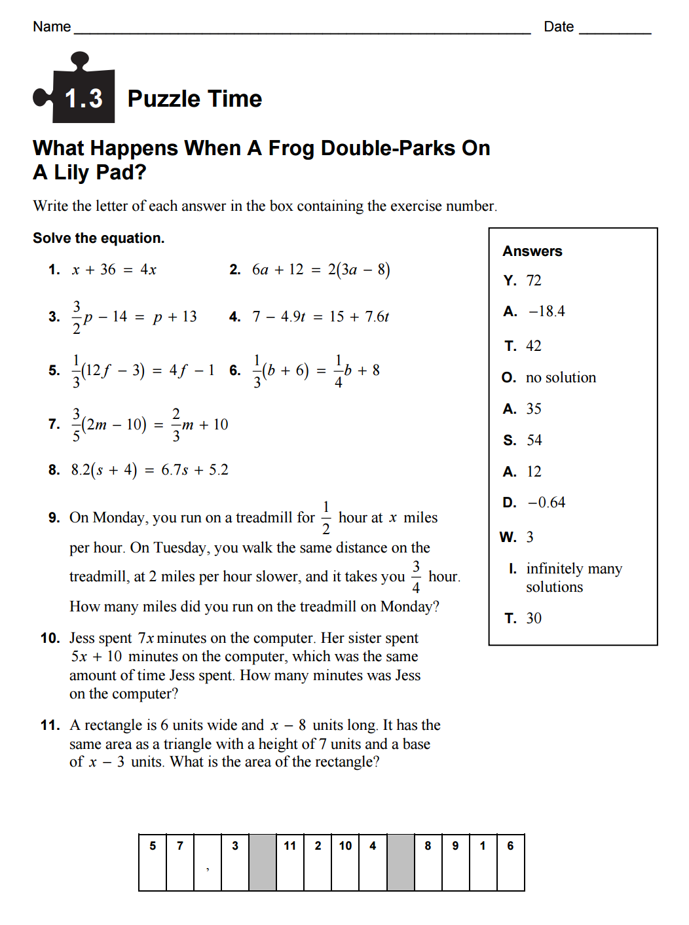

**Coordinate Grid for *Activity 5***

