**Accelerated I**

**Winter Student**

**Enrichment Packet**

***ANSWER KEY***

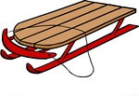

**™**

PRINCE GEORGE’S COUNTY PUBLIC SCHOOLS

Office of Academic Programs

Department of Curriculum and Instruction

**Accelerated I Winter Enrichment Choice Board**

**ANSWER KEY**

**Mandatory Activity: Autumn Leaves to Snow**

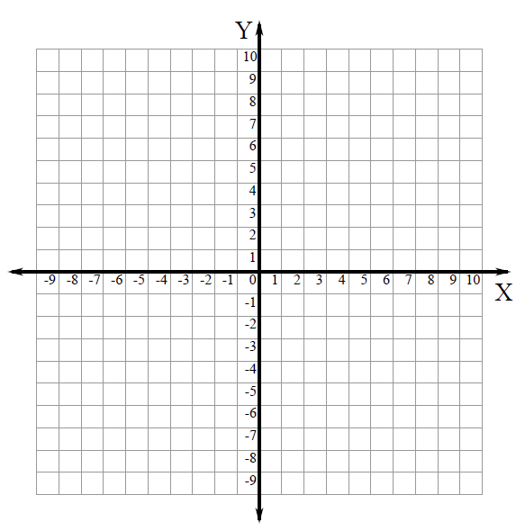

Every fall, Maya has to rake the leaves in her backyard. She wants to know the area of her backyard so she knows what space that she has to rake.

Three of the coordinates on the grid that can be used to represent her backyard are   
**(8.5, 4), (8.5, 8)** and **(–2, 8)**.

1. Plot the fourth coordinate of the rectangle. What is the ordered pair? ___**(-2, 4)**__

2. With straight lines, connect the points that form Maya’s backyard.

3. What is the length (going across), in units, of Maya’s backyard? In your response, include what you know about absolute value.

Example response: |-2| + |8.5| = 10.5

The length (going across) of Maya’s backyard is 10.5 units.

4. What is the width (going up and down), in units, of Maya’s backyard? ___**4**____

5. What is the area, in square units, that Maya has to rake? (Assume that leaves are covering all of her backyard.) Explain how you determined your answer.

Area of a rectangle = l x w

10.5 x 4 units = 42 square units

Maya rakes up the leaves and wants to put them into bags that hold  of a cubic yard. If she rakes 2 cubic yards of leaves in total, how many bags of leaves will she fill?

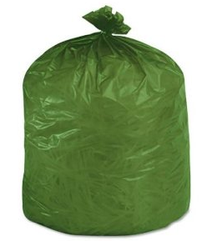

6. Write an expression to show how you can determine the answer to the question.

2 ÷ 

7. Draw a picture to model what is happening in the problem.

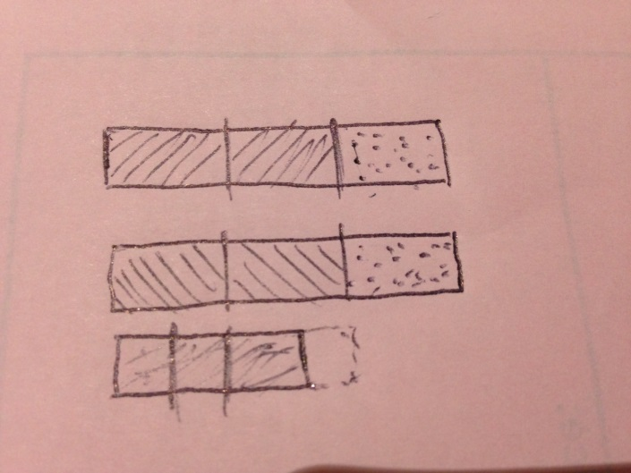

Student should sketch a picture similar

to the picture at right to show the expression

2 ÷ 

8. Using a method of your choice, determine how many bags of leaves that Maya will fill.

Students show an appropriate method for 2 ÷  = 3



Come winter time, Maya shifts her focus to shoveling the snow that falls on her driveway. The area of her driveway can be plotted on the coordinate grid below.



Two of the coordinates representing the corners of Maya’s rectangular driveway are   
(–1, 1) and (1, –8).

9. Plot the other two coordinates of Maya’s rectangular driveway. What are the ordered pairs that you plotted?

(1, 1) and (-1, –8).

______________________________________________________________________

10. Maya wants to determine the perimeter of her driveway. Explain in words, numbers and symbols how you could determine the perimeter of Maya’s driveway. In your response, use what you know about absolute value.

I can count the number of units between each of the points.

Since the dimensions of the rectangle are 2 by 9, I can add 2 + 9 + 2 + 9 = 24

11. One night, it snowed 3 inches in Maya’s town. That meant to clear her entire driveway, Maya had to shovel 593.75 cubic feet of snow! Maya has a snow shovel on which she can fit 1 cubic feet of snow. How many shovels full of 1 cubic feet of snow will Maya need to pick up to clear her driveway? Show how you determined your answer and clearly explain the process you used.

593.75 ÷ 1.5 = 395.8333… So Maya will pick up about 396 shovelfuls of 1 cubic feet to clear her driveway.

**Box #1: Reward from Genie**



After opening an ancient bottle you found in an antique store, a Genie appears. In payment for his freedom, he gives you two options: First 50,000 gold coins or, second, one magical coin. You can only have one or the other. The magical coin will turn into two gold coins on the first day. The two coins will turn into four coins at the end of two days. On the third day, there will be a total of eight gold coins. Genie explains that this pattern of doubling will continue each day for one moon cycle, 28 days. Which prize will you choose?

When you have made your choice, answer the 2 questions.

1. The number on the third day will be 2 x 2 x 2. Can you write another expression using exponents for the number of coins on the third day?

23

2. Write an expression for the number of coins there will be on the 28th day. Is this more or less than the first option?

228

**Box #2: Box Tops**

****1. Three sixth grade classes collected the most box tops for a school fundraiser. They won a $600 prize to share among them. Class X collected 3,760 box tops, Class Y collected 2,301, and Class Z collected 1,855. How should they divide the money so that each class gets the same fraction of the prize money as the fraction of the box tops that they collected?

3,760 + 2,301 + 1,855 = 7,916 total box tops

3760/7916 = 47.5 percent

2301/7916 = 29.1 percent

1855/7916 = 23.4 percent

To have the money reflected of the number of the box tops collected, the money should be split this way:

Class X: 600 x 0.475 = $285

Class Y: 600 x 0.291 = $174.60

Class Z: 600 x 0.234 = $140.40

**Box #3: What is the Value?**

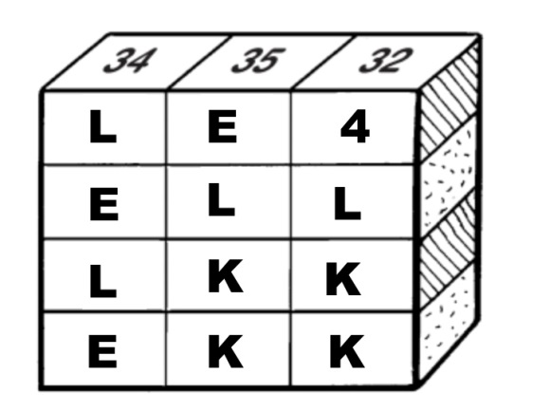

The numbers at the tops of the columns are the column sums.

Each letter represents a different numerical value.

Your task is to determine the values of the letters.

1. What is the value of L? __10___

2. What is the value of E? __7___

3. What is the value of K? __9___

4. How did you figure out the values of the letters? In detail, explain the process you followed.

I looked at the second and third columns and realized that the difference between the columns was 3, so **E** must be worth three more than 4, so **E** has a value of 7.

Then, looking at the first column, if **E** is 7, then two E’s are 14. Then, 34-14 = 20 and 20/2 = 10, so L is 10.

In looking at the third column, 4 + L (which is 10) is equal to 14. So 32 – 14 = 18 and 18/2 = 9, so K is 9.

5. How many *K*s are equal in value to nine *E*s? Show the process you used for determining your answer.

If E = 7, then 9 · 7 = 63.

If K = 9, then 63 ÷ 9 = 7, so 7 Ks are equal in value to 9 E’s.

**Box #4: Coordinates**

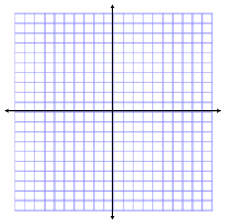

**Doubling Areas**

Rectangle A has vertices at (–2, 3), (1, 3), (1, –3), and one other point.

Rectangle B has vertices at (–3, –4) and (–3, –8), and two other points.

1. What is the other vertex for Rectangle A? Draw the rectangle on the coordinate grid.

The other vertex is (–2, –3)

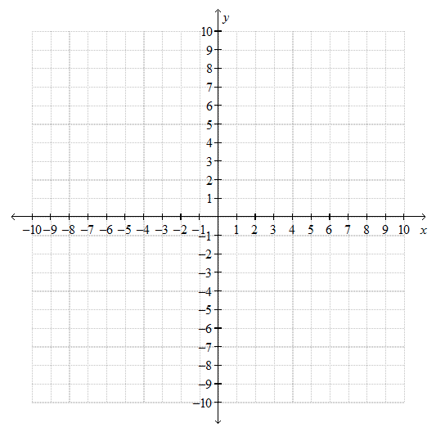

2. What is the area of Rectangle A in square units?

The area of Rectangle A is 18 square units

The area of Rectangle B is twice as large as the area of Rectangle A.

3. What are the two other vertices for Rectangle B? *The vertices must be able to be plotted on the coordinate grid shown above.* Draw the rectangle on the coordinate grid.

The other two vertices are (6, -4) and (6, -8)

4. What is the area of Rectangle B? Explain how you determined the area and how you knew to create the length of Rectangle B that you did.

The area of Rectangle B is 36 square units. I determined this area because 36 is twice 18.

**Box #5: Below and Above Sea Level**

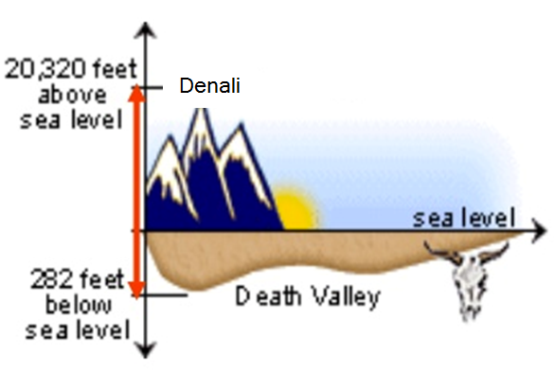

The highest elevation in North America is Denali (formerly named *Mt. McKinley*), which is 20,320 feet above sea level. The lowest elevation in North America is Death Valley, which is 282 feet below sea level.

1. Draw a number line to show the distance from the top of Denali to the bottom of Death Valley. What is the distance from the top of Denali to the bottom of Death Valley?

Students should draw a number line from which it can be concluded that the distance between the points is 20,602 feet.

2. Write an expression that represents the distance between the two points. Make sure to use absolute value symbols correctly, if you choose to write an expression that includes absolute value.

|20,320| + |-282|

3. The Marianas Trench is in the deepest part of the Pacific Ocean. It is has an elevation of 36,070 feet below sea level. Write an equation using absolute value to calculate the distance from the top of Mt. McKinley to the bottom of the trench. Then, solve the equation.

|-36,070| + |20,320| =

|-36,070| + |20,320| = 56,390

**Box #6: Shoveling Snow Business**



Alex plans to start up a shoveling snow business to make some extra money this winter break. He is charging $20 to shovel a driveway. It costs him $2 for supplies and snacks for each driveway he shovels.

1. If *d* stands for the number of driveways Alex shovels, what is an expression that he could write and simplify to calculate his profit from shoveling driveways this winter break?

20*d* – 2*d*

2. If Alex wanted to buy a present for his sister Patrice that is worth $51, but he only wants to use  of his total profits from shoveling driveways, how much should he aim to earn? Show one process he could use to determine the answer to the problem.

I can write the equation *x* = 51. If I solve my equation, I get $153. So Alex should aim to earn at least $153 if he only wants to use 1/3 of his total profits.

3. If Alex shovels only six driveways, how much would he have left if he buys Patrice’s gift?

20*d* – 2*d* = 18*d*

18(6) = 108 and 108 – 51 = 57. Alex would have $57 left if he buys Patrice’s gift.

4. When Alex was about to pay for Patrice’s gift, he was surprised to find out that the store gave him a 15% discount. How much did he pay for the gift?

51(0.15) = 7.65

51 – 7.65 = $43.35

So Alex would pay $43.35 for the gift if there was a 15% discount.

5. If Alex managed to shovel 5 driveways only, how much total money did he have left if he bought Patrice’s gift with the 15% discount?

18(5) = 90 and 90 – 43.35 = 46.65

**Box #7: Give Me the Meaning**

Math is better understood with literacy using the power of words. For this packet, complete the table to show what you understand about the words. Write a definition, give an example, and draw a picture.

|  |  |  |  |
| --- | --- | --- | --- |
| **Vocabulary Word** | **Definition** | **Example** | **Draw a Picture** |
| Variable | A symbol that represents one or more numbers | *c* | Will vary |
| Algebraic Expression | An expression that may contain numbers, operations and one or more symbols | 3*x* + 2*y* + 4 |  |
| Equation | A mathematical sentence that uses an equal sign to show that two expressions are equal | 2.5*g* = 12.5 |  |
| Numerical  Expression | An expression that contains only numbers and operations | 2 + 5 + 7.1 |  |
| Ordered Pair | A pair of numbers used for locating points on the coordinate plane. The x value is listed first and the y value second. | (8, 4.5) |  |

|  |  |  |  |
| --- | --- | --- | --- |
| **Vocabulary Word** | **Definition** | **Example** | **Draw a Picture** |
| Inequality | A math sentence that compares expressions and contains the symbols <, >, ≤, or ≥ | c > 9  1.53 < 1.55 |  |
| Absolute Value | The distance between the number and zero on the number line | |-9| = 9 |  |
| Quadrants | The four regions of the coordinate plane that are formed by the x- and y-axis | Quadrant IV has positive x-values and negative y-values |  |
| Coefficient | The numerical factor of a term that contains a variable | The number 8 is the coefficient in **8*n*** |  |

**Box #8: Holiday Cookies**



Mrs. Garcia is baking cookies to raise funds for charity. The ingredients for her recipe are shown in the list below. The ingredients in the list allow Mrs. Garcia to make one batch of 24 cookies.

|  |  |
| --- | --- |
| cup butter | cup sugar |
| cup brown sugar | 1 egg |
| tsp vanilla | 1 cups flour |
| tsp salt | tsp. baking soda |

1. If one batch of cookies fills four cookie tins, write an equation to find how many tins *t* would be needed to hold 96 cookies.

6*t* = 96

2. If Mrs. Garcia purchases the items for one batch of cookies at a local grocery store for $15.48, how much does it cost her to make one tin of cookies?

15.48 / 4 = 3.87

It costs $3.87 in supplies for one tin of cookies.

3. Mrs. Garcia has decided to make enough cookies to fill 36 tins. Rewrite the ingredients list so she has the correct quantities of ingredients to make the correct number of cookies.

|  |  |
| --- | --- |
| x 9 = 4.5 cups butter | x 9 = 4.5 cups sugar |
| x 9 = 3 cups br sugar | 1 x 9 = 9 eggs |
| x 9 = 4.5 tsp vanilla | 1 x 9 = 13.5 cups flour |
| x 9 = 2.25 tsp. salt | x 9 = 4.5 tsp. baking soda |

36 tins x 6 cookies per tin = 216 cookies

216 / 24 = 9

4. How many cookies will Mrs. Garcia’s new ingredients list from question #4 make in all?

36 tins x 6 cookies per tin = 216 cookies