Accelerated II
Winter Student
Enrichment Packet
ANSWER KEY

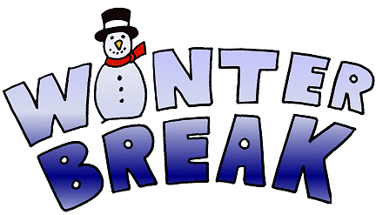

™

PRINCE GEORGE’S COUNTY PUBLIC SCHOOLS
Office of Academic Programs
Department of Curriculum and Instruction
Accelerated II Winter Enrichment Choice Board
Answer Key
Activity 1
Puzzle answer: IT’S TOAD AWAY
Activity 2
Student answers will vary. See activity directions and rubric.

Activity 3
Student answers will vary. See activity directions and rubric.

Activity 4
Student answers will vary. See activity directions and rubric.

Activity 5
Correct design:
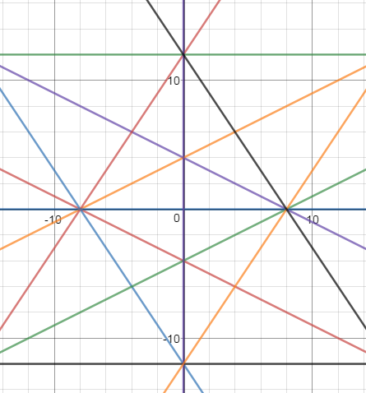

Activity 6
See activity directions and rubric.

Activity 7
See activity directions and rubric.

Activity 8
Student answers will vary. See activity directions and rubric.

Activity 9
Student answers will vary. See activity directions and rubric.

