College and Career Mathematics
Winter Student Enrichment Packet

Answer Key

PRINCE GEORGE’S COUNTY PUBLIC SCHOOLS
Office of Academic Programs
Department of Curriculum and Instruction

™
NOTE TO STUDENT

This Winter Student Enrichment Packet has been compiled to complement high school mathematics classroom instruction aligned to Maryland College and Career Ready Standards (MCCRS). It is intended to be used for review and practice of previously taught and new concepts.

We strongly encourage you to work diligently to complete the activities in this packet. You may experience some difficulty with some problems in this packet, but we encourage you to explore and attempt to find a solution to the best of your ability..

 | Answer | Assessment & Standard Reference
1 | C | SAT: ATM
2 | A | SAT: PAM
3 | B | SAT: PAM
4 | D | SAT: PAM
5 | D | SAT: PSDA
6 | D | SAT: PSDA
7 | B | SAT: HA
8 | D | SAT: PBDA
9 | B | SAT: ATM
10 | B | SAT: PSDA
11 | C, D | PARCC: F.BF.2
12 | D | PARCC: A.REI.12
13 | C, E | PARCC: F.IF.9
14 | B | PARCC: F.IF.6
15 | Part A: A  Part B: C | PARCC: F.INT.1
16 | (see below) | PARCC: A.APR.3, HS.C.18.4
17 | Part A: 8  Part B: B, F  Part C: C  Part D: B | PARCC: F.IF.4
18 | Part A: (see below)  Part B: (see below) | PARCC: S.IC.1, S.IC.3, HS.D.3.5
19 | Part A: (see below)  Part B: (see below) | PARCC: 7.RP.3, A.SSE.1, HS.C.CCR
20 | Part A: (see below)  Part B: (see below)  Part C: (see below) | PARCC: 8.EE.7, HS.D.1.1

HA: Heart of Algebra
PSDA: Problem Solving and Data Analysis
PAM: Passport to Advanced Math
ATM: Additional Topics in Math
16 | 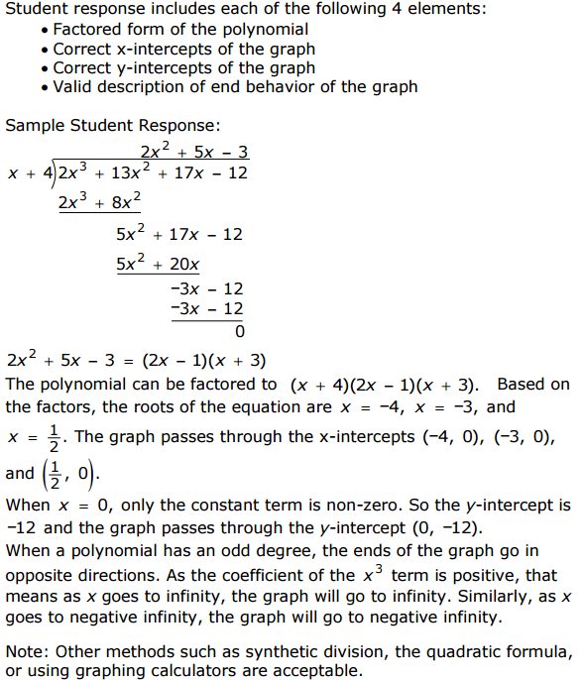

18 | Part A:  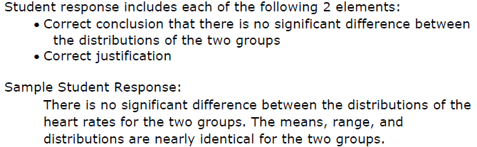  Part B:  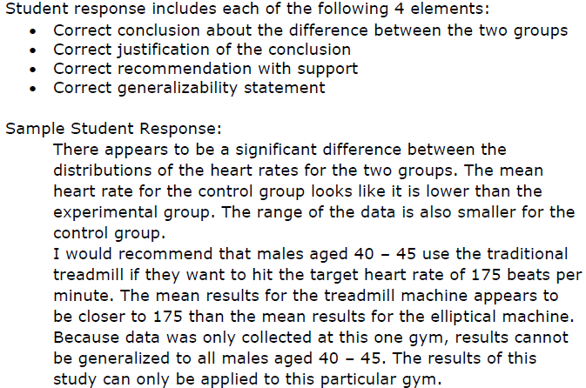

19 | Part A:  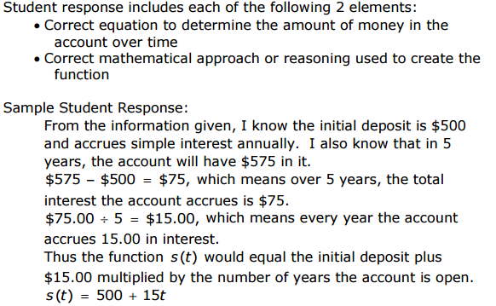  Part B:  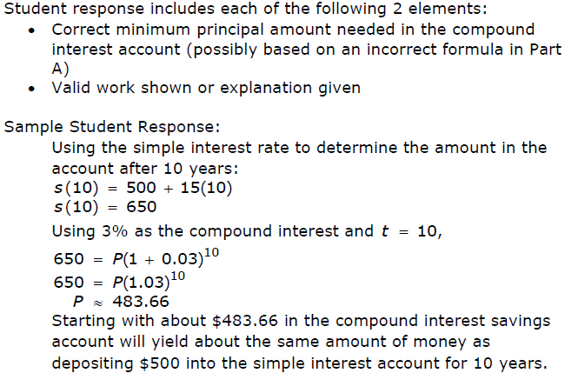

20 | Part A:  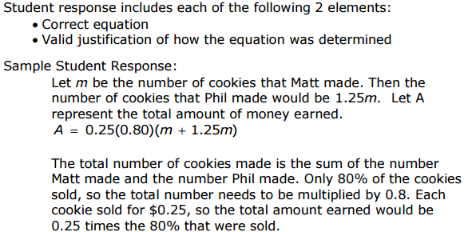  Part B:  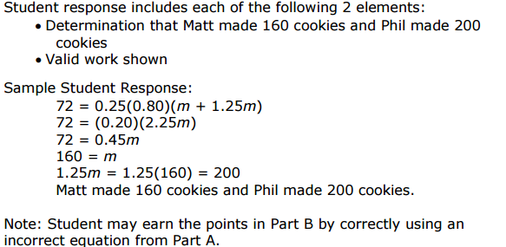

Part C:
