English 10
College and Career
Winter Student Enrichment Packet
Prince George’s County Public Schools
Answer Key

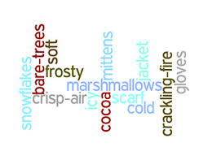

READING/ENGLISH LANGUAGE ARTS

™

Prince George’s County Public Schools
Office of Academic Programs
Department of Curriculum and Instruction
STUDENT READING ENRICHMENT PACKET
GRADE 10

In Preparation for College and Career Readiness

Note to Students: You’ve learned so much in school this year! It is important that you keep your brain active over the Winter Break. In this packet, you will find a calendar of activities to complete during the break

Parents are encouraged to assist in the following ways:

- Make a plan to complete the activities throughout the Winter Break.
- Families should preview the calendar together.
- Schedule times that fit your family’s schedule to complete the assignments and write the proposed times on the calendar dates as well. (Of course, these times may need adjustment, but having a plan is the first step to success.)
- Provide a quiet space and time for your child to complete the homework activities.
- Encourage the daily reading for a minimum of 30 minutes of a self-selected book. Students should read for a minimum of nine of the eleven days of the winter break.

Thank you for helping your child succeed.

Grade 10 Reading/English Language Arts
Independent Reading Calendar
Read daily for at least 30 minutes on at least nine (9) of the eleven (11) days you are out of school. It is suggested that you use this extended block of time to read a novel or nonfiction book.

Winter Break
Reading Calendar

Day 1  Title:  Pages read: | Day 2  Title:  Pages read: | Day 3  Title:  Pages read: |  | Day 4  Title:  Pages read: | Day 5  Title:  Pages read: | Day 6  Title:  Pages read: | Day 7  Title:  Pages read:
Additional  Title:  Pages read: | Additional  Title:  Pages read: | Additional  Title:  Pages read:

This page was left blank intentionally.

College and Career Readiness Tasks

“We grow accustomed to the Dark”
Emily Dickinson

We grow accustomed to the Dark -
When Light is put away -
As when the Neighbor holds the Lamp
To witness her Good bye -

A Moment - We Uncertain step
For newness of the night -
Then - fit our Vision to the Dark -
And meet the Road - erect -

And so of larger - Darknesses -
Those Evenings of the Brain -
When not a Moon disclose a sign -
Or Star - come out - within -

The Bravest - grope a little -
And sometimes hit a Tree
Directly in the Forehead -
But as they learn to see -

Either the Darkness alters -
Or something in the sight
Adjusts itself to Midnight -
And Life steps almost straight.

We Grow Accustomed to the Dark Vocabulary

Directions: Using the vocabulary listed below identify a synonym and an antonym for each vocabulary word listed. You may use the poem “We Grow Accustomed to the Dark” by Emily Dickinson, the dictionary and/or the Internet to help you identify each words classification.

Synonyms | Word | Antonyms
 | disclose
 | accustomed
 | alters
 | grope

Directions: After reading the poem “We Grow Accustomed to the Dark” by: Emily Dickinson, use the poem to complete the questions below.

Thinking Through the Text
- In lines 5-8, Dickinson uses imagery to describe what sensation?

- being in a bad mood or place.
- what it feels like when lights suddenly go out.
- frightened
- it feels like it’s bright and sunny outside

- How does the poet describe the sensation?

- You are sure of where you are going and can see in the dark
- The light is so bright it hurts your eyes
- You can’t see at all
- You are unsteady, but then your eyes get used to the darkness

- What startling concrete image does Dickinson use to convey the difficulty of facing the dark?
- walking headfirst into a tree.
- feeling like someone is in front of you
- falling flat on your face
- tripping over your shoes

- What is the effect of the unusual use of capital letters and dashes?

- They mean statements
- They call attention to a person’s happiness. They also emphasize their words of joy.
- They call attention to the uncertainty one feels in the dark. They also emphasize words, suggest a pause, and help set the poem’s rhythm.
- They represent someone talking to you.

Analyze the Text
Directions: Read the poem aloud for meaning without stopping at line endings and answer the questions listed below.
- What are the types of darkness the poet refers to in line nine?
Any scary experience; the unknown.

- What can change to make things nearly all right again and which lines in the poem support your ideas?
The situation itself can change or the way you view it can change. Lines 17 – 20 support the ideas.

- Dickinson used figurative language to make comparisons to this poem. What is being compared and identify what you think the image in line 10 describes?
Walking out into the dark is compared to facing a difficult or unknown situation. How people can’t think clearly when they are afraid of the unknown.

Performance Task
In “We Grow Accustomed to the Dark,” Emily Dickinson expresses her view of confronting the unknown. Think about a time when you faced an unsettling experience, such as moving to a new school or neighborhood. Write a 250-word essay to describe your experience using descriptive language.
_______________________________________________________________________________________________________________________________________________________________________________________________________________________________________________________________________________________________________________________________________________________________________________________________________________________________________________________________________________________________________________________________________________________________________________________________________________________________________________________________________________________________________________________________________________________________________________________________________________________________________________________________________________________________________________________________________________________________________________________________________________________________________________________________________________________________________________________________________________________________________________________________________________________________________________________________________________________________________________________________________________________________________________________________________________________________________________________________________________________________________________________________________________________________________________________________________________________________________________________________________________________________________________________________________________________________________________________________________________________________________________________________________________________________________________________________________________________________________________________________________________________________________________________________________________________________________________________________________________________________________________________________________________________________________________________________________________________________________________________________________________________________________________________________________________________________________________________________________________________________________________________________________________________________________________________________________________________________________________________________________________________________________________________________________________________________________________________________________________________________________________________________________________________________________________________________________________________________________________________________________________________________________________________________________________________________________________________________________________________________________________________________________________________________________________________________________________________________________________________________________________________________________________________________________________________________________________________________________________________________________________________________________________________________________________________________________________________________________________________________________________________________________________________________________________________________________________________________________________________________________________________________________________________________________________________________________________________________________________________________________________________________________________________________________________________________________________________________________________________________________________________________________________________________________________________________________________________________________________________________________________________________________________________________________________________________________________________________________________________________________________________________________________________________________________________________________________________________________________________________________________________________________________________________________________________________________________________________________________________________________________________________________________________________________________________________________________________________________________________________________________________________________________________________________________________________________________________________________________________________________________________________________________________________________________________________________________________________________________________________________________________________________________________________________________________________________________________________________________________________________________________________________________________________________________________________________________________________________________________________________________________________________________________________________________________________________________________________________________________________________________________________________________________________________________________________________________________________________________________________________________________________________________________________________________________________________________________________________________________________________________________________________________________________________________________________________________________________________________________________________________________________________________________________________________________________________________________________________________________________________________________________________________________________________________________________________________________________________________________________________________________________________________________________________________________________________________________________________________________________________________________________________________________________________________________________________________________________________________________________________________________________________________________________________________________________________________________________________________________________________________________________________________________________________________________________________________________________________________________________________________________________________________________________________________________________________________________________________________________________________________________________________________________________________________________________________________________________________________________________________________________________________________________________________________________________________________________________________________________________________________________________________________________________________________________________________________________________________________________________________________________________________________________________________________________________________________________________________________________________________________________________________________________________________________________________________________________________________________________________________________________________________________________________________________________________________________________________________________________________________________________________________________________________________________________________________________________________________________________________________________________________________________________________________________________________________________________
“Ozymandias”

I met a traveller from an antique land
Who said: Two vast and trunkless legs of stone
Stand in the desert. Near them on the sand,
Half sunk, a shatter'd visage lies, whose frown
And wrinkled lip and sneer of cold command
Tell that its sculptor well those passions read
Which yet survive, stamp'd on these lifeless things,
The hand that mock'd them and the heart that fed.
And on the pedestal these words appear:
"My name is Ozymandias, king of kings:
Look on my works, ye Mighty, and despair!"
Nothing beside remains: round the decay
Of that colossal wreck, boundless and bare,
The lone and level sands stretch far away.

-by Percy Shelley

Ozymandias Vocabulary
Directions: Using the text you just read and the definitions in the box below, identify vocabulary from the text to complete the crossword puzzle below.
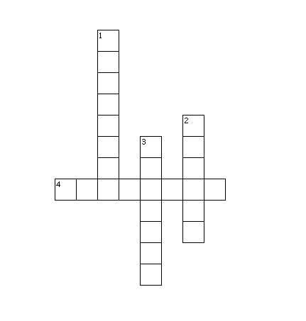

Across  4. extremely large (colossal) | Down  1. the support or base of a sculpture (pedestal)  2. the features and appearance of a face (visage)  3. the complete loss or absence of hope (despair)

Thinking Through the Text
- What has happened to the sculpture?

- It fell to the side and cracked.
- Nothing has happened to the statue
- The statue wobbled.
- It has fallen down and broken. The head lies on the ground with the face smashed.

- How does the traveler know what type of man Ozymandias was?

- The traveler studied the expression on the stone face, or what remains of the face. Even though the face is broken, the traveler says that it has an expression of anger and contempt.
- The traveler examined the features of the statue
- The traveler examined the features of the statue and thought the model looked happy.
- The traveler looked at the statue to see the damage.

- What would someone see if he or she followed the command to “look on my works”?
- The person would see the smashed statue.
- The person would see all of the things around the statue.
- The person would not see anything because the traveler says that there is nothing else left standing around the statue.
- The person would see the features on the face of the statue.

Analyze the Text
- What is ironic about the words written in lines 10-11?
The words suggest that people should be afraid of Ozymandias and his accomplishments and yet all that is left of him is a broken statue.

- What message do you think the poet is expressing through the theme of this poem?
We will all be long forgotten someday.

Performance Task
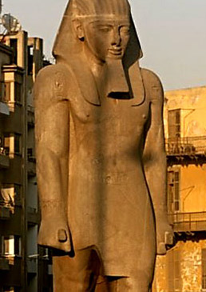
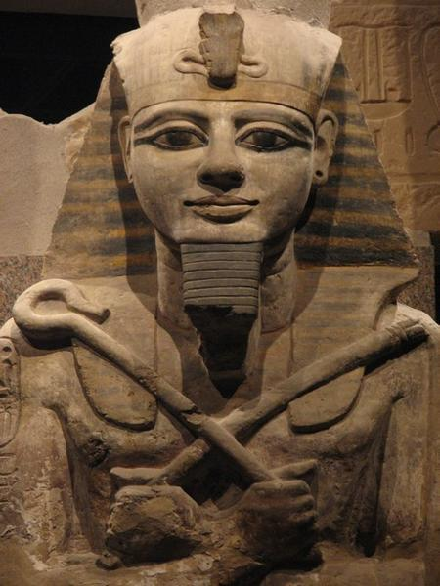
Look at the two photo depictions of Ramses II. Write a brief essay to compare the depiction of Ramses II in the photos with the depiction that Shelley provides in his poem. Cite evidence from the poems and pictures to support your ideas.

_______________________________________________________________________________________________________________________________________________________________________________________________________________________________________________________________________________________________________________________________________________________________________________________________________________________________________________________________________________________________________________________________________________________________________________________________________________________________________________________________________________________________________________________________________________________________________________________________________________________________________________________________________________________________________________________________________________________________________________________________________________________________________________________________________________________________________________________________________________________________________________________________________________________________________________________________________________________________________________________________________________________________________________________________________________________________________________________________________________________________________________________________________________________________________________________________________________________________________________________________________________________________________________________________________________________________________________________________________________________________________________________________________________________________________________________________________________________________________________________________________________________________________________________________________________________________________________________________________________________________________________________________________________________________________________________________________________________________________________________________________________________________________________________________________________________________________________________________________________________________________________________________________________________________________________________________________________________________________________________________________________________________________________________________________________________________________________________________________________________________________________________________________________________________________________________________________________________________________________________________________________________________________________________________________________________________________________________________________________________________________________________________________________________________________________________________________________________________________________________________________________________________________________________________________________________________________________________________________________________________________________________________________________________________________________________________________________________________________________________________________________________________________________________________________________________________________________________________________________________________________________________________________________________________________________________________________________________________________________________________________________________________________________________________________________________________________________________________________________________________________________________________________________________________________________________________________________________________________________________________________________________________________________________________________________________________________________________________________________________________________________________________________________________________________________________________________________________________________________________________________________________________________________________________________________________________________________________________________________________________________________________________________________________________________________________________________________________________________________________________________________________________________________________________________________________________________________________________________________________________________________________________________________________________________________________________________________________________________________________________________________________________________________________________________________________________________________________________________________________________________________________________________________________________________________________________________________________________________________________________________________________________________________________________________________________________________________________________________________________________________________________________________________________________________________________________________________________________________________________________________________________________________________________________________________________________________________________________________________________________________________________________________________________________________________________________________________________________________________________________________________________________________________________________________________________________________________________________________________________________________________________________________________________________________________________________________________________________________________________________________________________________________________________________________________________________________________________________________________________________________________________________________________________________________________________________________________________________________________________________________________________________________________________________________________________________________________________________________________________________________________________________________________________________________________________________________________________________________________________________________

