BIOLOGY

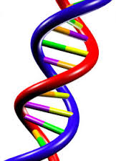
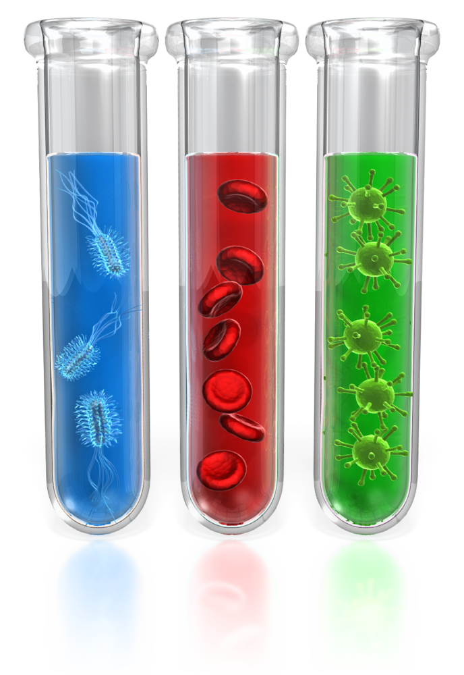

Biology

It Grows On You!

Winter Break
Enrichment Packet

PRINCE GEORGE’S COUNTY PUBLIC SCHOOLS
Office of Academic Programs
Department of Curriculum and Instruction

Directions: Circle the letter of the correct answer. (Questions 1-10 are worth 1 point each.)

1. The model shows water molecules interacting. The gray circles represent oxygen, and the white circles represent hydrogen.
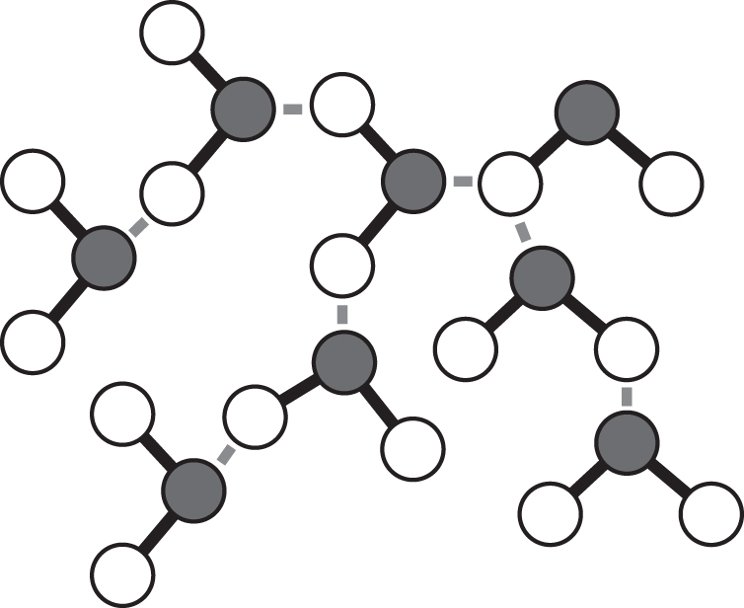
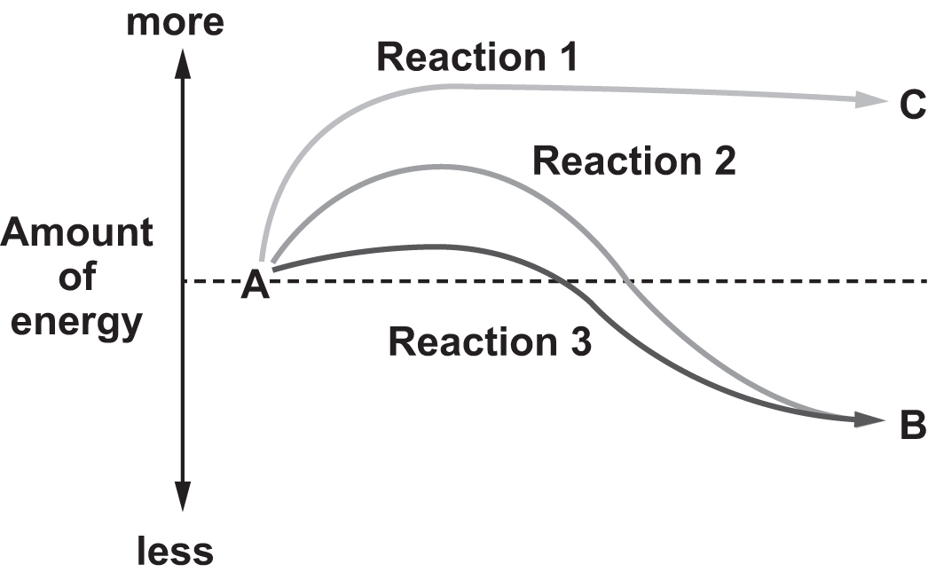

What conclusion does this model support?
A. Slight negative charges around the oxygen molecule and the slight positive charges of hydrogen atoms form a polar molecule.
B. The two hydrogen atoms are both attracted to the negative oxygen atom, sharing the electrons equally, forming a nonpolar molecule.
C. Strong negative charge of oxygen molecules is equally shared by the hydrogen atoms, forming polar molecules that exhibit hydrogen bonding.
D. The two hydrogen atoms generate a strong positive charge that attracts and bonds with the weak negative oxygen atom that exhibits ionic bonding.

2. Which process would bacteria living near a heat vent on the ocean floor use to build carbon-based molecules, such as sugars?

A. fermentation
B. chemosynthesis
C. cellular respiration
D. light-independent reactions
3. The graph shows the energy involved in three chemical reactions.

Energy of a Reaction

Which of these statements regarding the graph is true?

A. It is identical to the original substances.
B. It is a compound, just like the original substances.
C. It contains more atoms than the original substances.
D. It is in a different physical state than the original substances.

4. Two species of shorebirds are both adapted to live in coastal marshes. One species outcompetes the other for the small fish that live within one niche in the marsh. What is likely to happen to the other species of bird?

A. It would die off completely.
B. It would move to a totally different ecosystem.
C. It would find another niche within the same ecosystem.
D. It would shrink in population size but stay in the same niche.
5. Products of the light reactions of photosynthesis that are required by the dark reactions are __________.

A. oxygen and ATP
B. ATP and NADPH
C. water and oxygen
D. oxygen and NADPH

6. A cell contains __________.

A. one kind of enzyme that assists in thousands of different chemical reactions
B. approximately 100 kinds of enzymes, each assisting in a different chemical reaction
C. thousands of different kinds of enzymes, each assisting in a different chemical reaction
D. one enzyme that assists in reactions involving protein substrates and one enzyme that assists in reactions involving substrates that are not proteins

7. Organisms rely on both negative feedback processes and behavior to maintain __________.

A. evolution
B. ecosystems
C. adaptations
D. homeostasis

8. As a characteristic of all living things, homeostasis relates most directly to which of the following biological themes?

A. stability
B. evolution
C. scale and structure
D. interacting systems
9. Use the diagram below to answer the question.

Which two processes in the carbon cycle are also parts of the oxygen cycle?
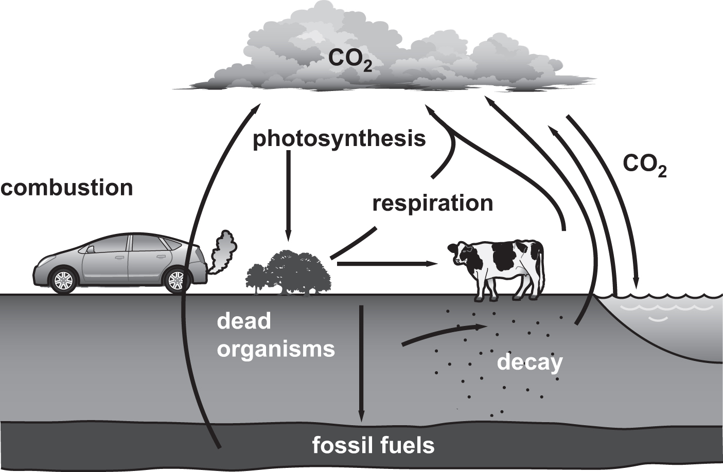

A. combustion and decay
B. photosynthesis and decay
C. combustion and respiration
D. photosynthesis and respiration

10. Refer to the illustration.

Population Growth over Time
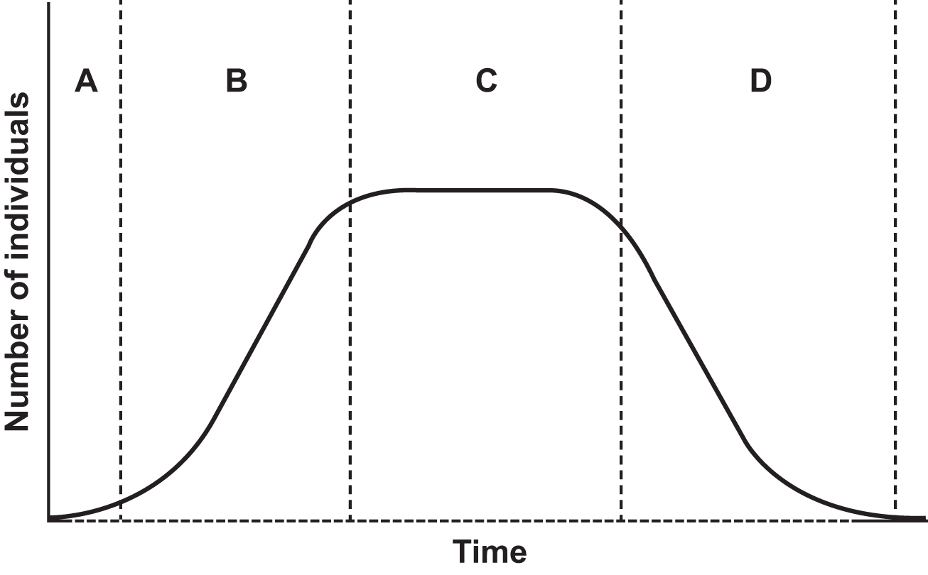
During which time period are the birthrate and death rate equal?

A. period A
B. period B
C. period C
D. period D

Directions: For questions 11 and 12, read each statement and write your answer on the lines following each question. (Questions 11-12 are worth 2 points each.)

11. How do animals participate in the carbon and oxygen cycles?

___________________________________________________________________________

___________________________________________________________________________

___________________________________________________________________________

___________________________________________________________________________

12. How does photosynthesis in plants affect the carbon cycle?

___________________________________________________________________________

___________________________________________________________________________

___________________________________________________________________________

13. A researcher is studying the movement of energy in an agricultural setting. She is investigating how matter and energy are moved through an ecosystem by natural processes such as photosynthesis and cellular respiration. She is also investigating how humans can use the forms of energy and matter that are obtained from these processes. The diagram shows the movement of energy in the agricultural setting she is studying.
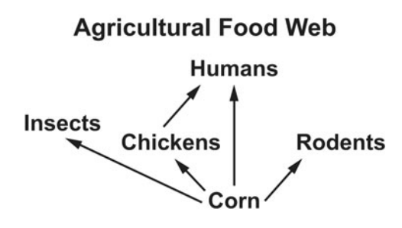

Circle the letters of the two correct statements regarding energy in this system. (2 points)

A. Most of the energy stored by corn is lost as it is transferred to chickens.
B. The energy available to rodents is greater than the energy available to insects.
C. Energy is lost between each trophic level as heat released through cellular respiration.
D. The corn can convert 100% of the sun’s energy to usable energy through photosynthesis.

14. The diagram shows part of the carbon cycle.
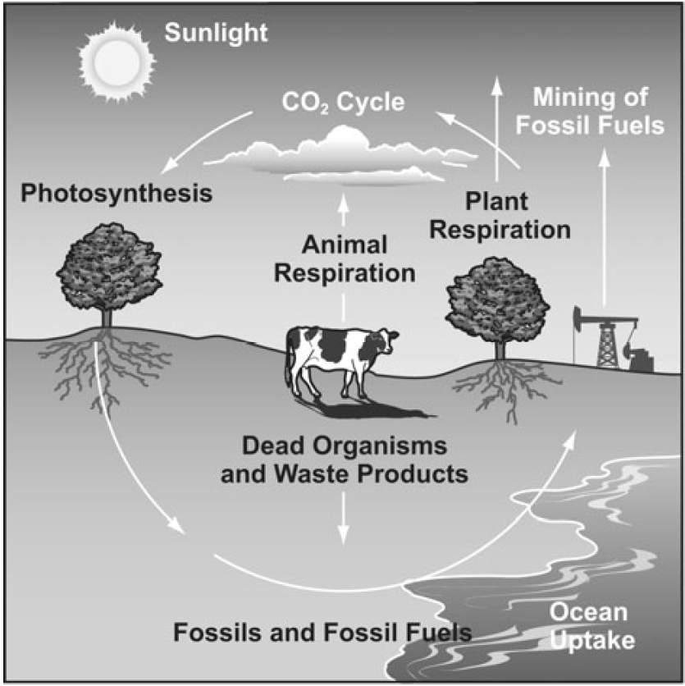

Write the letter of the process that best matches each description in the box next to the description. (3 points)

adds carbon to the soil |  |  | - dead organisms  - photosynthesis  - animal respiration
adds carbon to the atmosphere

removes carbon from the atmosphere

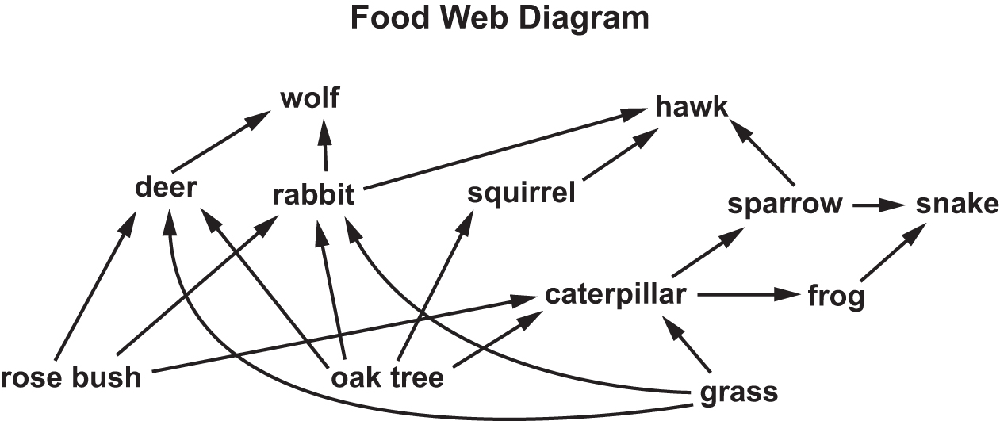
15. The diagram below shows a forest food web.

Identify one food chain in the diagram. (1 point)

__________________________________________________________________________

16. The food web shows the flow of matter and energy in a desert ecosystem. Write one letter in each box to complete the food web of the desert ecosystem. (5 points)
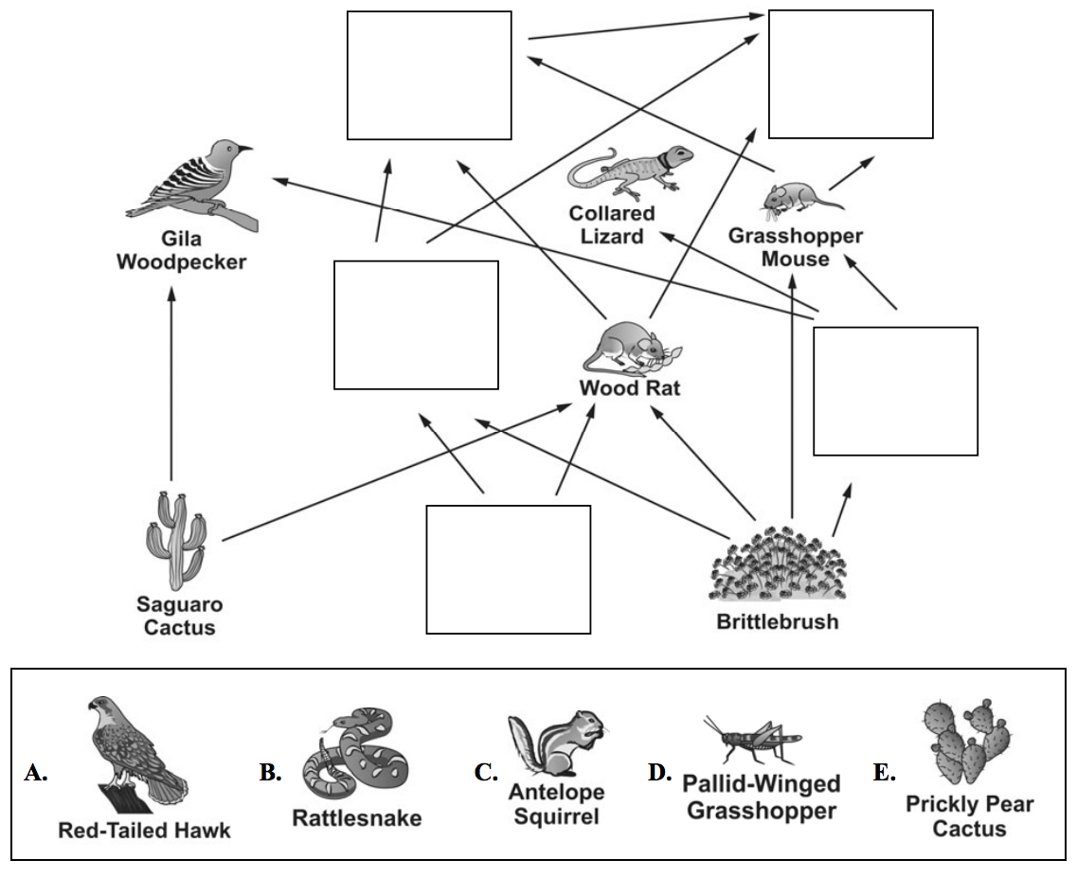

17. Which of these best describes how the atmosphere and hydrosphere rely on each other?
(1 point)

A. to maintain a consistent temperature for life on Earth
B. to provide homes for most organisms living on Earth
C. to keep ice caps from melting and sea levels from rising on Earth
D. to allow the water cycle to constantly provide fresh water for Earth

18. Explain how Earth’s spheres rely on the water cycle. (2 points)

__________________________________________________________________________

__________________________________________________________________________

__________________________________________________________________________

__________________________________________________________________________

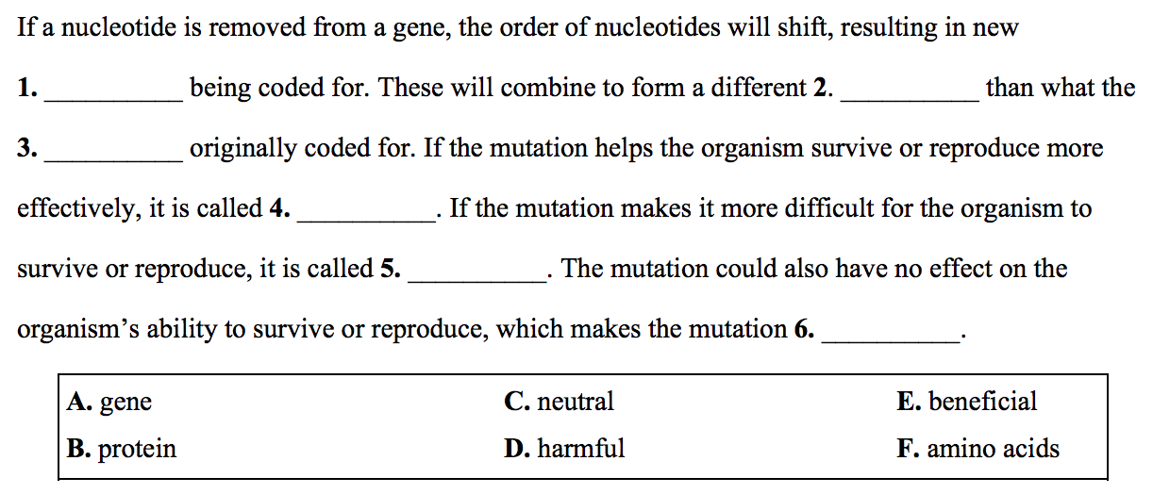
19. Write the letter of each word in the correct blank to complete the paragraph. (6 points)

20. Fermentation occurs in the cells of many organisms, including the cells of animals. Provide an example of fermentation that occurs in human cells and explain why it is important.
(2 points)

__________________________________________________________________________

__________________________________________________________________________

__________________________________________________________________________

__________________________________________________________________________

Directions: Use the information below to answer questions 21 and 22.
(Questions 21 and 22 are worth 2 points each.)

Carbon Bonding
The figure shows carbon atoms forming bonds with a variety of other atoms. The number and types of bonds an atom can form can provide information about the structure of the atom.
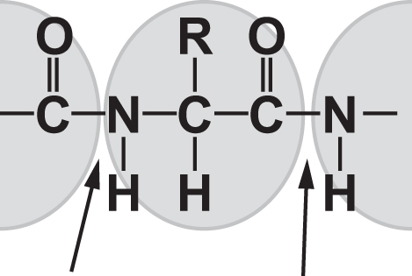

21. What do the four lines that surround the C illustrate about carbon?

__________________________________________________________________________

__________________________________________________________________________

__________________________________________________________________________

__________________________________________________________________________

22. Can the central carbon atom in the diagram form more bonds than those that are shown? Why or why not?

__________________________________________________________________________

__________________________________________________________________________

__________________________________________________________________________

__________________________________________________________________________

Directions: Circle the letter of the correct answer. (Questions 23-26 are worth 1 point each.)

23. The model shows water molecules interacting. The gray circles represent oxygen; the white circles represent hydrogen.

The diagram shows both a chemical change and a physical change.

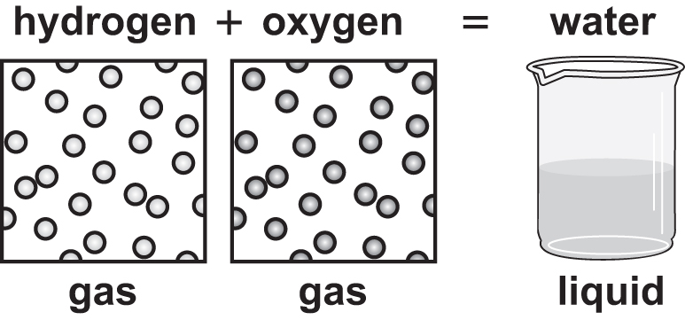

Which statement is true of the substance produced by the simple chemical reaction depicted in the diagram?

A. It is identical to the original substances.
B. It is a compound, just like the original substances.
C. It contains more atoms than the original substances.
D. It is in a different physical state than the original substances.

24. On a hot day, which of these is an outward sign that thermoregulation is taking place?

A. sunburn
B. sweating
C. dry mouth
D. slow breathing

25. Which of these biotechnologies has the potential to repair tissues inside the body?

A. biometrics
B. biomimetics
C. epidemiology
D. nanotechnology

26. Biotechnology raises ethical questions, primarily concerning the __________.

A. safety of eating transgenic plants
B. best use of funds for biological research
C. wisdom of continuing to use technology
D. ways in which knowledge should be used

Directions: Use the information below to answer questions 27-30.
A scientist is researching the role that respiration plays in the movement of matter in ecosystems. She has developed the model shown here to illustrate the transfer of matter.

Respiration and the Movement of Matter
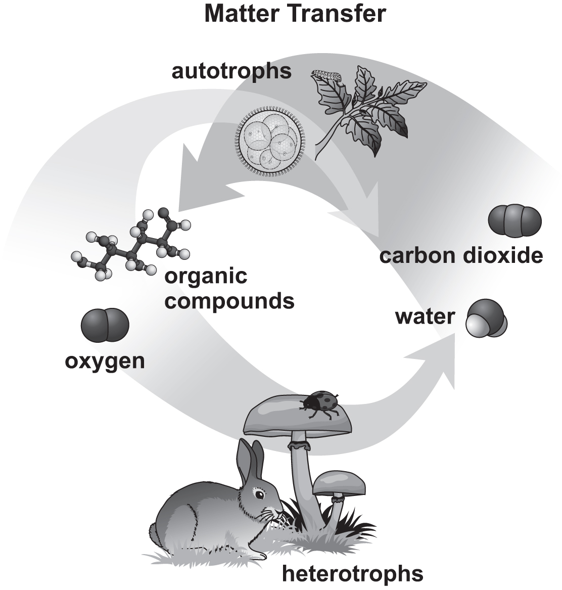

27.The scientist is conducting an experiment on cellular respiration in which she supplies a cell culture with radioactively labeled oxygen gas. After a period of time, she samples the culture. Which of these molecules will contain the radioactive oxygen atoms? Circle the letter of the correct answer. (1 point)

A. ATP
B. water
C. carbon dioxide
D. organic compounds

28. The scientist is studying the processes for which cellular respiration provides work, such as the contraction of muscles. Number the processes from 1 to 5 to show to show how respiration provides energy to a muscle fiber for contraction to take place. Number 1 should be the first step, and number 5 should be the last step. (5 points)

The energy in ATP is used to make muscle cells contract.
Glucose molecules are broken down into smaller sugars.
The electron transport chain is used to produce ATP.
Energy is captured in the form of NADH and FADH₂.
Glucose molecules in the bloodstream are absorbed by a muscle cell.

29. The scientist places a small organism into a sealed container and the organism is allowed to undergo respiration for a one-hour period. The container holds water, oxygen, carbon dioxide, and nitrogen gas. The scientist measures the amount of each substance in the container both before and after the one-hour period. Write a letter to each substance in the correct box to show whether it would be expected to increase, decrease, or remain the same as a result of respiration. (4 points)
Increase | Decrease | Remain the same |  | A. water  B. oxygen  C. nitrogen gas  D. carbon dioxide

30. As part of her studies, the scientist is researching the ways that respiration and photosynthesis provide the energy for an ecosystem. The diagram illustrates how matter and energy move through an aquatic ecosystem.

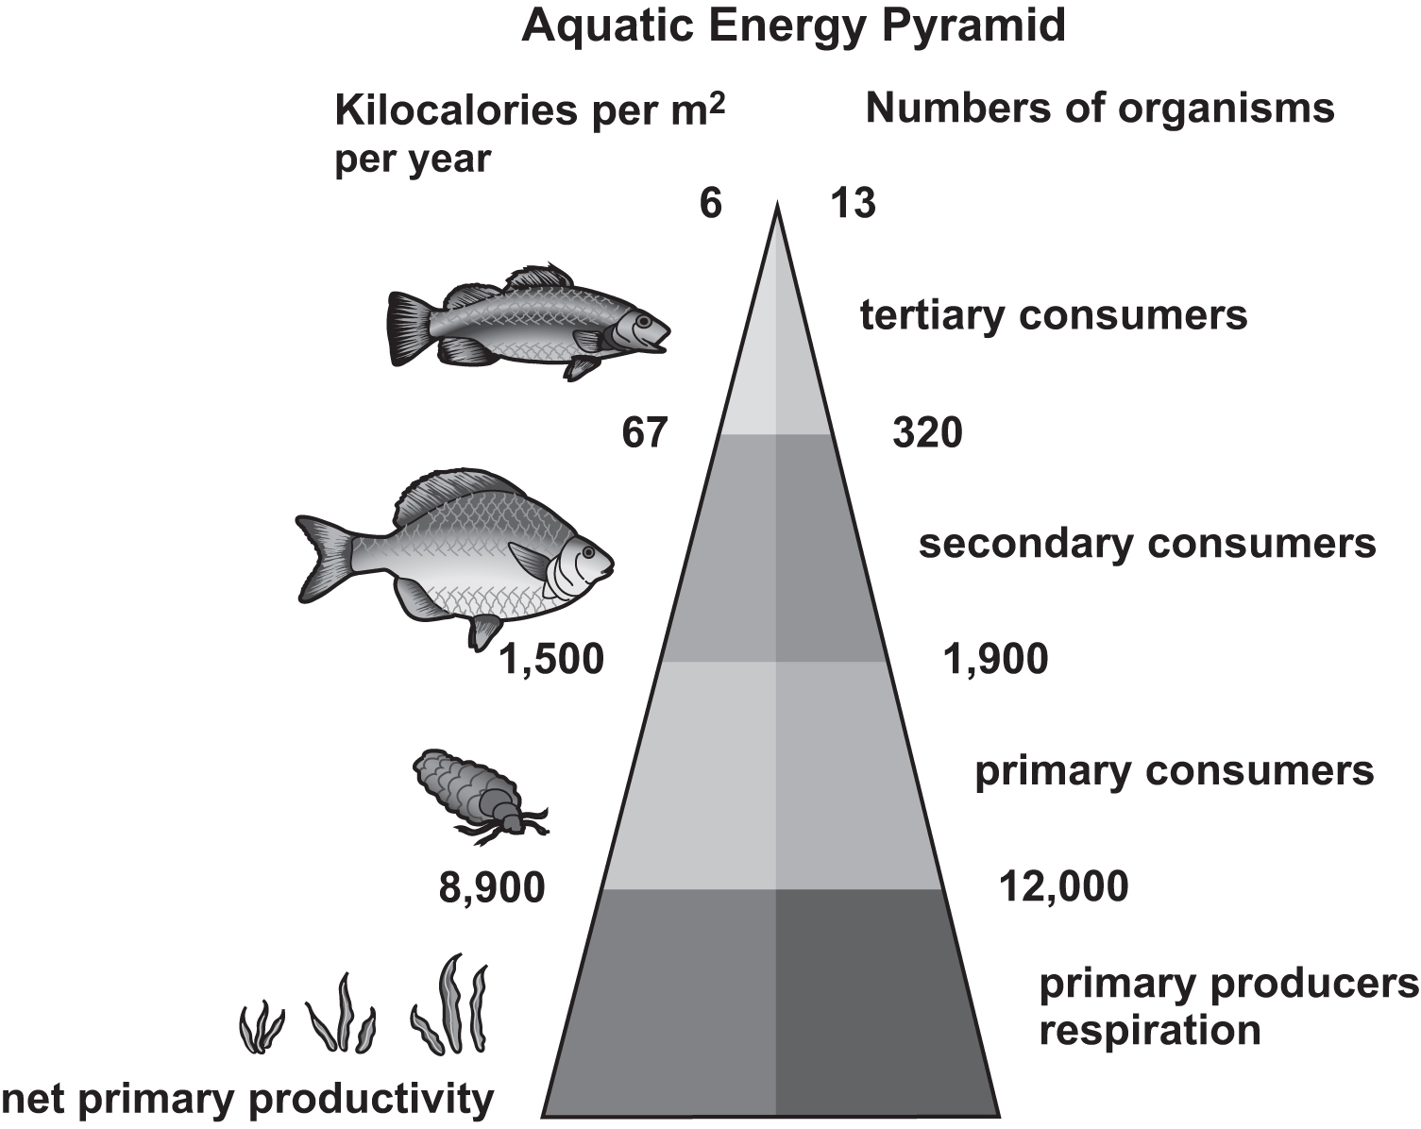

Describe the formation of new matter and the transfer of energy in the provided model of photosynthesis and cellular respiration. (2 points)

__________________________________________________________________________

__________________________________________________________________________

__________________________________________________________________________

Biology
Winter Break Packet Answer Key

Item Number | Answer | Standard  (one per item)
1 | A | NGSS.SCI.HS-LS1-6
2 | B | NGSS.SCI.HS-LS1-5
3 | D | NGSS.SCI.HS-PS1-4
4 | C | NGSS.SCI.HS-LS2-6
5 | B | NGSS.SCI.HS-LS1-5
6 | C | NGSS.SCI.HS-LS1-1
7 | D | NGSS.SCI.HS-LS1-3
8 | A | NGSS.SCI.HS-LS1-3
9 | D | NGSS.SCI.HS-LS1-5
10 | C | NGSS.SCI.HS-LS2-1
11 | Animals take in oxygen and release carbon dioxide in respiration and release carbon dioxide in decomposition. | NGSS.SCI.HS-LS2-4
12 | Plants take in carbon dioxide in the process of photosynthesis. | NGSS.SCI.HS-LS2-5
13 | A and C | NGSS.SCI.HS-LS2-4
14 | A. Dead organisms- adds carbon to the soil because some carbon from the decaying organisms stays in the soil making the soil more fertile.  B. Photosynthesis- removes carbon from the atmosphere because this process uses carbon dioxide gas to build sugar molecules.  C. Animal respiration- adds carbon to the atmosphere because this process releases carbon dioxide gas as a waste product. | NGSS.SCI.HS-LS2-5
15 | Sample answer:  - rosebush-rabbit-hawk | NGSS.SCI.HS-LS2-6
16 | A. Red-tailed hawk is correct for the top right box, above the grasshopper mouse, because it is a tertiary consumer that would eat the rattlesnake as well as the wood rat, grasshopper mouse, and antelope squirrel.  B. Rattlesnake is correct for the top left box, above the gila woodpecker, because it is a secondary consumer that would eat wood rats and antelope squirrels, and would be eaten by the red-tailed hawk.  C. Antelope squirrel is correct for the middle left box, between the wood rat and the gila woodpecker, because it is a primary consumer that would eat cactus, and would be eaten by both a rattlesnake and a red-tailed hawk.  D. Pallid-winged grasshopper is correct for the middle right box, to the right of the brittlebrush, because it is a primary consumer that would eat brittlebrush leaves and would be eaten by the grasshopper mouse.  E. Prickly pear cactus is correct for the bottom center box, between the saguaro cactus and the brittlebrush, because it is a producer at the base of the food web. | NGSS.SCI.MS-LS2-3  **This is a Middle School Performance Expectation**. This question is being used to help students review information from the previous school year, that will be present in the Biogeochemical Systems course (ecosystem interactions)
17 | D | NGSS.SCI.HS-LS1-2
18 | The atmosphere stores water as gas that it receives by evaporation from the hydrosphere. The cryosphere stores water in solid form, which it receives as precipitation from the atmosphere.  The lithosphere and hydrosphere store water in liquid form, which they receive as precipitation from the atmosphere. The hydrosphere also receives water from the lithosphere in the form of runoff.  The biosphere absorbs water during photosynthesis and releases water during cellular respiration. | NGSS.SCI.HS-LS1-6
19 | 1F. Amino acids- genes code for amino acids.  2B. Protein- amino acids combine and fold to create proteins.  3A. Gene- the gene is the thing that holds the code.  4E. Beneficial- beneficial.  5D. Harmful- mutations that make an organism’s life more difficult are harmful.  6C. Neutral- mutations that neither help nor harm are neutral. | NGSS.SCI. MS-LS3-1  **This is a Middle School Performance Expectation**. This question is being used to help students review information that will be needed during the second semester of the biology course.
20 | - Answers should include a discussion of lactic acid fermentation in muscle cells that allows ATP production to continue  in the absence of oxygen.  - Answers may include, but are not limited to, (1) bacteria that produce lactic acid during fermentation and give cheese its variety of flavors, and (2) alcoholic fermentation by yeast in bread. | NGSS.SCI.HS-LS2-3
21 | Sample answer:  The four lines surrounding the C represent the four bonds that carbon can form. By forming bonds with many other elements, carbon can form large, complex molecules like proteins. | NGSS.SCI.HS-PS2-6
22 | Sample answer:  Four is the largest number of covalent bonds carbon can form because it has four unpaired electrons in its outer energy level. Unpaired electrons are required for forming covalent bonds. | NGSS.SCI.HS-PS1-1
23 | D | NGSS.SCI.HS-PS1-2
24 | B | NGSS.SCI.HS-LS1-3
25 | D | NGSS.SCI.HS-ETS1-4
26 | D | NGSS.SCI.HS-ETS1-3
27 | B | NGSS.SCI.HS-LS1-7
28 | The numbers in order should be  5, 2, 4, 3, and 1.  First, glucose is absorbed by the muscle cell, and then broken down during glycolysis. During glycolysis and Krebs cycle, the energy in glucose is transferred to NADH and FADH₂. These molecules are used by the electron transport chain to produce ATP, which provides energy for the contraction of muscles. | NGSS.SCI.HS-LS1-7
29 | A. Water belongs in the Increase  column because water is released  during respiration.  B. Oxygen belongs in the Decrease column because oxygen is consumed during respiration.  C. Nitrogen gas belong in the Remain the same column because nitrogen gas is not involved in respiration.  D. Carbon dioxide belongs in the Increase column because carbon dioxide is released during respiration. | NGSS.SCI.HS-LS1-7
30 | Sample answer:  - The process of photosynthesis takes carbon dioxide, water, and the sun’s energy from the environment to create new compounds in the form of organic compounds such as sugars, which are consumed by organisms as the matter moves through the ecosystem. Those sugars combine with oxygen to break down to carbon dioxide and water to release usable energy in the form of ATP. | NGSS.SCI.HS-LS2-3

