**Grade 1**

**MATHEMATICS**

**WINTER STUDENT**

**ENRICHMENT PACKET**

  

**™**

**Prince George’s County Public Schools**

**Office of Academic Programs**

**Department of Curriculum and Instruction**



|  |
| --- |
| **Directions and Notes**  **for Students and Parents**  **Grades 1 - 5** |
| 1. Plan to work for about one hour to complete the entire packet.  2. Find a quiet place to complete your work independently.  3. Read each problem carefully before selecting or writing your answer.  4. Check your work.  Thank you for helping your child succeed! |

**Winter Fun**

1. Create number sentences to show four ways that you can eat 18 cookies. **1.OA.3, 1.OA.6**
2. 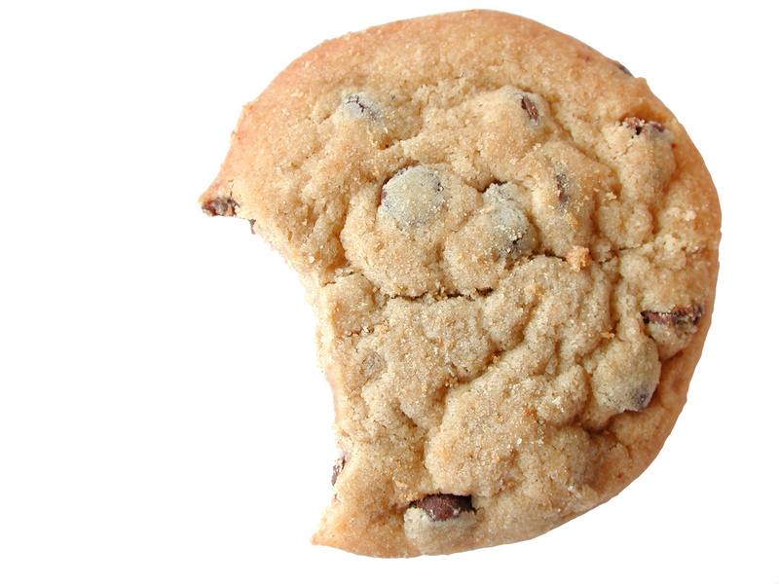____ + ____ = ____ b) ____ + ____ = ____

c) ____ + ____ = ____ d) ____ + ____ = ____

**2.** Place red and blue hats on the snowmen below to create two different ways to show 10. **1.OA.6**

**First way**

     

     

____ + ____ = 10

How many snowmen have no hat? _________

**_______________________________________________**

**Second way**     

    

 

____ + ____ = ____

How many more snowmen do you need to have another 10? _______

**3.** A group of 15 children went out to play. Complete the paragraph with numbers that show 15 children went out to play. Read your story to a family member when you are finished. **1.OA.1**

There were _______ girls  in the group and ________ boys. 

Each of the girls wore bright red mittens, so there were ________red mittens.

The boys all wore green mittens, so there were

_________ green mittens.

**Complete the chart:**

|  |  |
| --- | --- |
| **Number of children** |  |
| **Number of girls** |  |
| **Number of boys** |  |
| **Total number of mittens in all** |  |
| **Total pairs* of mittens** |  |
| **Total number of fingers in all** |  |

**\*A pair is equal to two.**

**4**. Write a story problem that can be solved by using the number sentence 8 + 6 = ______. **1.OA.8**

|  |
| --- |
|  |
|  |
|  |
|  |
|  |
|  |

**5**. Write a story problem that can be solved by using the number sentence 14 - 7 = ______. **1.OA.4**

|  |
| --- |
|  |
|  |
|  |
|  |
|  |
|  |

**6.** Which doubles fact can help you solve this problem? 5 + 6 = 11 **1.OA.6**

Explain how the fact that you chose can help. _______________________________________________

____________________________________________________________________________________

medium 0-25 number line

**7**. Use the number line above to show three numbers that will add up to 20. Write the number sentence that matches your picture in the space below. **1.OA.2, 1.OA.8**

_______+_______ + _______ = 20

**8**. What number is missing in the pattern below? Write the number on the blank space. Then, write a sentence explaining why you chose that number. **1.NBT.5**

15, ___, 35, 45, 55

Use numbers, words, and/or symbols to explain how you found your answer.

|  |
| --- |
|  |
|  |
|  |
|  |
|  |
|  |

**9**. Look at the number sentences below. Circle the ones that are true. **1.NBT.3**

16 > 20 10 < 5 3 < 7 12 > 10 8 > 8

On the lines below, rewrite the incorrect comparisons using the correct symbol. Then, explain how you know your answer is correct.

|  |
| --- |
|  |
|  |
|  |

**10**. Sort all these shapes into two groups so that each group has something in common. Show how you grouped the shapes by writing the letter/number from each shape into the boxes marked Group 1 and Group 2. Then, write a sentence that explains how you decided to group the shapes. Write a number sentence to show how many shapes there are in all. **1.G.1**

|  |  |
| --- | --- |
| Group 1 | Group 2 |
|  |  |

**A**

**7**

**9**

**M**

**2**

**S**

|  |
| --- |
|  |
|  |
|  |