Grade 5 Science
Winter Enrichment Packet

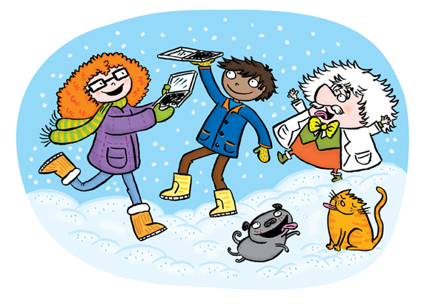
STUDENT BOOK
Illustration by Patricia Storms

Prince George’s County Public Schools
Office of Academic Programs
Department of Curriculum and Instruction
Note to Parents and Students

This is an at-home science student instructional packet for Winter Break. This packet has been created to provide practice for students to answer Selected Response (SR) items and work through technical reading passages of informational text to support elementary science and the PGCPS Literacy Initiative.

- For more information about the PGCPS Literacy Initiative, visit: http://www.pgcps.org/literacy/ for parents and students.

Students will use the passages to write claims, evidence, and reasoning for Brief Constructed Response (BCR) items and to answer Selected Response (SR) items. Please write your responses to the SRs and BCRs on the space provided in this booklet.

It is highly recommended that students practice their annotating skills when reading the text.

The items in the Winter Break Packet are related to earth and space science, physical science and life science concepts that are aligned to the Next Generation Science Standards (NGSS).

For more information about the PGCPS Science and NGSS, visit:
- PGCPS Science Department: http://www1.pgcps.org/science/
- NGSS Website: https://www.nextgenscience.org/
- NGSS Parent Guide: https://tinyurl.com/NGSSParentGuide

The packet should be used for review purposes in preparation for the new Maryland Integrated Science Assessment (MISA). MISA is administered during the months of March and April.

Enclosed in this packet, is a “Claim, Evidence, and Reasoning Rubric for Writing,” retrieved from the National Science Teachers Association (NSTA) for students to self-assess their BCRs responses.

Several articles, questions and images were retrieved from Readworks.org. ReadWorks® is a Registered Trademark | © 2017

The answer key and writing rubric are located on the last page of this packet.

Life Science
Use the reading passage to complete items 1, 2, 3 and 4.

The Ecosystem Forest

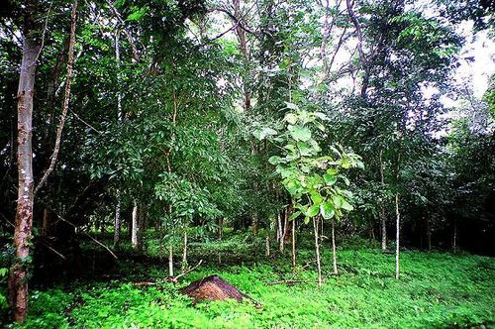

Even if it doesn’t look like it, all living things constantly interact with their environment. For instance, every time you take a breath, you get oxygen from the air, and every time you breathe back out, you release carbon dioxide into the world around you. Both oxygen and carbon dioxide are vital gases that different organisms can use. You, a human, need the oxygen for energy and need to get rid of the carbon dioxide, because it’s a waste matter.
Just like us, all other organisms take something from their environment while putting waste back into it. When several kinds of organisms interact with each other in one particular area, it’s called an ecosystem. In the forest, living beings (plants, animals, insects, fungi and bacteria) all interact with each other and with the soil and water to form the forest’s specific kind of ecosystem.
So, how does it work? Every organism in the forest can be put in one of three categories. Depending on which category they’re in, they’ll interact with each other and the forest’s resources in a different way. The categories are producer, decomposer and consumer. Let’s look at each one.
Producers are living things that can make their own energy out of non-living resources all around them like, oxygen and water. They’re also known as autotrophs. Autotrophs do not need to kill anything in order to eat. Plants and algae, for example, are producers. In the forest’s ecosystem, the trees, shrubs and moss are all producers. They turn water and sunlight into the energy they need to live and grow, through a process called photosynthesis. And remember that carbon dioxide you expelled as waste matter? Well, for plants, carbon dioxide is a vital gas. It is used to help aid with the process of photosynthesis.

Like producers, decomposers don’t need to kill another living being to obtain food. However, they differ from producers because they still need to get their nutrients from other organisms or from waste matter expelled by other organisms. Usually they eat dead animals and plants. Bacteria and certain kinds of fungi are examples of decomposers. They’re very important because by helping break down dead organisms, they actually provide energy to living ones.
Consumers are the living beings that need to eat other organisms to survive. You may have heard about this group as being “at the top of the food chain.” They’re also known as heterotrophs. Humans are heterotrophs who eat both plants and animals to live. In the forest, a deer eating plants, a wolf hunting deer, a hawk eating rodents, and rodents eating both bugs and plants, are all examples of the ecosystem’s consumers. As you can see, carnivores, omnivores and herbivores are all different kinds of heterotrophs. It doesn’t matter which kind of organism they eat; as long as they eat other organisms to survive, they’re consumers/heterotrophs.
So, now that you know each type of player, how does the ecosystem’s cycle work? Well, when an organism dies and its body decomposes, bacteria go to work. Let’s imagine the dead organism is a deer. Bacteria obtain energy from the deer’s body, while helping it decompose efficiently. When the deer’s body breaks down, because of the work done by the bacteria, it returns to the soil. This is important for the earth, because the carcass actually gives vital energy back to the environment. It makes the soil rich in nutrients for plants to grow there. Grasses, flowers and trees then grow in that soil and get the energy they need, along with energy from the sun and water. The water also filters through the soil, which is necessary for the forest’s flowers and trees to be able to take it up through their roots. Heterotrophs, like deer, eat those plants to get their energy, and other heterotrophs, like wolves, eat the deer for their energy.
As you can see, in a forest ecosystem or any kind of ecosystem, every being interacts with other beings. What’s important to remember is that each part of the ecosystem is as important as another. Without soil, there’d be no plants. With no plants, there’d be no deer, rodents or certain kinds of insects. And without tiny microbes (remember, the decomposers), animals and plants would die without their bodies being returned to the earth. Because forests cover about a quarter of the total land surface of the world, keeping their ecology balanced is important for the entire earth. © 2013 ReadWorks®, Inc. All rights reserved.

1. Ecosystems are important to all living things. From the article, which statement best describes an Ecosystem.

- Ecosystems are living things, such as a human, that eat other living things in order to survive.
- Ecosystems only process living things broken down by decomposers.
- Ecosystems are areas where several kinds of organisms interact with each other.
- Ecosystems are organisms that breathe in oxygen and then breathe out carbon dioxide.

2. In an ecosystem, different organisms interact with each other. What evidence from the passage supports this statement?

- Plants use sunlight, water and carbon dioxide in a process called photosynthesis.
- Forest ecosystems cover about a quarter, or one-fourth, of the total land surface in the world.
- Producers are living things that can make their own energy out of non-living resources.
- A deer decomposing in the soil provides food bacteria and nutrients for plants to grow.

3. Based on the information in the passage, what do all ecosystems have in common?

- All ecosystems are home to living things that interact with each other.
- All ecosystems are home to tree, deer, humans, rodents, wolves and bacteria.
- All ecosystems have an equal number of consumers, decomposers and producers.
- All ecosystems have a few consumers that do not interact with decomposers and producers.

4. Which of the following objects will float or sink in water: a basketball or a hockey puck?
When supporting your claim, please be sure to use evidence from the passage with reasoning to write an explanation as to why the object will float or sink. You may include a labeled model to explain your thinking.

Earth and Space Science
Use the reading passage to complete items 5, 6, and 7.

The Life Cycle Of A Snowman by Michael Stahl

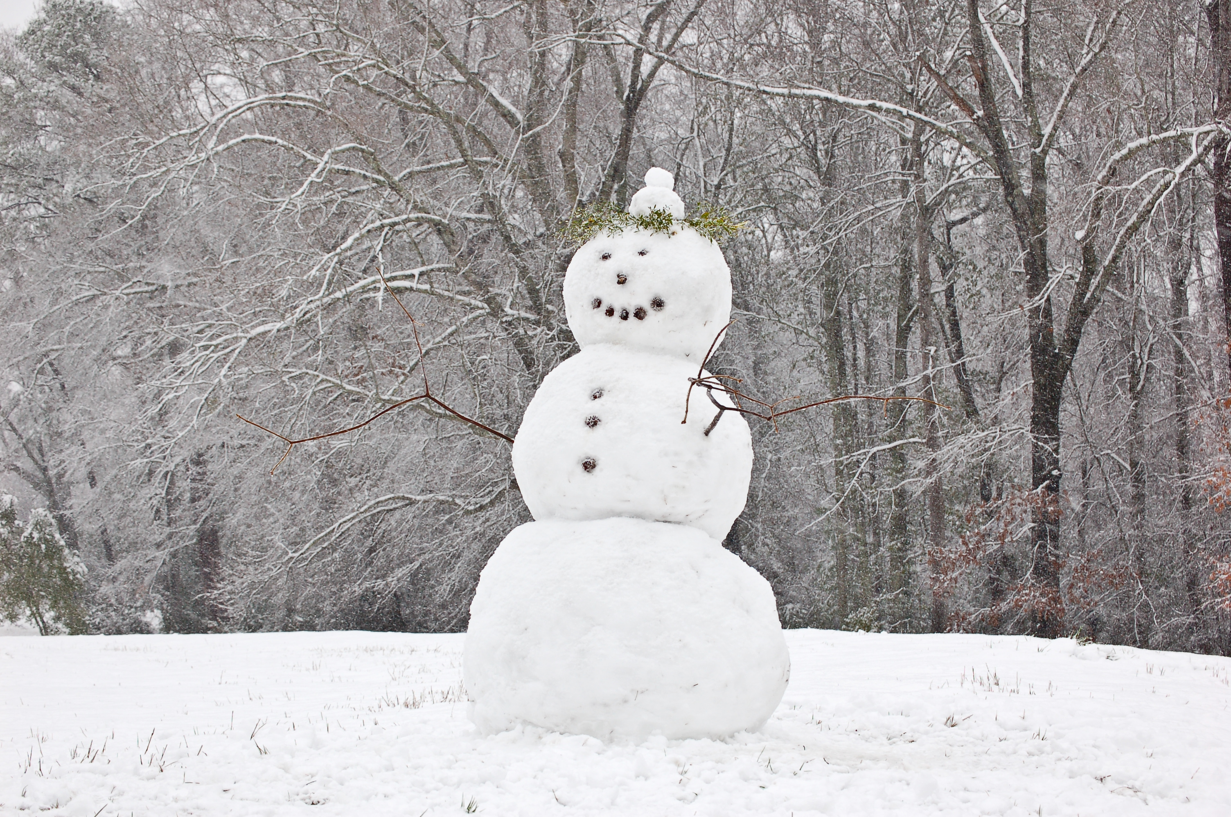
There are so many things to enjoy during the season of winter. As the temperature drops, just about everything seems to change. People put away their shorts and dresses and replace them with long pants and sweaters. The sports on television change from baseball and soccer to hockey and football. There are a few special holidays and boys and girls get to enjoy their longest vacation during the school year. And, of course, there is snow! A winter’s snow means it is possible to go outside for sledding, ice skating and, one of the most fun things to do, making a snowman. People of any age can make a snowman, but it would not be possible without water, water’s cycle, and water’s three states of liquid, solid and gas.

Before anybody can begin to even think of making a snowman in the freezing cold temperatures of winter, water, in its liquid form, has to actually warm up. Water is made up of the elements hydrogen and oxygen and it covers two-thirds of planet Earth. Most of the water on Earth makes the oceans, but water also makes streams, lakes, ponds and rivers possible. The sun gets the water cycle going. It warms the planet’s water supply, causing a certain amount of it, depending on the height of the temperature, to evaporate.

Water Cycle
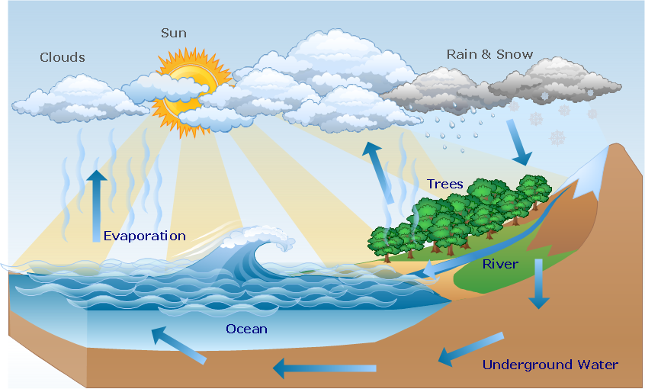

When water evaporates, it becomes a gas called water vapor. Though people cannot see it, evaporated water as a gas rises through the air into the atmosphere to form clouds. Clouds are created when a large amount of water vapor begins to cool as it rises through the air. Clouds can grow bigger when they come into contact with
more water vapor as well as other clouds. As clouds get larger, they become unstable. They cannot continue to be so big without something changing, so precipitation must happen. Precipitation is when the hydrogen and
oxygen of the water vapor in clouds become so closely packed together that it falls back to Earth in the form of water. Rain is the type of precipitation that happens most often, but, when the temperature in the air is particularly cold, the water falling down to Earth chills and becomes snow.

Snow and ice are examples of water being in its solid state. Precipitation can also include hail and sleet. Hail is precipitation as pieces of ice formed in cloud layers that are below freezing levels. Sleet is when the water is somewhere in between rain and snow. If the temperature is cold enough and if clouds overhead are big and unstable enough, snow will fall to the ground. If the snow starts to accumulate on the ground, then one can possibly make a snowman. A person or group of people needs a lot of snow to make a snowman. They will need to pack up enough of that snow to make three tremendous balls, one for the base or the legs, another for
the middle part of the body, and one, usually smaller than the others, for the head. It’s best to decorate a snowman with a hat, a scarf, and some eyes and a mouth made of coal, or other objects.

Snowmen are fun while they last, but the Earth’s water cycle has to continue on. Eventually, no matter how much a person might wish for it not to be the case, the snowman will warm up from the sun and melt, turning back into water and being sopped up by the ground. However, over time, that water will only evaporate back into the air to form more clouds that will make more snow for more snowmen. © 2014 ReadWorks®, Inc. All rights reserved.

5. The sequence of the water cycle is explained in the passage. What happens after the sun warms the Earth’s water supply?

- Large clouds become unstable and cause precipitation.
- Water evaporates and becomes a gas called, “water vapor.”
- Clouds come in contact with more water vapor and grow larger.
- Water vapor rises through the air into the atmosphere and cools.

6. Cool air is needed to form clouds. What evidence from the passage supports this statement?

- When water evaporates, it becomes a gas called water.
- Clouds grow larger as they come in contact with other clouds.
- Water vapor cools as it rises through the air, which creates clouds.
- As clouds get bigger, they become unstable. This causes precipitation.

7. What must ocean water go through to fall as snow? Use the space below to write your explanation. Remember to use the evidence from the passage and your reasoning to support your explanation.

Physical Science
Use the reading passage to complete items 8, 9, and 10.

Talk About Dense

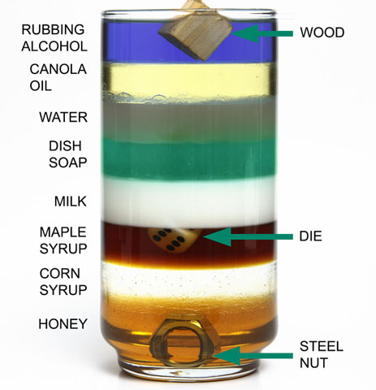

When you drop ice cubes into a glass of water, the ice floats to the top. Why? Ice is not as dense as water. But is that always a cold, hard fact? In most substances, the solid form is more dense than the liquid form. A bar of solid gold, for example, sinks to the bottom of a bucket of liquid gold.

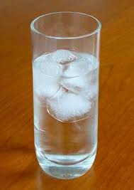
Scientists have been trying to determine why water is an exception. In the process, they have developed a new kind of ice that is denser than water. This new ice is made of water molecules. Unlike regular ice molecules, the molecules in the new ice do not fall into regular patterns. They are packed more tightly, as well.

In order to make ice that sinks, scientists squeeze regular ice at very low temperatures- much colder than the temperature in your freezer. The squeezing and freezing changes the arrangement of water molecules into high-density ice. Scientists have found five new kinds of water ice, in addition to 13 types already known. Scientists think that the new ices may exist naturally elsewhere in the universe. © 2012 ReadWorks®, Inc. All rights reserved.

8. Based on the reading passage, it is likely that…

- ice is always less dense than water.
- solid gold is less dense than liquid gold.
- scientists have found all the types of ice in the universe.
- most people would not be able to create ice that is denser than water.

9. What happens when you drop a bar of gold into liquid gold?

- It floats to the top.
- It sinks to the bottom.
- It stays at the surface.
- It sinks down to the middle.
10. How does solid water exist with different densities? Write in the space provided below.
Remember to use the evidence from the passage and your reasoning to support your explanation.

National Science Teachers Association: Claim, Evidence, and Reasoning Rubric for Writing
Score | Claim  A statement or conclusion that answers the original question/problem. | Evidence  Scientific data that supports the claim. The data needs to be appropriate and sufficient to support the claim. | Reasoning  A justification that connects the  evidence to the claim.  It shows why the data counts as evidence by using appropriate and sufficient scientific principles.
4 | All aspects of level 3 included and is written in a way that engages the reader. | All aspects of level 3 included; correctly identifies the sources and is written in a way that engages the reader. | All aspects of level 3 included and is written in a way that engages the reader.
3 | Makes an accurate and complete claim and includes points from the question in the writing. | Provides all or most of the expected pieces of evidence from the sources used in an appropriate manner. | Provides reasoning components for all or most of the evidence and explains how the evidence supports the claim.
2 | Makes an accurate and  complete claim. | Provides some of the expected pieces of evidence from the sources used (e.g., data like numbers, observations, etc.) in an appropriate manner. | Provides reasoning components for some of the evidence and explains how the evidence supports the claim.
1 | Makes an accurate but vague  or incomplete claim. | Makes a general statement regarding evidence, but does not include specific details. | Repeats evidence and links it to the claim, but does not explain how the evidence supports the claim.
0 | Does not make a claim, or  makes an inaccurate claim. | Does not provide evidence, or only provides inappropriate evidence or vague evidence, like “the data shows me it is true.” | Does not provide reasoning, or only provides inappropriate reasoning.

Grade 5 Winter Enrichment Packet Answer Key
1. C
2. D
3. A
4. Use the NSTA rubric to score your writing response.
5. B
6. C
7. Use the NSTA rubric to score your writing response.
8. D
9. B
10. Use the NSTA rubric to score your writing response.

Use the rubric below to score items #4, #7, and #10.

