**WINTER STUDENT ENRICHMENT PACKET**

**RESEARCH QUEST & READING LOG**

**7TH GRADE**



**Reading/English Language Arts**



**[Type the company address]**

**Prince George’s County Public Schools**

**Department of Curriculum and Instruction**

**Office of Academic Programs**

**NOTE TO STUDENT**

You've learned so much in school so far! It is important that you keep your brain active over the winter to be ready for the New Year. In this package you will find a calendar of activities to last you all Winter Break. This year we have also incorporated a fun project for you to complete. Create a journal that you can use to note your thoughts, ideas, and any work you complete.

**Directions:**

Family members should preview the calendar together. There are activities that may require advance planning, or you may want to consider working together with other families and friends on some activities.

* **Student should read for at least 30 minutes each day.**
* **Students will need a Reader’s & Writer’s Journal to complete this winter work.** Your journal will be your special place for your daily calendar work and writing. Students can purchase a journal or they can make one by stapling several pieces of paper together or by using a notebook/binder with paper. Student should be creative and decorate the journal. Specific journal tasks are given some days, but students may also journal after each day's reading, notice things that stood out, questions that they have, or general wondering about the text.
* **Each journal entry should:**
* Have the date and assignment title.
* Have a clear and complete answer that explains the students thinking and fully supports the response.
* Be neat and organized.
* **Use the chart in this package to record all of the books read during Winter Break.**



**QUEST TASK CALENDAR**

|  |  |  |  |  |  |  |  |  |
| --- | --- | --- | --- | --- | --- | --- | --- | --- |
| **Directions:**  This first calendar provides guidance to write and perform a play based on culture and historical events of a location related to your World Cultures studies. More details on this task are on the next page.  The second calendar (p. 7) is a log upon which you should note the time you spend reading.  **Enjoy your research quest!** |  | |  | |  | | **Day 1**  Plan for your play. Review models of plays. Find historical resources for your play.  **Read for 30 minutes daily.** | **Day 2**  Conduct research for your play. Take notes of useful information (cite sources). Be sure to note/cite your sources! |
| **Day 3**  Continue research as needed.  Begin to outline your play (purpose, characters, setting, plot, tone, etc.). | | **Day 4**  Use your ideas and outline to begin to write the script for your original, short play.  **Read for 30 minutes daily.** | | | **Day 5**  Continue to develop your script. Be sure to focus on stage direction and dialogue. Make and send invitations to friends and family for the performance. | **Day 6**  Complete your script. Review the script to ensure all stage directions and dialogue are included. Try this by reading your play aloud. | **Day 7**  Make revisions to the script and write your final draft. | **Additional**  Rehearse your play. Make sure that you have all needed props. |
| **Additional**  Conduct the final rehearsal of your play. Ensure all is ready for the performance.  Perform your play for your invited guests. Share the inspiration for your script. Celebrate your success! | | **Additional**  Reflect on your experience as a researcher, playwright, and actor. Add your reflection to your script as an introduction**.** | | **C:\Users\Andrea.Munson\AppData\Local\Microsoft\Windows\Temporary Internet Files\Content.IE5\2R2BM0ST\MC900031061[1].wmf** | | | | |

**TASK DETAILS AND CONSIDERATIONS**

The purpose of this “research quest” is to give students an opportunity to research and to refine their knowledge about a topic that is of interest. The learning activities below will assist students as they write and perform a play about their chosen topic.

Additionally, one of the PARCC assessment tasks revolves around research. Completing this packet offers students useful practice.

If students would like to show their “research quest” through other products other than a play, additional ides include performing a monologue (<http://www.monologuegenie.com/monologue-writing-101.html>), writing a speech (<http://www.enotes.com/topics/how-write-speech>), or creating a collage.

At the end this packet, there is a sampling of resources on the first emperor of China that can be used if students do not have access to the Internet or public library during the winter break.

* Consider working on this portion of the research quest with a partner or two. Be sure that all group members will do their part!
* Use the calendar on page 2 as a general guide to complete your project. Evaluation criteria can be found on page 6.
* Your play may be historical non-fiction, or you may choose to develop it as historical fiction. Your final production should be 7-10 minutes in length. You might want to skim through your World Cultures textbook for ideas.
* If you aren’t sure how to conduct research, refer to Unit 9 of your RELA textbook, *Literature.* You may refer to either your textbook or to the online version (<http://my.hrw.com>).
* Begin to research your topic. Use a variety of primary and secondary sources. Keep in mind whether or not your sources are accurate. Use information from websites and books to provide the historical background for the play you write. Use a variety of primary and secondary sources. Keep in mind whether or not your sources are accurate. Some suggestions are listed below.
  + <http://www.asia.si.edu/exhibitions/online.asp>
  + <http://africa.si.edu/exhibits/past.html>
  + <http://www.european-museums.com/> (look for online exhibitions)
  + <http://www.britishmuseum.org/explore.aspx> (exhibits that reflect many cultures)
* Based on your research, script and perform a play (you might record it to share with others). In your script, be sure to include stage directions (see page 509 of *Literature* for more information). You may want to review samples of dramatic works in your textbook as models.
  + *The Monsters Are Due on Maple Street* (Rod Serling), page 140 of *Literature*
  + *A Christmas Carol* (Charles Dickens), page 400 of *Literature*
  + *Clara Barton: Battlefield Nurse* (Jeannette Covert Nolan), page 858 of *Literature*
* If your family chooses to take a field trip to a museum, you can use the documents linked to this page to help you gather historical evidence: [www.smithsonianeducation.org/educators/lesson\_plans/collect/telsto/telsto04.htm](http://www.smithsonianeducation.org/educators/lesson_plans/collect/telsto/telsto04.htm).
* Be sure to include an annotated bibliography of the sources you used. You can find citation styles and a model at <https://www.nhd.org/annotated-bibliography>.

**EVALUATION CRITERIA**

From a Literacy Point of View:

* Is the main idea or topic clear and coherent, or are the ideas presented in a scattered, incoherent way?
* Is information enhanced with formatting, graphics, and other visual images?
* Is the language used precise and appropriate for the format of presentation? Does it maintain an appropriate style or tone? Does it show a command of conventions of writing and/or speaking?
* Is the annotated bibliography correct in format and content?

From an Historical Point of View:

* Is the entry historically accurate and authentic, or does it have serious errors and/or omissions?
* Is there a wide use of primary and secondary sources? Is the research balanced, and—if appropriate--does it demonstrate an analysis of all points of view?
* Does the presentation demonstrate the balance of viewpoints?
* Is the annotated bibliography correct in format and content?

Quality of Presentation:

* Is the overall organization of the quest project coherent?
* Does the final product exhibit a high degree of creativity?
* Are all aspects of the final product appropriate to the topic and to the grade level of the student(s) who created it?
* Is the presentation/performance of the quest project of high quality?
* Are all incorporated visuals, sound effects, music, and/or speeches clear and relevant?

**READING LOG**

**Ideally, students in the middle grades should read for 30 or more minutes each day.**

|  |  |  |  |  |  |  |
| --- | --- | --- | --- | --- | --- | --- |
| bd05509_[1] | :  ***All good books are alike in that they are truer than if they had really happened and after you are finished reading one you will feel that all that happened to you and afterwards it all belongs to you…***  Ernest Hemingway  *Esquire,* December 1936 | : | | | **Day 1**  Pages Read:  Amount of Time: | **Day 2**  Pages Read:  Amount of Time: |
| **Day 3**  Pages Read:  Amount of Time: | **Day 4**  Pages Read:  Amount of Time: | **Day 5**  Pages Read:  Amount of Time: | **Day 6**  Pages Read:  Amount of Time: | **Day 7**  Pages Read:  Amount of Time: | **Additional**  Pages Read:  Amount of Time: | **Additional**  Pages Read:  Amount of Time: |
| **Additional**  Pages Read:  Amount of Time: | **Additional**  Pages Read:  Amount of Time: | C:\Users\Andrea.Munson\AppData\Local\Microsoft\Windows\Temporary Internet Files\Content.IE5\OOWGAXCR\MC900390846[1].wmf | | | | |

**Looking for a “novel” idea?** Browse your bookshelves at home for a title, or visit your local library or bookstore for a great read! If you need some ideas, a few authors are listed below.

* + Avi
  + Virginia Hamilton
  + Lois Lowry
  + Louis Sachar

**Do you prefer nonfiction?** Browse your bookshelves at home for a title, or visit your local library or bookstore for a great informational text.

* + From your World Cultures studies
  + From your Science studies
  + Current events (such as presidents and political races or global warming and other environmental issues)
  + Biographies of interesting people

**Are you still looking for ideas?**

* + Prince George’s County Memorial Library suggested reading lists by grade - <http://www.pgcmls.info/website/childrens-graded-reading-lists-442>
  + Metametrics’ Lexile website - <http://www.lexile.com/fab/>

Spring Vacation Culture Quest – Grade 6 RELA/SS SY2013

**SAMPLE OF RESOURCES**

**First Emperor of China**

The following is a sampling of resources for the first emperor of China can be used if you do not have access to the Internet or public library during the Winter Break.

**DOCUMENT 1**

**Excerpted from Explore / Leaders and Rulers**

**Qin Shihuangdi**

**The Rise to Power**

Before its unification under Qin Shihuangdi [*say chin shee whang dee*], its First Emperor (259 – 210 BC), China was made up of seven major states which were often at war with each other, vying for power and supremacy. Historians call this time the Warring States period (475 – 221 BC).

The First Emperor’s ancestors were from a small state in the far west of the region called Qin (pronounced *chin*). The Qin were horse breeders for the ruling Zhou people (pronounced *joe*). After the Zhou gave them land for the task, they began to organise themselves and develop political skills. They gradually assumed power, giving their leaders the title of ‘Duke of Qin’ and then in 325 BC raising it to ‘King of Qin’.

When they conquered and occupied the lands that belonged to the Zhou, the Kings of Qin also felt they had inherited the right to rule from them. That feeling fuelled the ambition of the 13 year old boy Ying Zheng, who became King of Qin in 246 BC.

In 221 BC the King of Qin defeated the last of the Warring States and gave his state’s name to the unified empire. Historians believe that this is the origin of the western word China.

He chose a new title for himself: Qin Shihuangdi, which means First August and Divine Emperor of Qin:

* ‘First’ because he planned a long line of successors;
* ‘August and Divine’ as he was now equal to a god;
* ‘Emperor’ to separate himself from his ancestors who were only kings and dukes, and align himself with mythical emperors of the past.

**Ruling an Empire**

The First Emperor governed his vast land with a mixture of strict discipline and excellent organisation. He divided it into 36 parts called ‘commanderies’, and chose officials to administer them. Going against tradition, he abolished the aristocracy and awarded posts on the basis of ability alone. He also created a central bureaucracy, which continued throughout following dynasties.

His harsh rule was based on the philosophy of Legalism, which grew from the theory that human beings were by wayward by nature and needed regulation by law. Obedience was rewarded but there were defined punishments for every crime and no one was immune.

This differed from the teaching of Confucius, who believed that people would follow a good example.

**Unification**

**[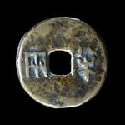](http://www.britishmuseum.org/explore/highlights/highlight_objects/cm/b/bronze_banliang_coin.aspx)**

When the First Emperor unified China, he made the *banliang* coin of the Qin state the single currency of the new Qin Empire. All other forms of bronze money, which came in a number of different shapes and sizes, became obsolete. The standardization of coinage can be seen as both a symbol of the emperor’s political authority and as an important economic development.

The circular shape of the coin with a square hole within is significant because in early Chinese cosmology, the earth was seen as being square and the heavens were considered to be domed. This shape could therefore be seen as a powerful symbol combining both heaven and earth.

The word *banliang*, inscribed on the coin, refers to its weight. *Banliang* means half *liang*, which is about eight grammes.

The First Emperor also announced that standard weights and measures would be used throughout his empire and standardized written Chinese characters to produce a script that could be read everywhere. Before his reign, Chinese words could be written in a variety of ways, but this key reform allowed him to govern and control the unified empire more easily.

People in China today still use characters based on his innovations.

**Protecting and defending**

China’s First Emperor built a great wall to protect his land from invaders from the north. Around 300,000 captured soldiers and conscripts lived, worked and died in remote areas of the empire to complete this huge project. The Great Wall of China we know today is built on the foundations of the Qin wall.

**A universal ruler**

China's First Emperor saw himself as more than the ruler of China – the whole universe was his empire. He demonstrated this by visiting China’s sacred mountains, as mythical emperors of the past are said to have done. There he sacrificed to the gods and communicated with powerful spirits.

He had the mountains inscribed with descriptions of his great achievements and character, beginning a tradition of mountain inscription that still continues in China today.

Death did not suit the ambitions of a man who believed he ruled the universe. The First Emperor wanted to govern forever, and tried out many pills and potions to prolong his life. He even sent servants to look for magic herbs which were thought to grow on the mythical islands of the immortals off the east coast.

Qin Shihuangdi became increasingly afraid of dying after at least three attempts to kill him were made between 227 and 218 BC. The most famous of these attempts happened in 227 BC. The assassin, Jing Ke, sent by another state, hid a knife in a scroll and attacked the Emperor during an audience, though he was ultimately unsuccessful as his weapon struck a pillar rather than its target.

**An eternal ruler**

Qin Shihuangdi died suddenly in 210 BC, aged 49. Despite his declaration that the Qin Dynasty would last thousands of years, it collapsed in 207 BC.

Before his death, and believing he would rule forever, the First Emperor decided to recreate his entire empire and court underground in clay, wood and bronze. Over a period of more than 30 years, around 700,000 laborers built him a palace for the afterlife.

He surrounded this palace with representations of his officials, his buildings, his parks and animals – everything he would need to carry on his life without end. He planned that his body would be buried under a mound representing a miniature mountain, so that he would become an eternal part of China’s landscape.

The site was chosen for its location, protected by mountains in the south (mount Li) and west (Qinling mountains) and water to the north (Wei river). The east led to the Great Central Plains, but was protected by a terracotta army: 8.000 soldiers and horses modeled in clay in what marks a new highpoint in the art of sculpture in early China.

When the First Emperor died he was buried in a tomb at the heart of the complex and while the location of the tomb mound was known, the terracotta army remained hidden until its chance discovery by farmers in 1974. The tomb itself has not yet been excavated although scientific tests have been carried out.

Although his dynasty did not last long, the deeds of the First Emperor created a huge legacy. He was crucial to the formation of China as a unified state and was even responsible for giving China its English name. Scripts, weights and coins were standardized, road networks were established and the first part of the Great Wall was constructed to keep out marauding nomads.

The First Emperor's impact on the world can still be felt today.

*Retrieved October 16, 2014, from* [*http://www.britishmuseum.org/explore/themes/leaders\_and\_rulers/qin\_shihuangdi.aspx*](http://www.britishmuseum.org/explore/themes/leaders_and_rulers/qin_shihuangdi.aspx)

**DOCUMENT 2**

# Terra-Cotta Army Protects First Emperor's Tomb

**By John Roach**

Workers digging a well outside the city of Xi'an, China, in 1974 struck upon one of the greatest archaeological discoveries in the world: a life-size clay soldier poised for battle.

The diggers notified Chinese authorities, who dispatched government archaeologists to the site.

They found not one, but thousands of clay soldiers, each with unique facial expressions and positioned according to rank. And though largely gray today, patches of paint hint at once brightly colored clothes. Further excavations have revealed swords, arrow tips, and other weapons, many in pristine condition.

The soldiers are in trench-like, underground corridors. In some of the corridors, clay horses are aligned four abreast; behind them are wooden chariots.

The terra-cotta army, as it is known, is part of an elaborate mausoleum created to accompany the first emperor of China into the afterlife, according to archaeologists.

**Young Emperor**

Ying Zheng took the throne in 246 B.C. at the age of 13. By 221 B.C. he had unified a collection of warring kingdoms and took the name of Qin Shi Huang Di—the First Emperor of Qin.

During his rule, Qin standardized coins, weights, and measures; interlinked the states with canals and roads; and is credited for building the first version of the Great Wall.

According to writings of court historian Siam Qian during the following Han dynasty, Qin ordered the mausoleum's construction shortly after taking the throne. More than 700,000 laborers worked on the project, which was halted in 209 B.C. amid uprisings a year after Qin's death.

To date, four pits have been partially excavated. Three are filled with the terra-cotta soldiers, horse-drawn chariots, and weapons. The fourth pit is empty, a testament to the original unfinished construction.

Archaeologists estimate the pits may contain as many as 8,000 figures, but the total may never be known.

**Unexcavated Tomb**

Qin's tomb itself remains unexcavated, though Siam Qian's writings suggest even greater treasures.

"The tomb was filled with models of palaces, pavilions and offices as well as fine vessels, precious stones and rarities," reads a translation of the text.

The account indicates the tomb contains replicas of the area's rivers and streams made with mercury flowing to the sea through hills and mountains of bronze. Precious stones such as pearls are said to represent the sun, moon, and other stars.

Modern tests on the tomb mound have revealed unusually high concentrations of mercury, lending credence to at least some of the historical account.

Chinese archaeologists are also using remote-sensing technology to probe the tomb mound. The technique recently revealed an underground chamber with four stair-like walls. An archaeologist working on the site told the Chinese press that the chamber may have been built for the soul of the emperor.

Experimental pits dug around the tomb have revealed dancers, musicians, and acrobats full of life and caught in mid-performance, a sharp contrast to the military poses of the famous terra-cotta soldiers.

But further excavations of the tomb itself are on hold, at least for now.

"It is best to keep the ancient tomb untouched, because of the complex conditions inside," Duan Qinbao, a researcher with the Shaanxi Provincial Archaeology Institute, told the China Daily in 2006.

*Retrieved October 16, 2014, from* [*http://science.nationalgeographic.com/science/archaeology/emperor-qin/*](http://science.nationalgeographic.com/science/archaeology/emperor-qin/)

**DOCUMENT 3**

**Images from Mausoleum of the First Qin Emperor**

It is likely that thousand of statues still remain to be unearthed at this archaeological site, which was not discovered until 1974. Qin, the first unifier of China, is buried—surrounded by the famous terracotta warriors—at the center of a complex designed to mirror the urban plan of the capital, Xianyan. The figures are all different, with their horses, chariots, and weapons; they are masterpieces of realism and also of great historical interest.

Pit 1 of the Terracotta Warriors and Horses Museum was excavated in 1974 when the local farmers were drilling a well. Pit 1 covers an area of 14,260 square meters. It has a rectangular shape with chariots and ranks of 6,000 soldiers arranged in a war formation - a vivid display of Emperor Qin Shi Huang's formidable army.

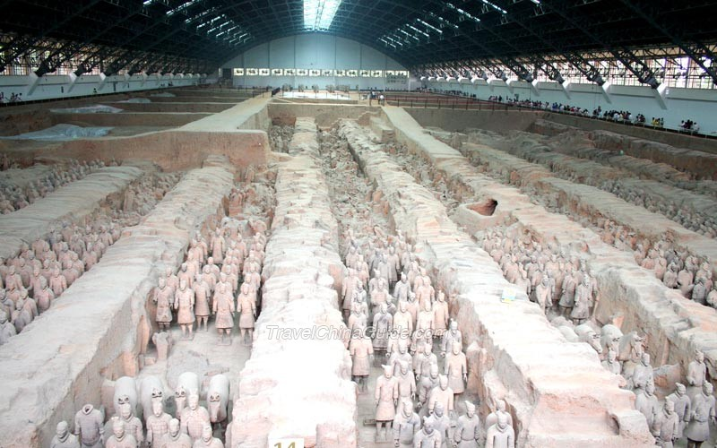

Unearthed from the west side of Qin Shi Huang's tomb in 1980, the two bronze chariots and horses are considered to be the earliest, largest and best-preserved bronze chariots and horses in the history of Chinese archaeology. The front chariot was named the "High chariot" and the rear chariot was named the "Security chariot." Both are exactly half life-size models of an actual chariot, horses and driver. They are now exhibited in the Multi-Exhibition Hall of the Museum Qin Terracotta Warriors and Horses.

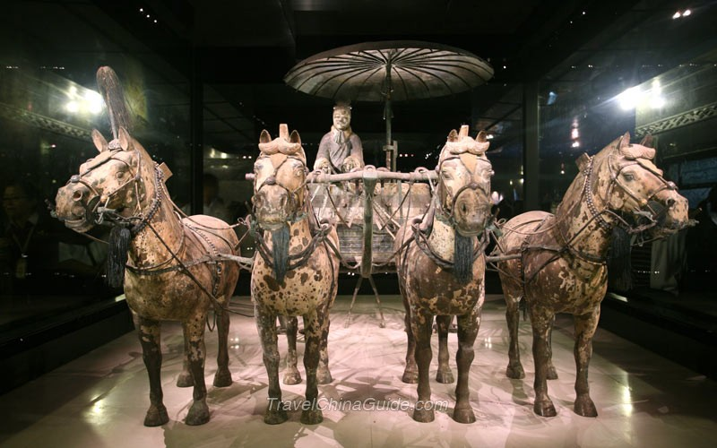

Situated about 20 meters northeast of Pit 1, Pit 2 is the most spectacular of three pits. Though the terracotta figures in Pit 2 are almost the same as those in Pit 1, the battlefield formation in Pit 2 is more complex and the arms of soldiers are more complete.

The Kneeling Archers warriors are quite unique. They were in a kneeling position in the pit. The artisans in Qin Dynasty designed these soldier figures strikingly true to life. They endowed these static terracotta warriors with a sense of motion which was reflected in every detail in these sculptures.

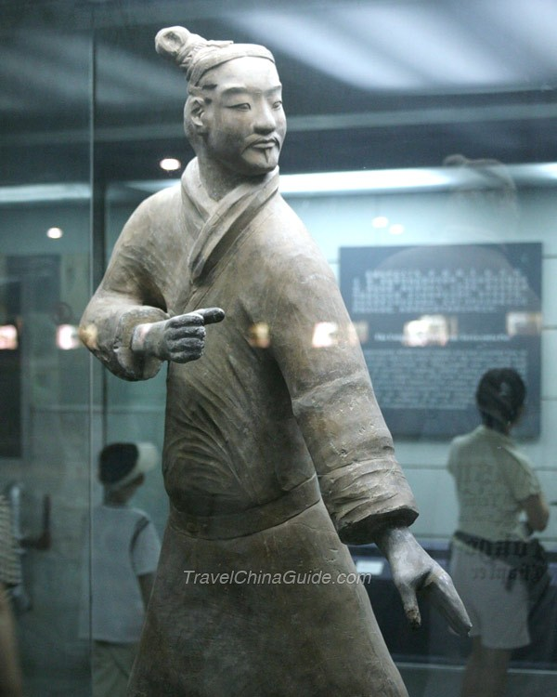 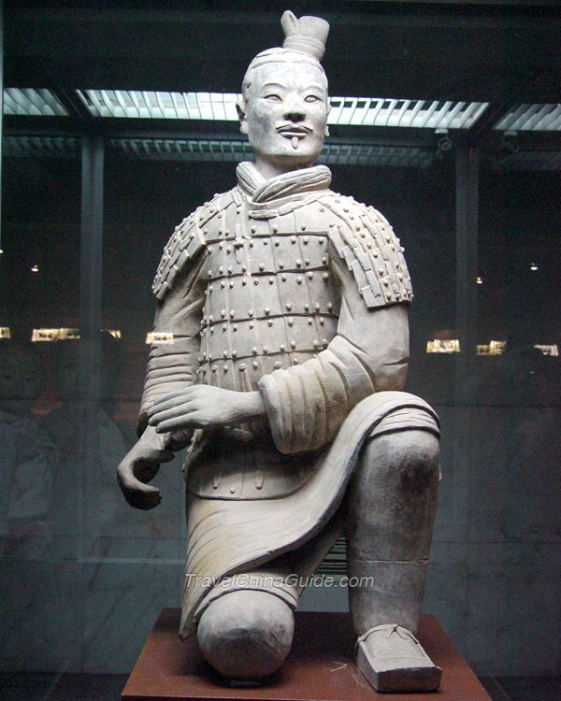

*Retrieved on October 16, 2014, from* [*http://www.travelchinaguide.com/picture/shaanxi/xian/terra\_cotta\_warriors/qinshihuang-park.htm*](http://www.travelchinaguide.com/picture/shaanxi/xian/terra_cotta_warriors/qinshihuang-park.htm)