Math 8
Winter Student Enrichment Packet



PRINCE GEORGE’S COUNTY PUBLIC SCHOOLS
Office of Academic Programs
Department of Curriculum and Instruction

™
NOTE TO THE STUDENT

This Winter Student Enrichment Packet has been compiled to complement middle school mathematics classroom instruction aligned to the Maryland College and Career Ready Standards (MCCRS). The packet is intended to be used for review and practice of previously taught and new concepts.

We strongly encourage you to work diligently to complete the activities for the choice board. You may experience some difficulty with some activities in this packet, but we encourage you to think critically and creatively and complete them to the best of your ability.

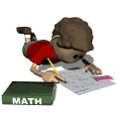

Math 8 Winter Student Enrichment Choice Board
Directions: Complete three activities in a tic-tac-toe (three in a row across, down, or diagonal) pattern. Follow all directions closely and complete each activity entirely. Use the rubrics to guide your work.
Activity 1  Power Up or Key It  Create a PowerPoint, keynote, or Google document of at least five slides.   | Activity 2  It’s Real  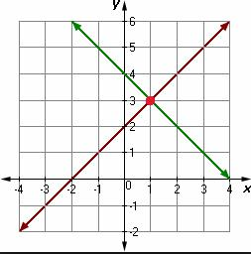  Write and solve systems of linear equations to represent word problems. | Activity 3  Explain It  Explain how you can determine if a relation is a function.  
Activity 4  All About Coding  Complete a Code.Org coding activity.   | Activity 5  What’s Your Solution?  Create three different linear equations written in one variable that each has one of the following solutions: one solution; no solution; infinitely many solutions.   | Activity 6  Puzzle Time  Complete a task in which you match systems of equations to their solutions as ordered pairs.  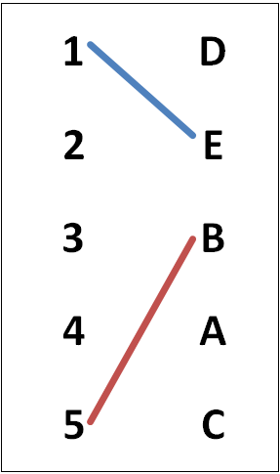
Activity 7  Solve Them  Solve systems of equations by elimination and substitution.  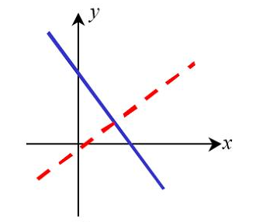 | Activity 8  Map It Out  Examine the street layout of Washington, D.C., and create your own mini street layout.   | Activity 9  Create a Quiz  Create a quiz on ProProfs Quiz Maker that assesses Solving Linear Equations.  

Math 8 Choice Board Activity Directions

Activity 1: Power Up or Key It  Standard 8.G.5  Create a PowerPoint, Keynote, or Google Slides presentation of at least five slides on transversals. Include the following terms, their definitions, examples and/or pictures or videos:  - Transversal  - Parallel Lines  - Vertical Angles  - Corresponding Angles  - Alternate Interior Angles  - Alternate Exterior Angles | Activity 2: It’s Real  Standard 8.EE.8  On loose leaf paper, write and solve a system of linear equations for each of the following word problems. State the solution to each system in a sentence.  1. A test has 20 questions and is worth 100 points. The test consists of True/False questions worth 3 points each and multiple choice questions worth 11 points each. How many multiple-choice questions are on the test?  2. Danielle is selling her handmade jewelry online. Yesterday, she sold 2 bracelets and 4 necklaces, for a profit of $118. Today, she made a profit of $132 by selling 4 bracelets and 4 necklaces. How much profit does Danielle earn from each piece? | Activity 3: Explain It  Standard 8.F.1  On loose leaf paper, explain how you can determine if a relation IS or IS NOT a function from each of the representations below. Give a detailed example of a relation that IS a function and a relation that IS NOT a function to illustrate your explanation for each.  - A set of ordered pairs  - A graph line  - A mapping diagram  - A table

Math 8 Choice Board Activity Directions

Activity 4: All About Coding  Standards in 8.F  Complete the Farmer coding activity at the following link:  https://studio.code.org/s/20-hour/stage/8/puzzle/1  1. Watch the video on “Functions.”  2. Click on the orange tab “Finished! Continue to next stage.”  3. Work through the stages of the coding activities. Take a selfie that shows your computer screen AND YOUR NAME in the frame of the photo after you have completed the 11th stage.  4. For three videos that appear throughout the Farmer coding activity (shown below), write one sentence that summarizes the main idea of each video.  - Repeat Times Block (Mark Zuckerberg)  - While Block (Makinde Adeagbo)  - If Block (Bill Gates) | Activity 5: What’s Your Solution?  Standard 8.EE.7  On loose leaf paper, create three different linear equations with one variable but that have variable terms on each side of the equal sign.  One equation each should have the following answers:  - One Solution  - No Solution  - Infinitely Many Solutions | Activity 6: Puzzle Time  Standard 8.EE.8  On the coordinate grids contained in this packet or on other coordinate grids that you print or create, do the following:  - Graph the systems of equations from the puzzle sheet 5.1 Puzzle Time.  - Determine the solutions to the systems of equations.  - Identify the solutions on the puzzle sheet and find the words that correspond to the answers.  - Write the answer to the riddle on the puzzle sheet or on loose leaf paper.

Math 8 Choice Board Activity Directions

Activity 7: Solve Them  Standard 8.EE.8  On loose leaf paper, solve each system of equations by elimination and substitution. Explain your steps for each method used.  $\left\{\begin{aligned}2x+4y=7 \\ x+2y=3\end{aligned}\right.$ $\left\{\begin{aligned}4x+4y=-8 \\ 3x-2y=19\end{aligned}\right.$ | Activity 8: Map It Out  Standard 8.G.5  Using a computer, iPad, or mobile device:  - Go to the “Maps” app or Google Earth or Google Maps. Search for “Washington D.C.”  - On a sheet of loose leaf paper, describe the layout of the city’s streets in at least five sentences. For example, you may write about how the city is divided into quadrants; the direction and arrangement of numbered, lettered, and state-name streets, etc.  - On the coordinate grid sheet in this packet, draw parallel lines that represent two streets.  - Create two more streets that cross the parallel streets at non-right angles and name them. The cross streets cannot be parallel to each other.  - Label each of the angles formed by numbers: L1, L2, L3, L4, etc.  - Explain the relationship between all congruent pairs of angles that are formed by the cross streets to the parallel lines. Name all pairs of Vertical Angles, Corresponding Angles, Alternate Interior Angles, and Alternate Exterior Angles. | Activity 9: Create a Quiz  Standard 8.EE.7  Go to www.proprofs.com.  - Click on the link for Quizzes.  - Click on the link for Create a Quiz.  - Click on the link for Create a Scored Quiz.  - Title your quiz “Solving Linear Equations.”  - Each question should have a problem that requires solving a linear equation with variables on both sides.  - Create five multiple-choice questions and include the four answer choices. Mark the correct answer with a .  - After you have created your five problems:  - Email your teacher the link to your quiz. MAKE SURE TO INCLUDE YOUR NAME in your message.  - You may also print out your quiz and submit it to your teacher.

Coordinate Grid for Map It Out Activity

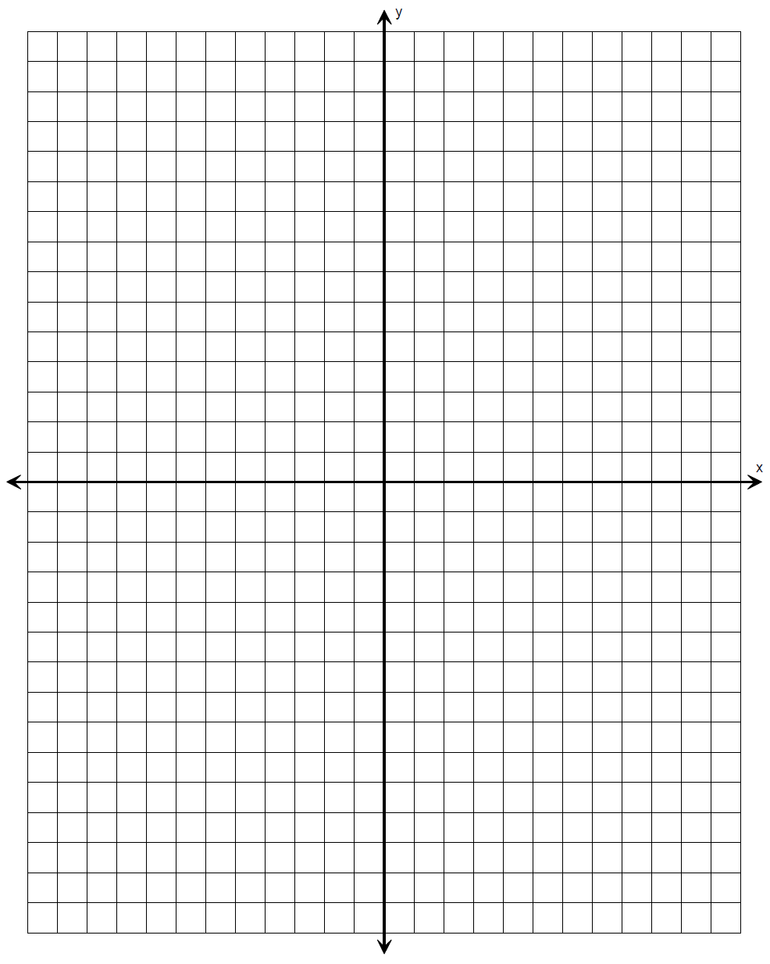
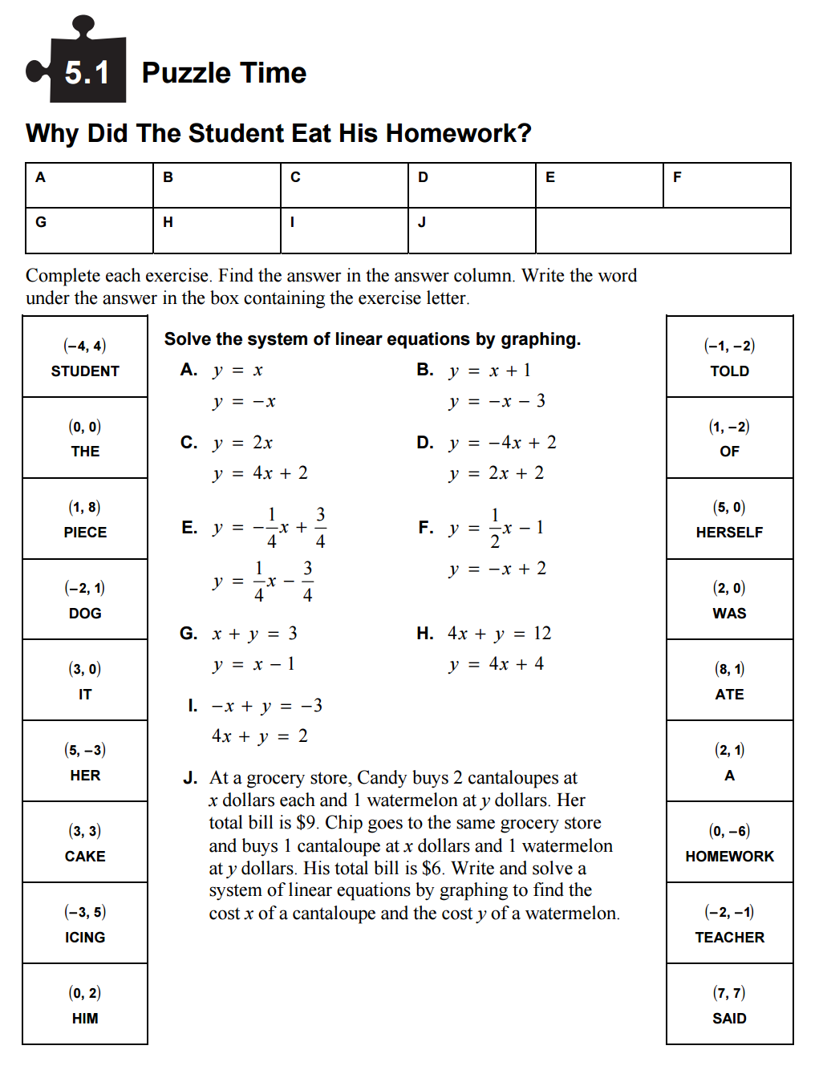
Coordinate Grids for Puzzle Time Activity

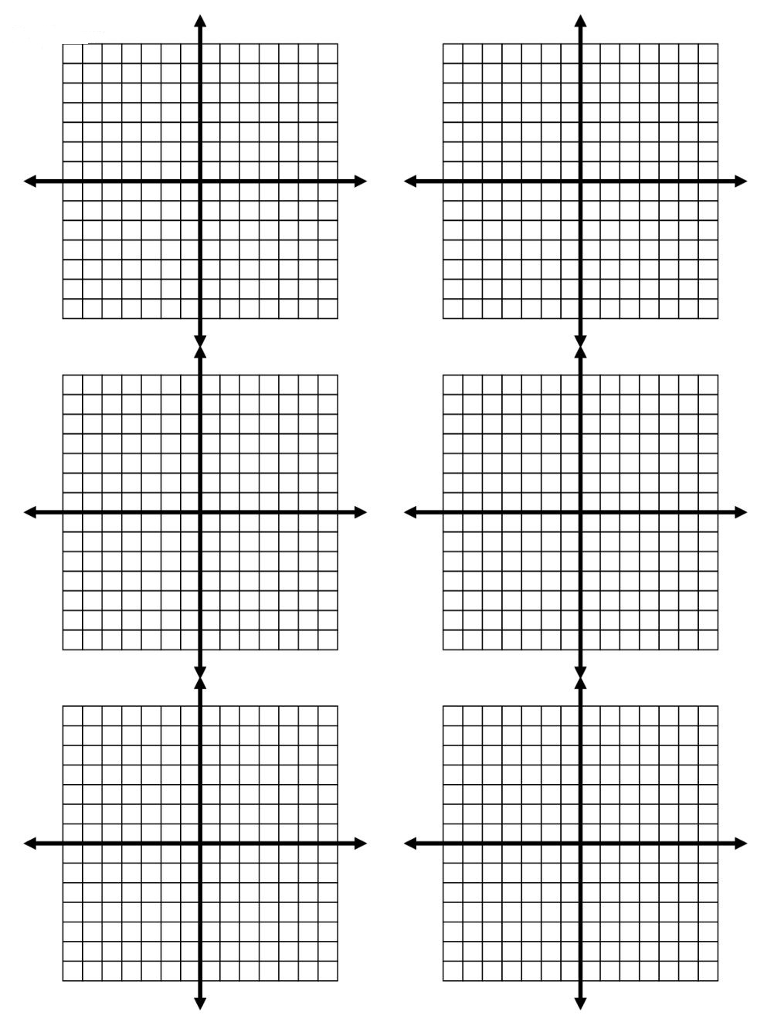

Coordinate Grids for Puzzle Time Activity

